Worksheet 10

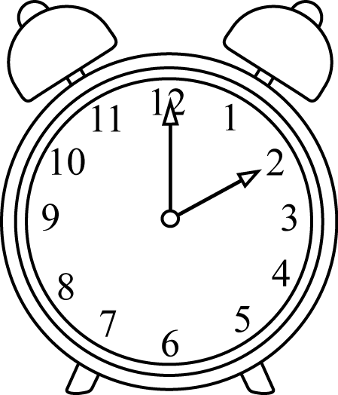
Questions(?) or Exclamations (!)

• Where’s your homework
• Ow
• Who’s that
• Wow, that’s great
• Sit down
• Where
• Why were you late
• No Way
• Why not
• Choice
• What’s the time
• Do you want to come over for tea
•
•
•

