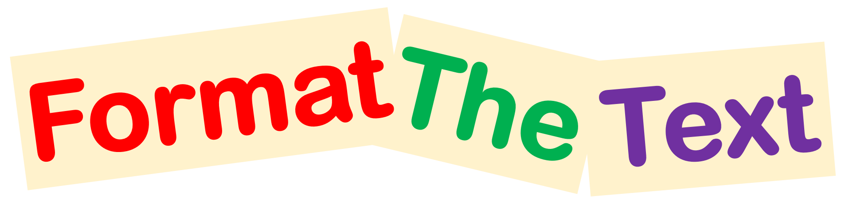

Read the instructions below and use one of the following Formatting Tools on them.

Make my font style Comic Sans MS
Make me, bold
Centre align me
Left align me
Make me, size 20
Make me green
Make me italic
Copy and paste me so that I am also the first instruction
Underline me
Right align me
Make me, orange
Make me, size 12
Make my font style Times New Roman
Copy and paste me so that I am also the fourth instruction

