Book Trivia

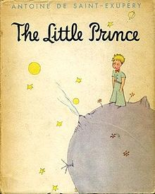
Tasks:

- Open a blank presentation.
- Choose a theme.
- On the title slide, add the text, “Book Trivia” and your name and class as the subtitle.
- Add a Title and Content/Body slide for each of the 4 facts.
- Add the facts from this page into each slide of the presentation.
- Add transitions between slides.
- Add animations for the body text for each slide.
Book Trivia
- There is over 130 million books in print.
- The first book ever published was the Gutenberg Bible in 1453.
- The biggest book every printed was “The Little Prince”. It was published in Brazil and measured 2.01 m high by 3.08 m wide (book open) and contained 128 pages.
- Codex Leicester, by Leonardo Da Vinci, was the most expensive book ever sold. It was purchased by Bill Gates for $30.8 million.

- Add pictures to each slide that go with the fact.
- Add transitions between each slide.
- Choose a simple theme and remember to use colours that look good together.
- Use duplicate slide for your ‘4 facts’ slides.

extras:

tips:

