Design Choices
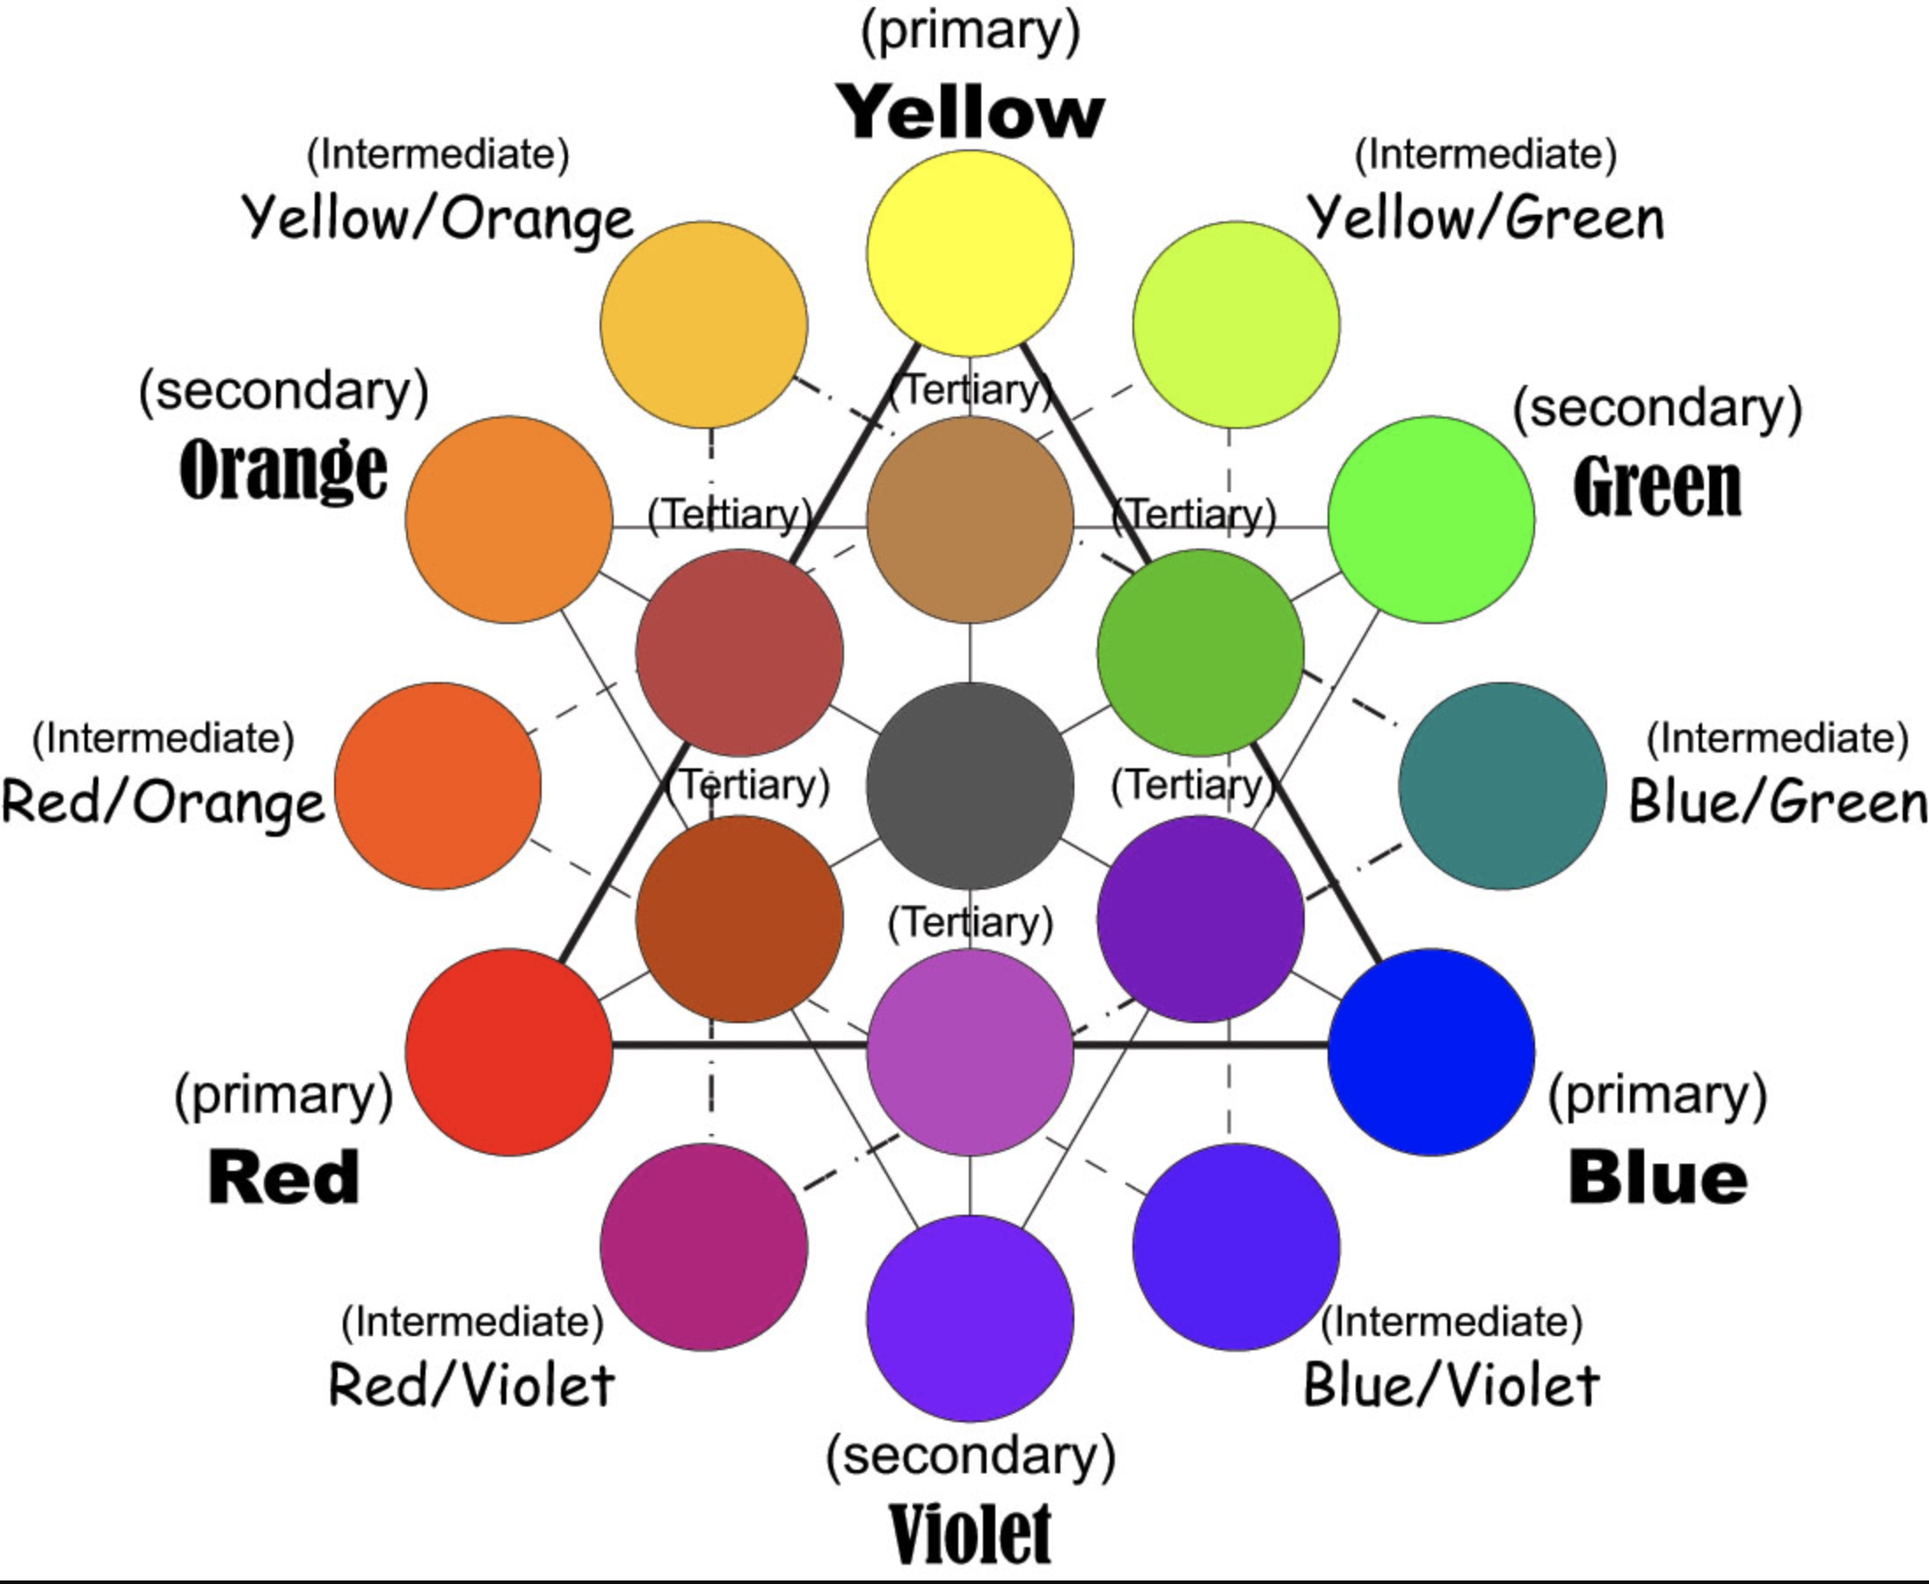

Using the colour wheel, write three colours that go together based on the triangle lines that attach the colour dots. Choose 4 designs.
Choices | Colour 1 goes with | Colour 2 and | Colour 3
First
Second
Third
Fourth

Why do we not want to choose only bright colours for a school presentation? ____________________________________________________________________________________________________________________________________________________________

