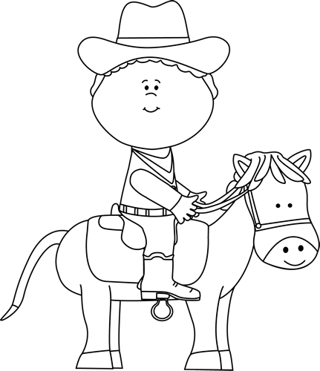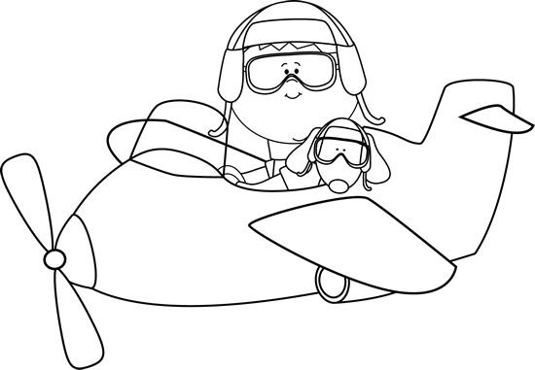

**Some adventure stories I know are:**

**Characteristics of Adventures**

* Usually stories of survival.
* The main character is in danger or needs to save something.
* Keeps you on the edge of your seat (cliff-hanger) wondering what will happen next.
* A huge final event (climax) leads to the end of the story.

Adventure Stories

**Author’s Purpose:**

**To entertain**

**Keep track of the adventure stories you read here!**

**Name:___________________________**

**Good Readers Know About Genres**