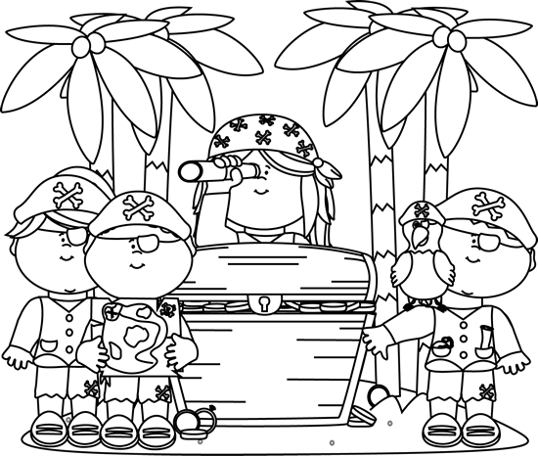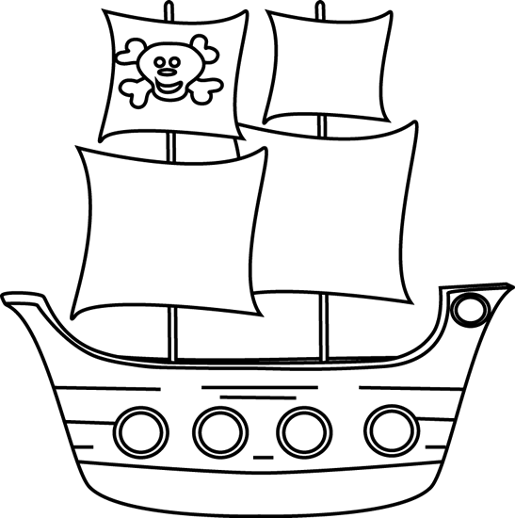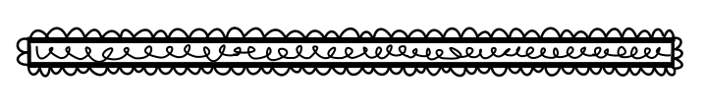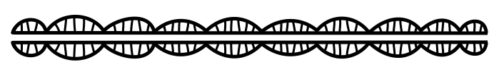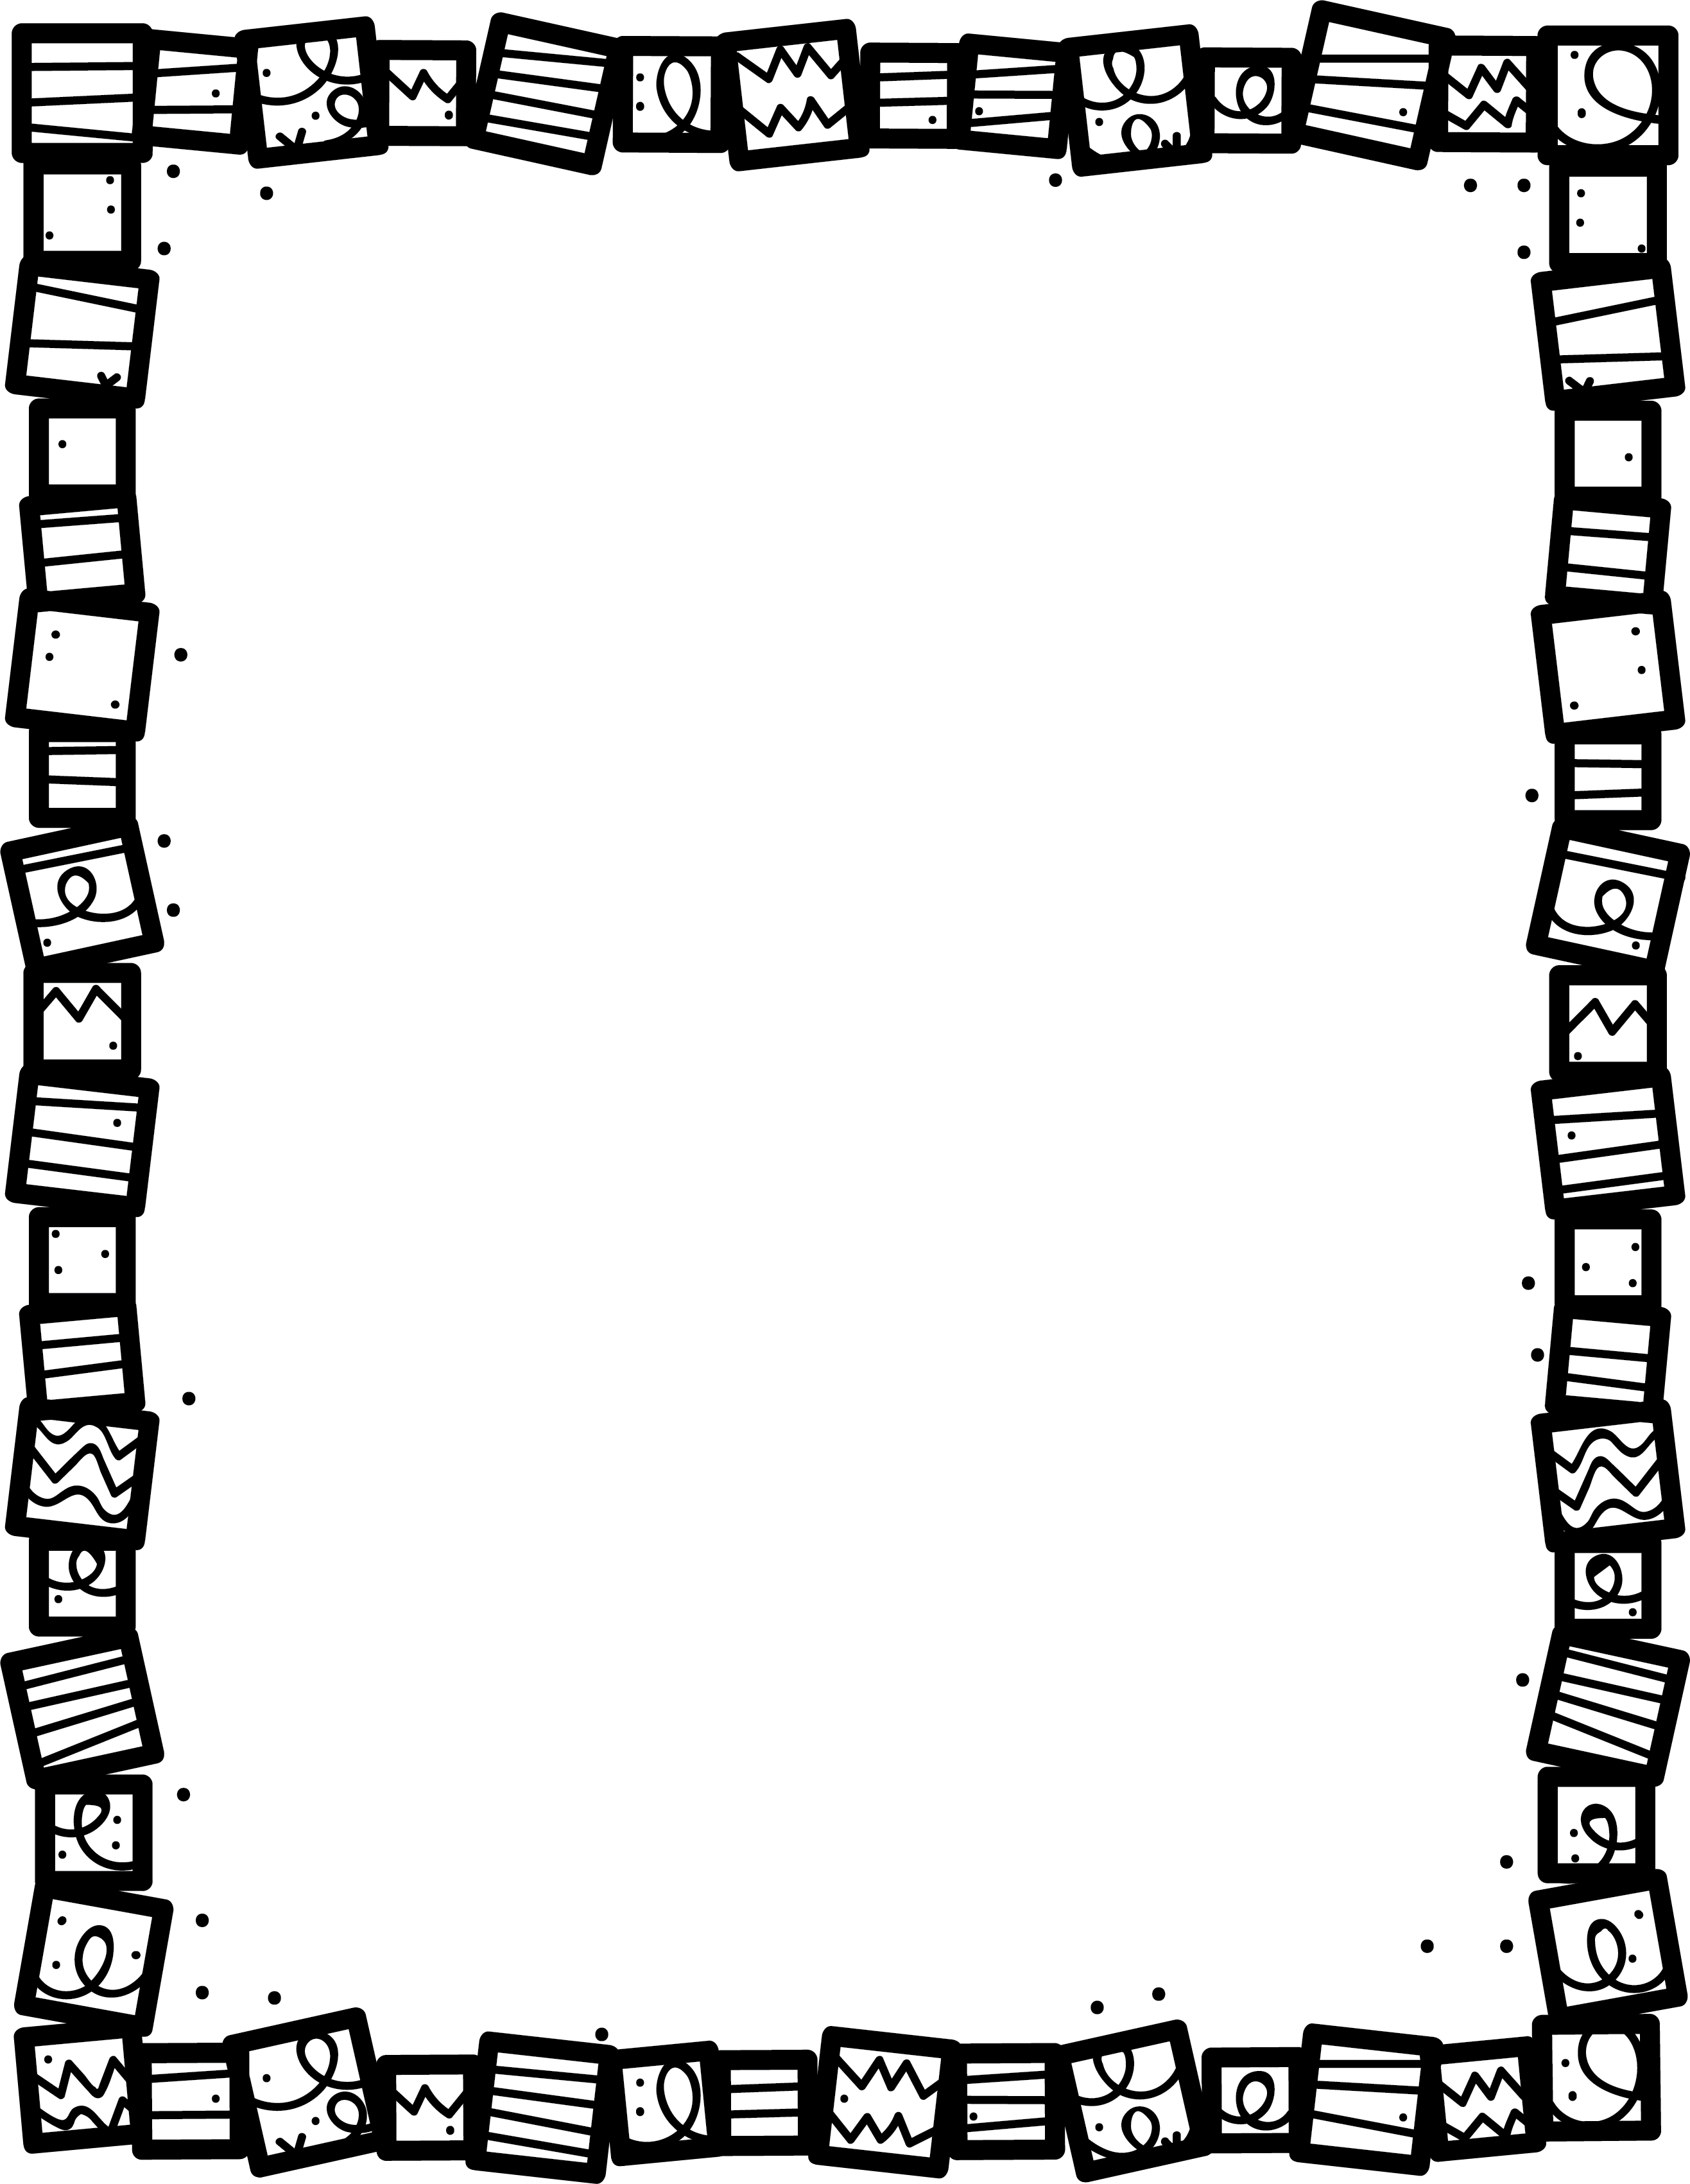

**What was your favourite part? Why?**

Adventure Stories

**How do you know this book is an Adventure story?**

**What part is the funniest? Why?**

**Describe the plot. What happens in the story?**

**What is the setting?**

**Who are the main characters?**

**Book Title:**

**Name:___________________________**

**My Little Activity Book About**