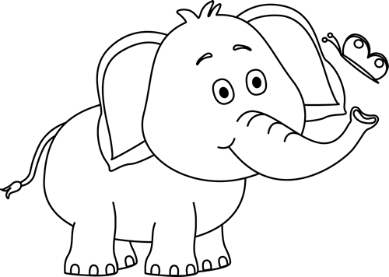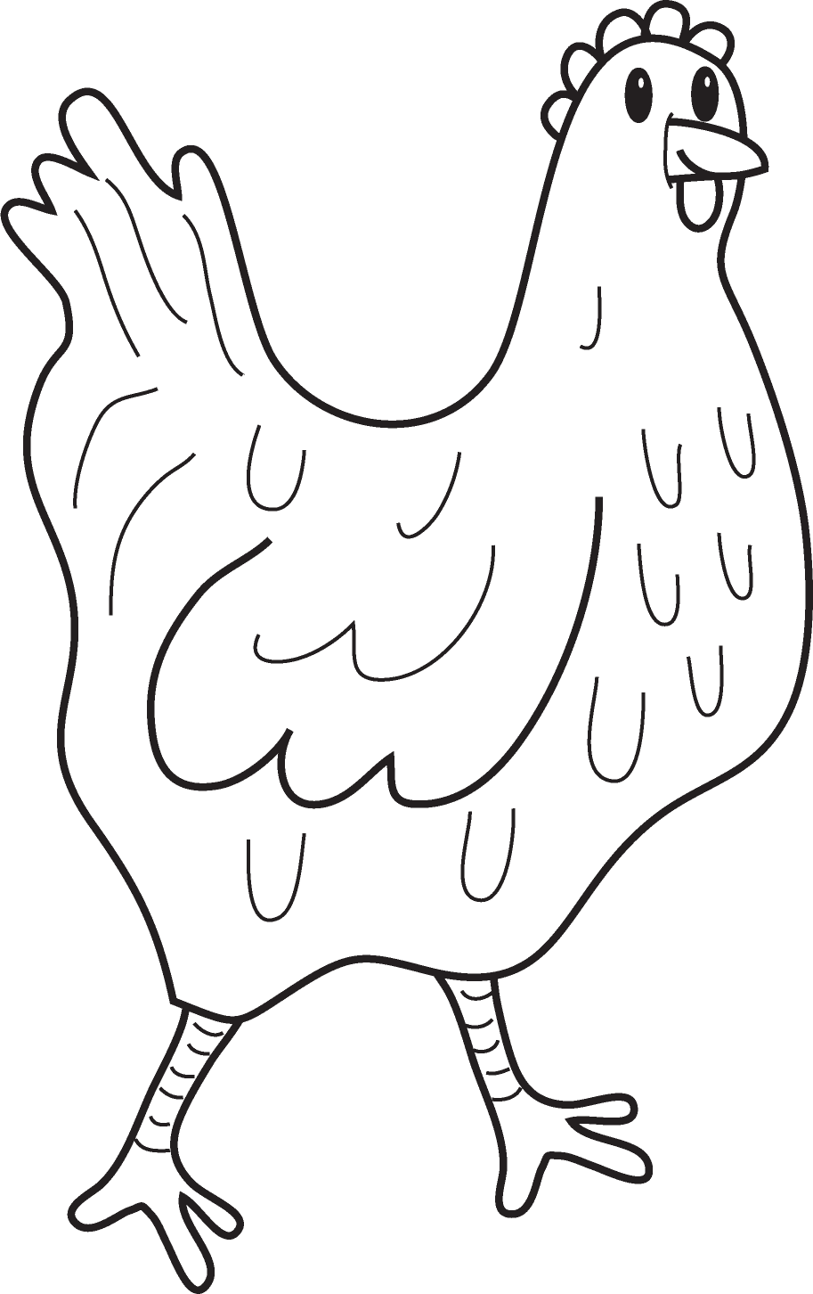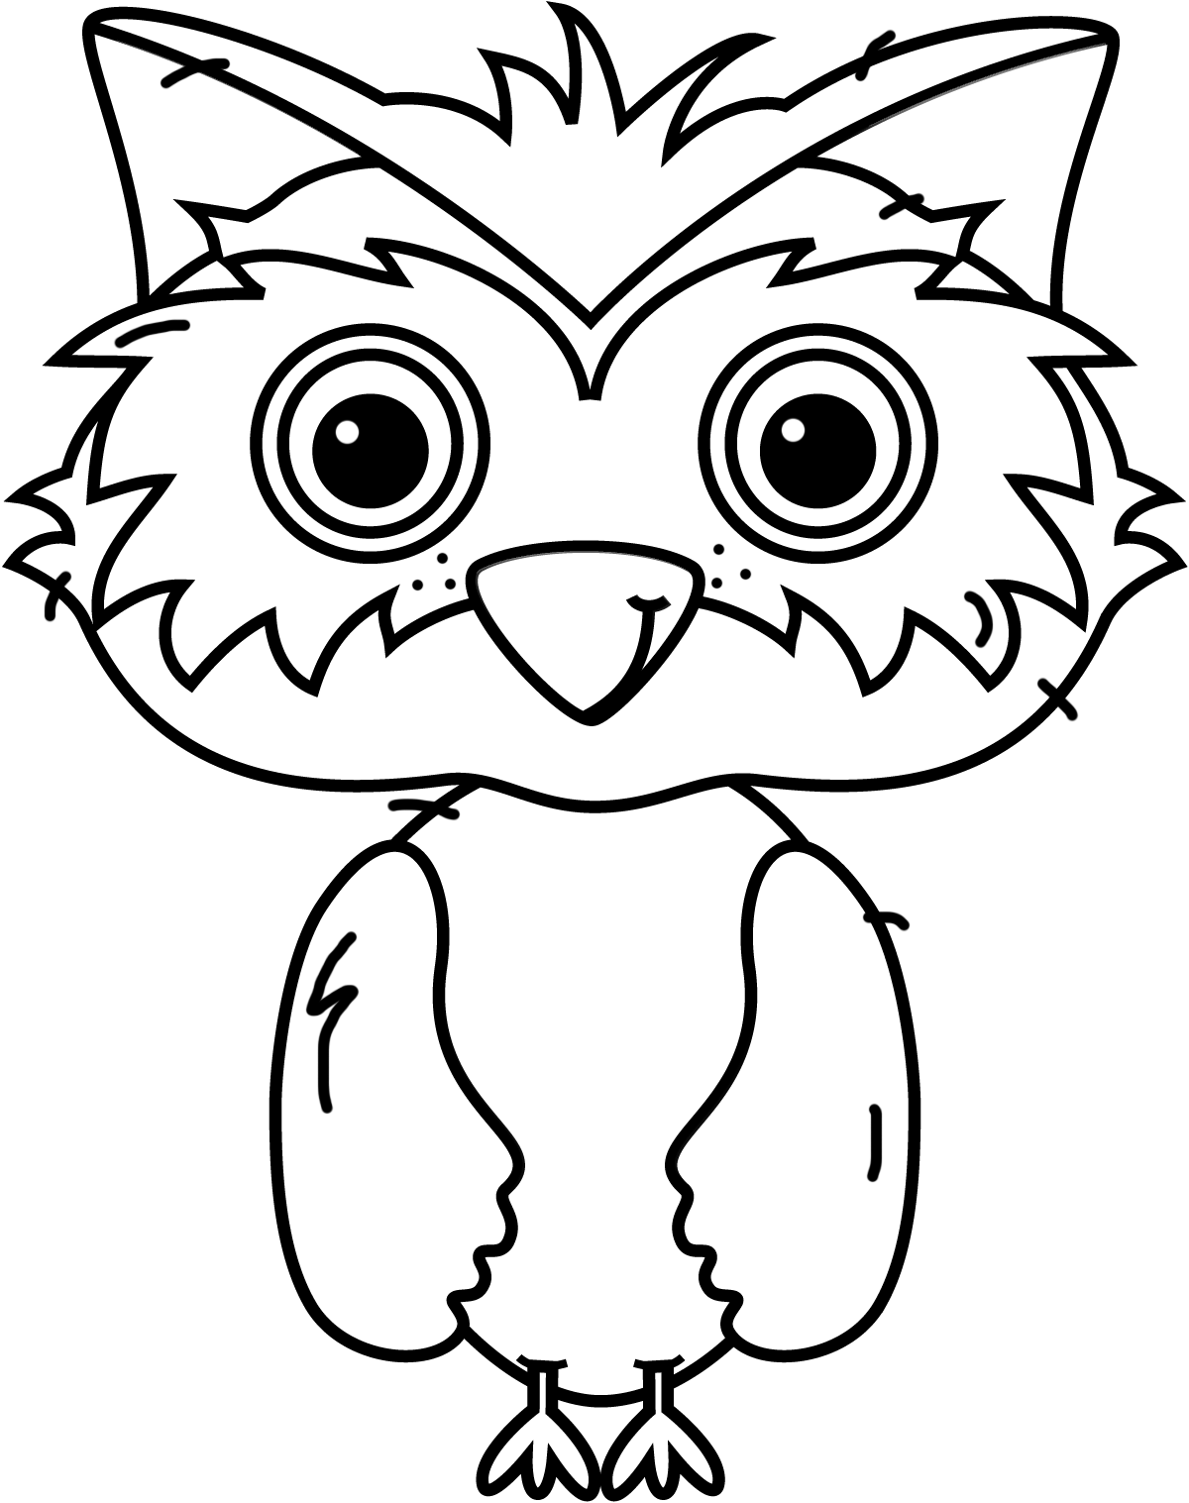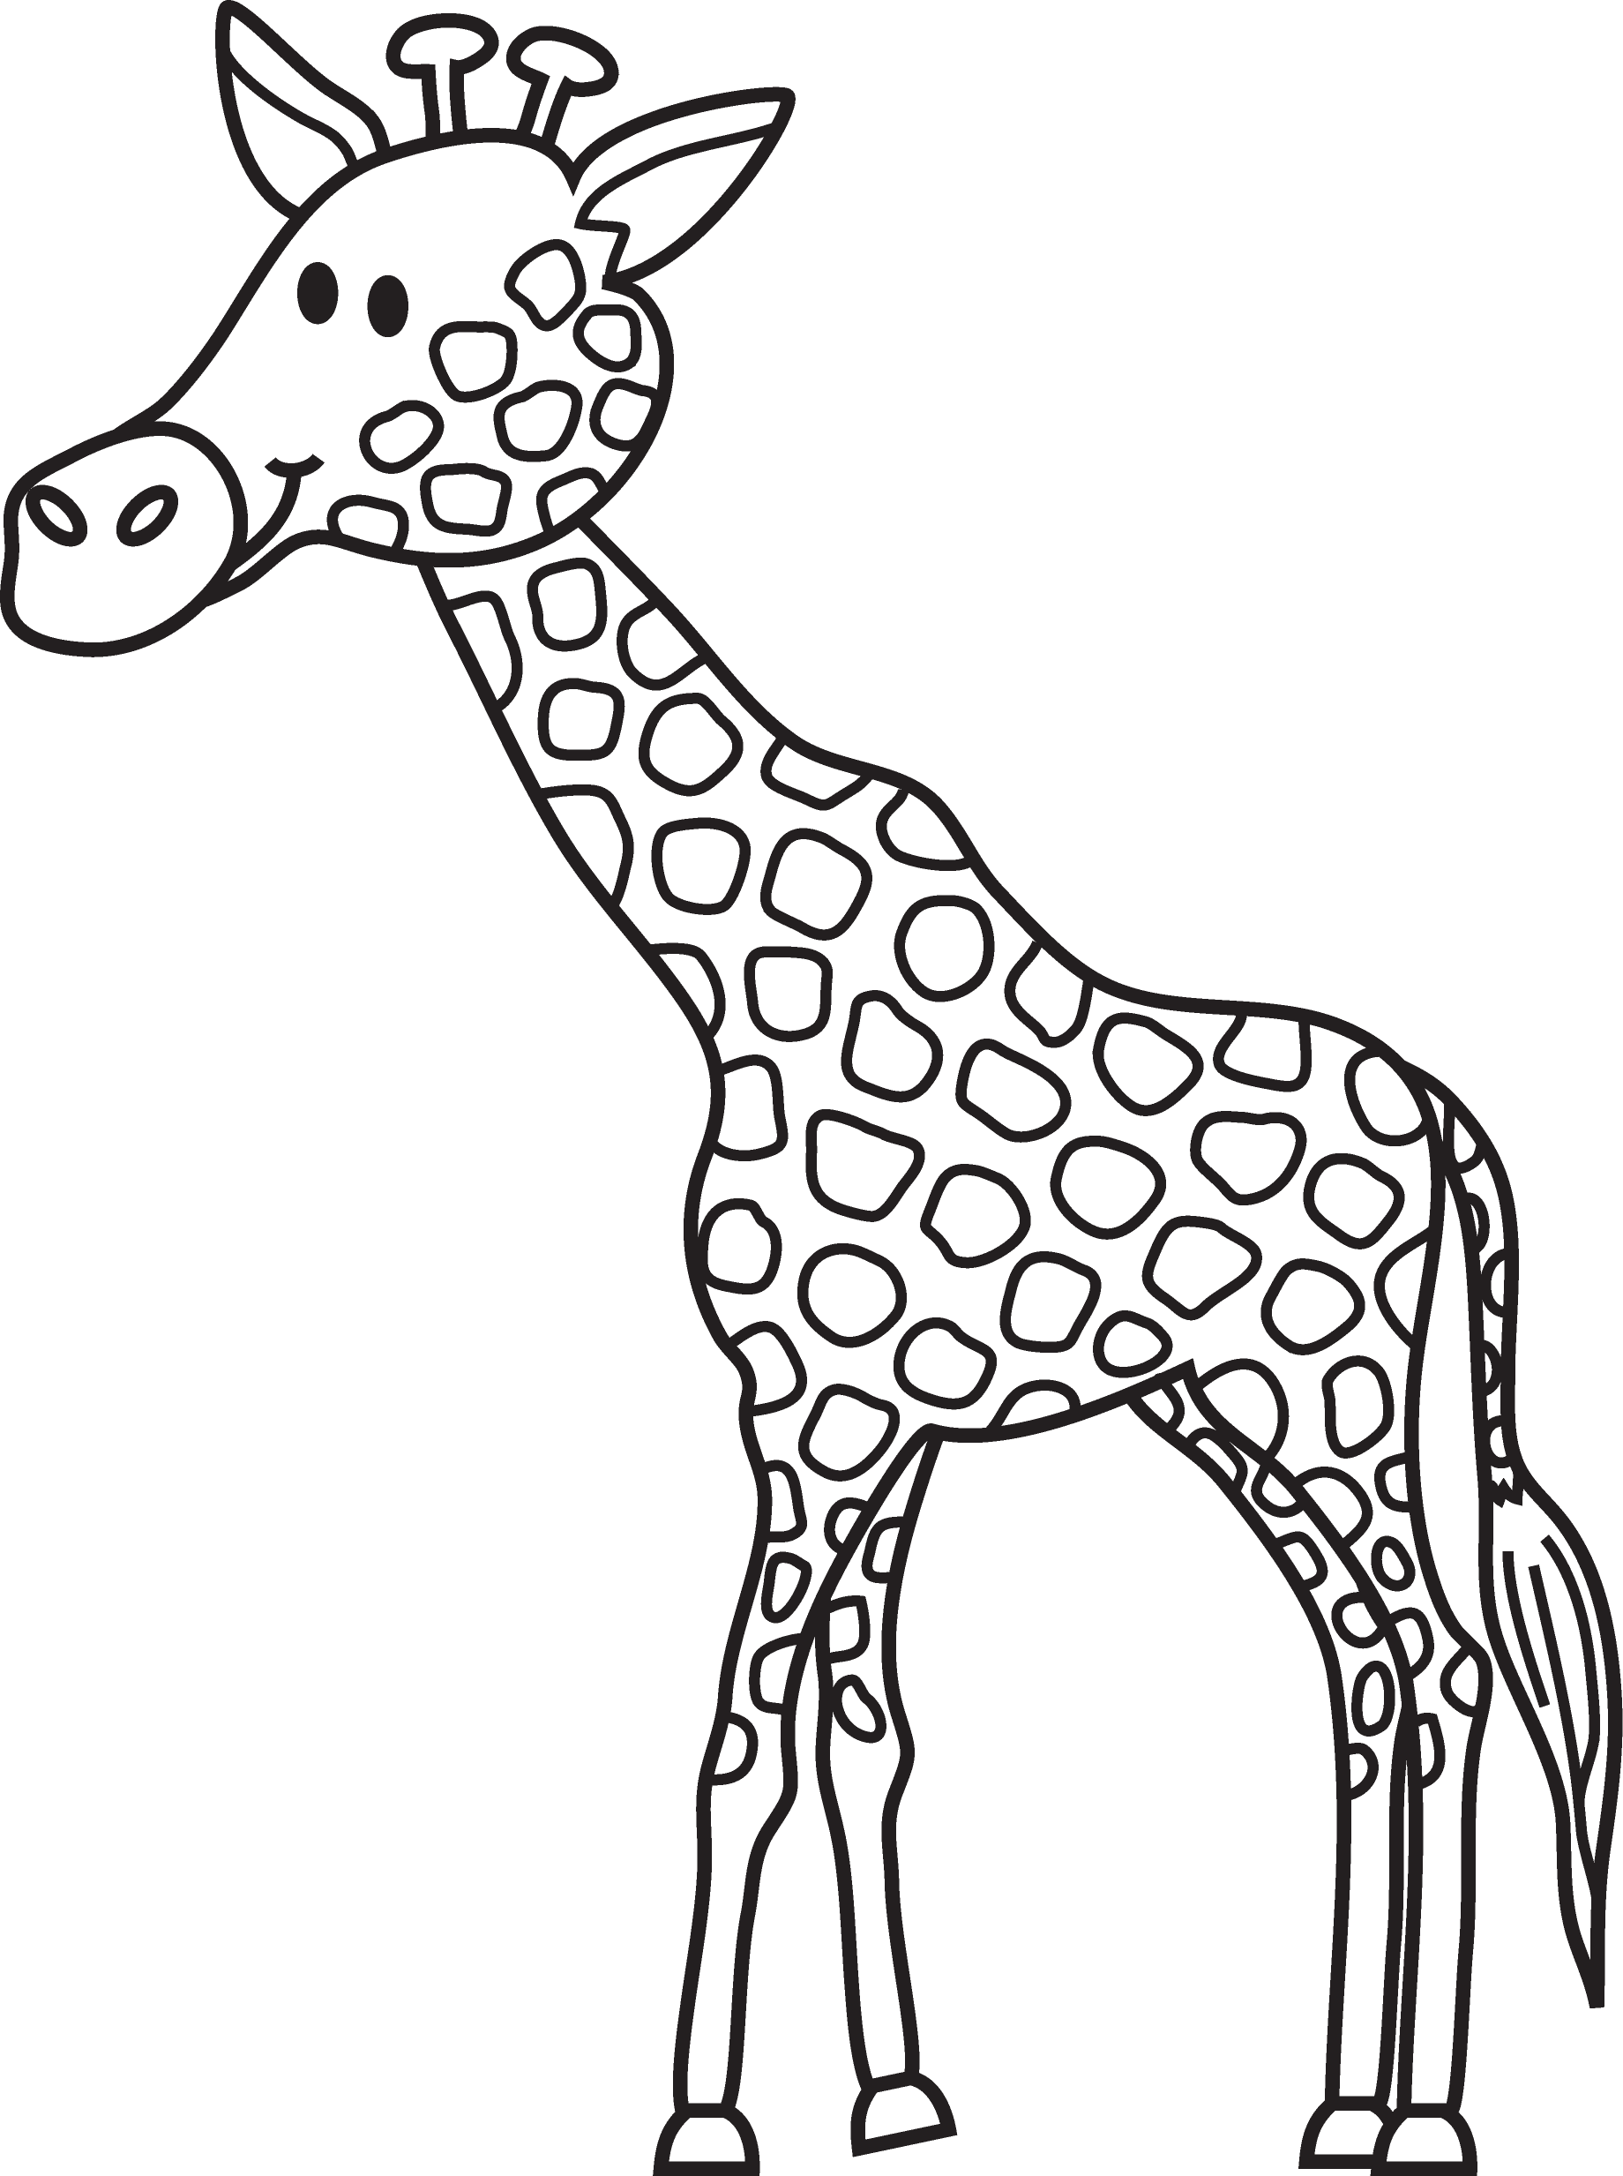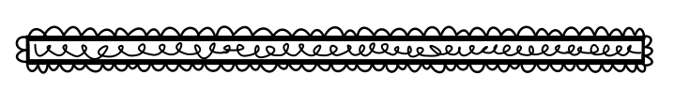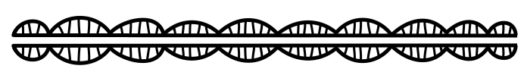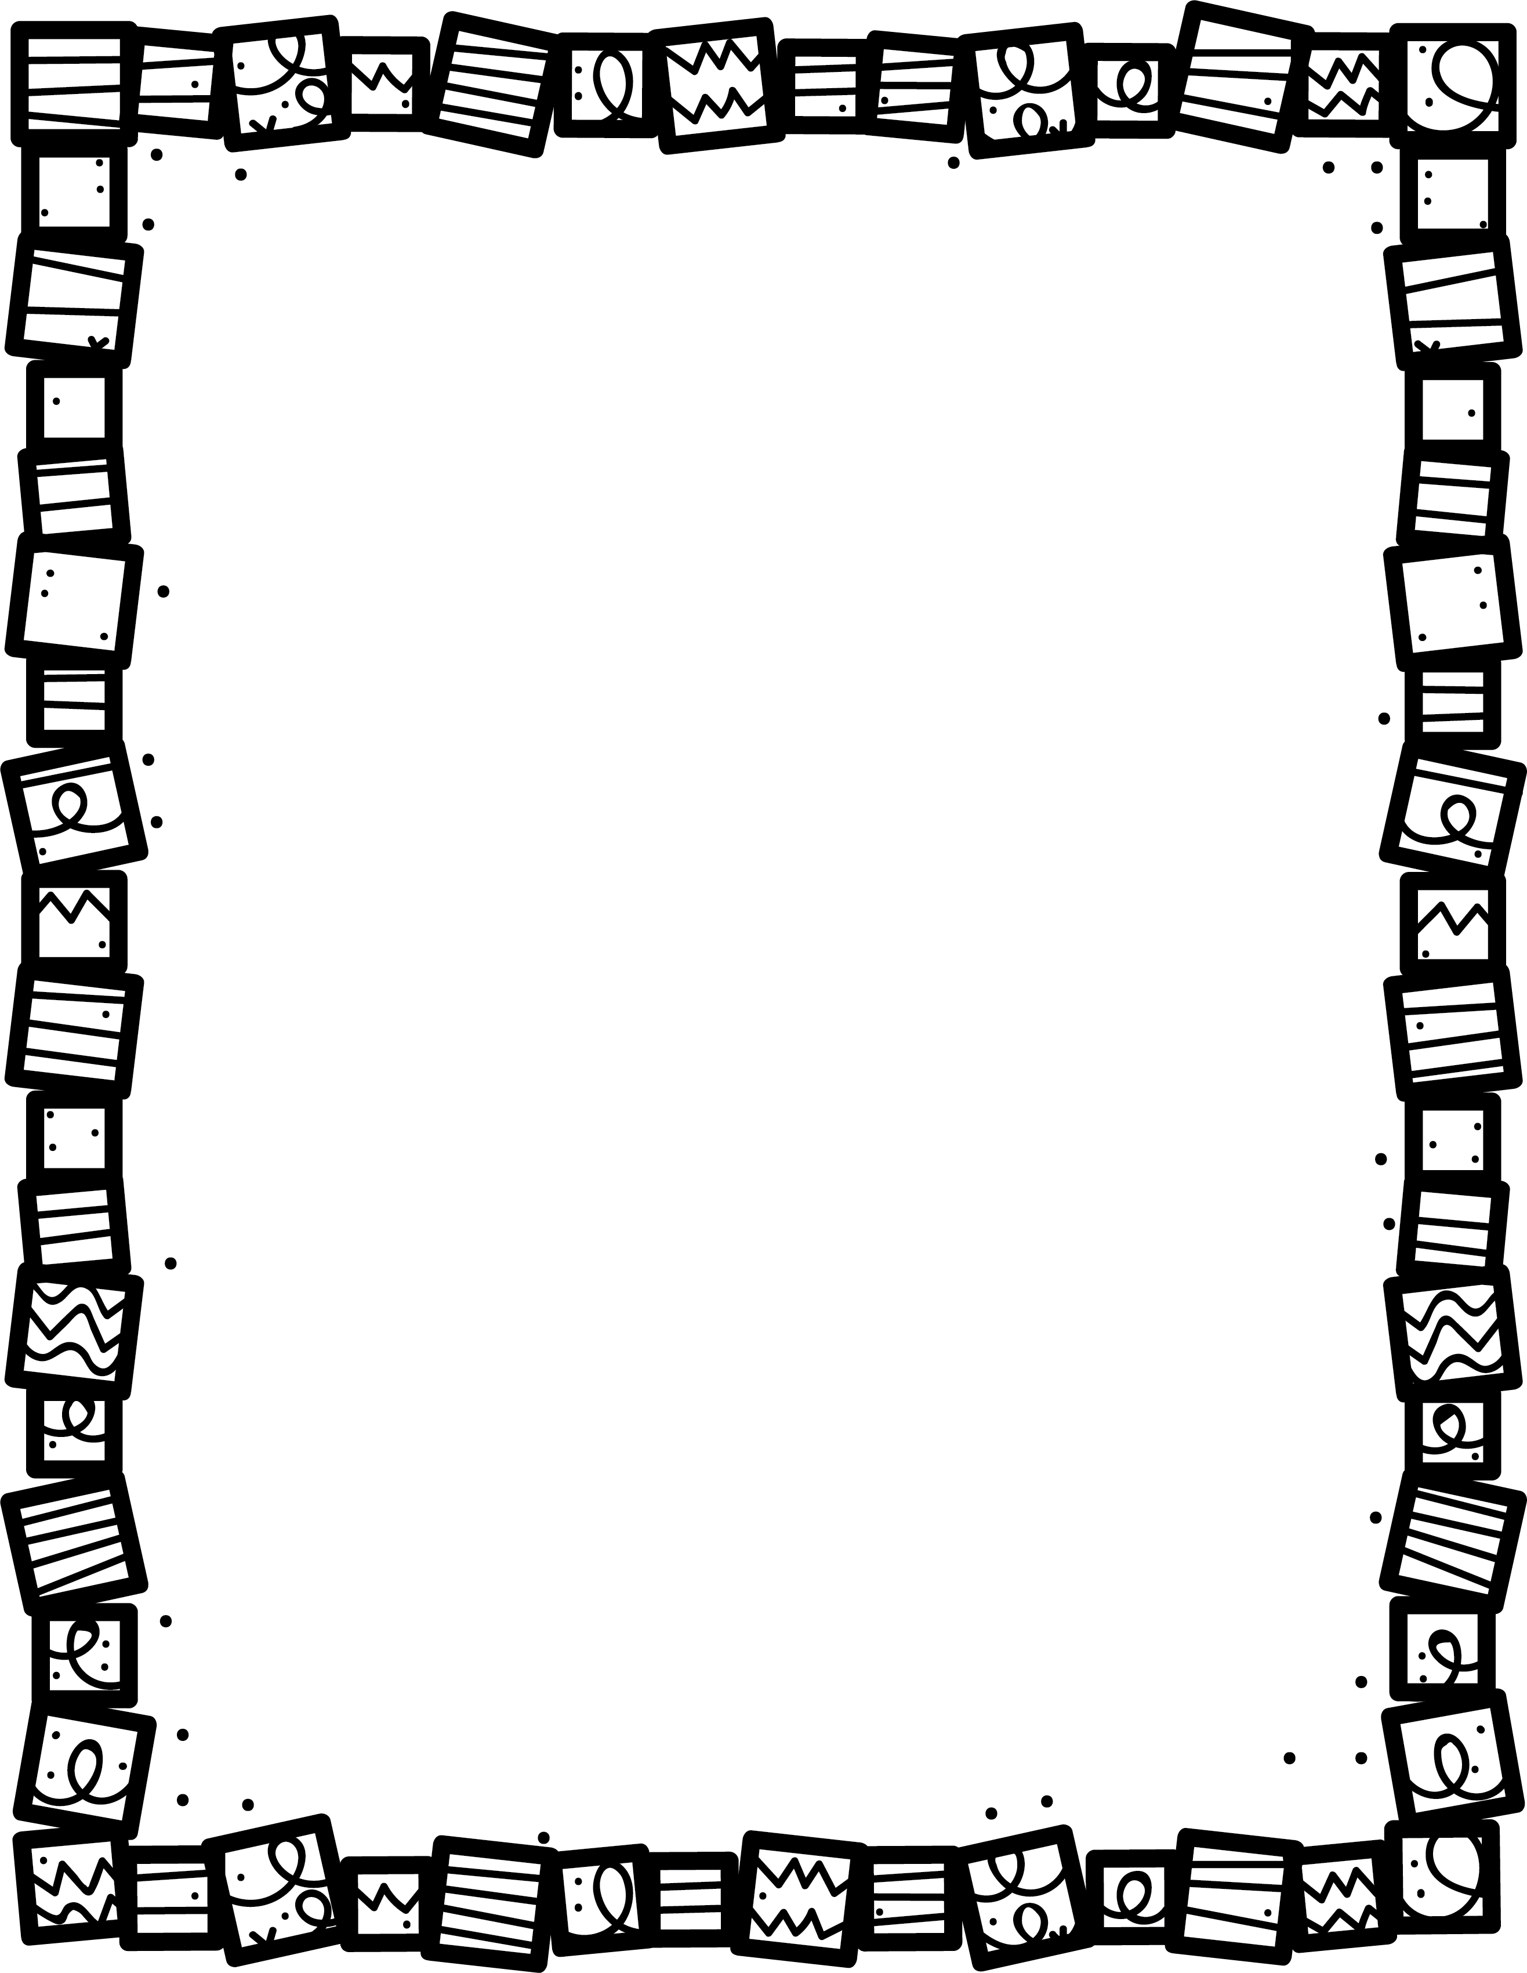

**My Little Activity Book About**

Animal Stories

**What did you learn about this animal?**

**Who are the main animal characters?**

**What was your favourite part? Why?**

**What happens in the story? What are the main events?**

**Describe the setting.**

**Do humans create any problems for the animals?**

**Book Title:**

**Name:___________________________**