

**Beth washes her dog.**

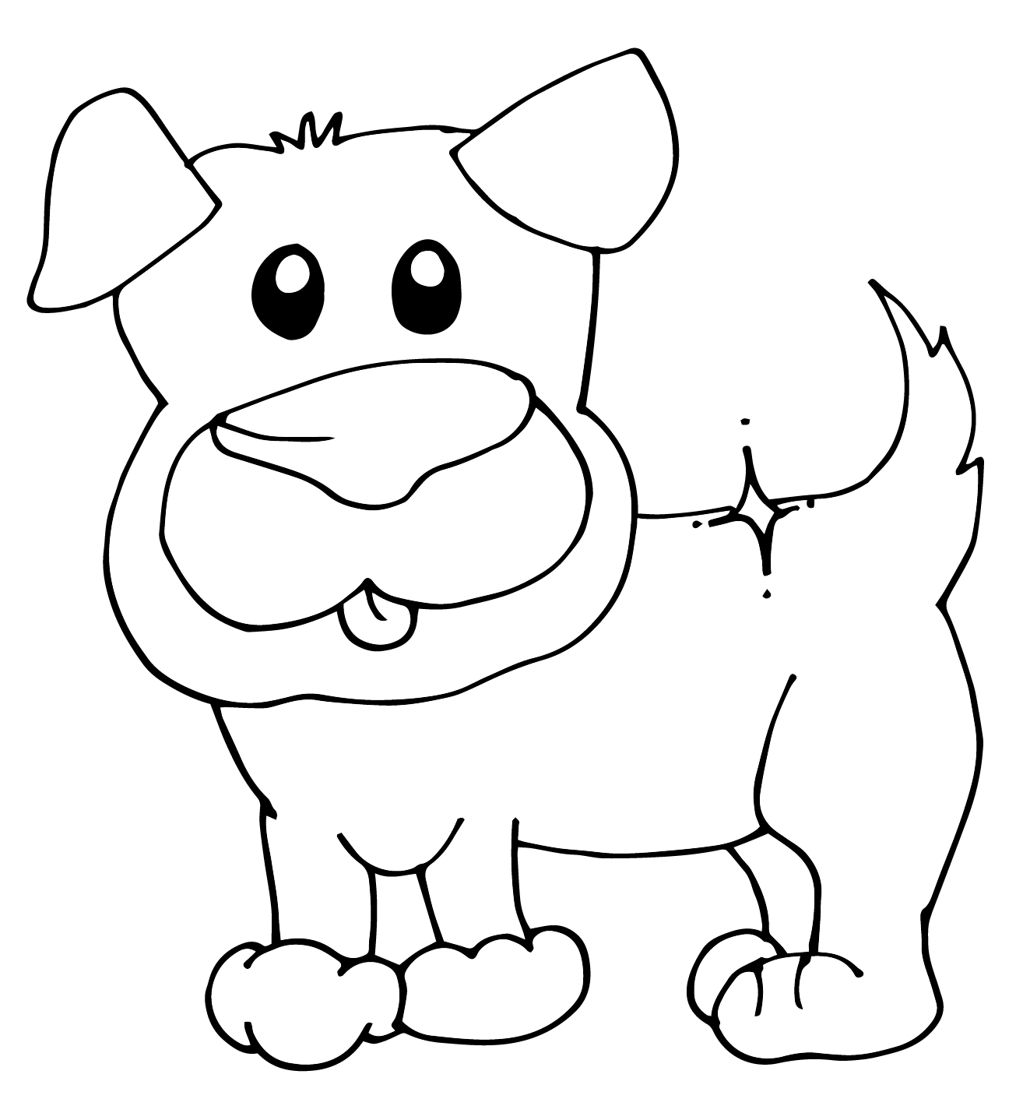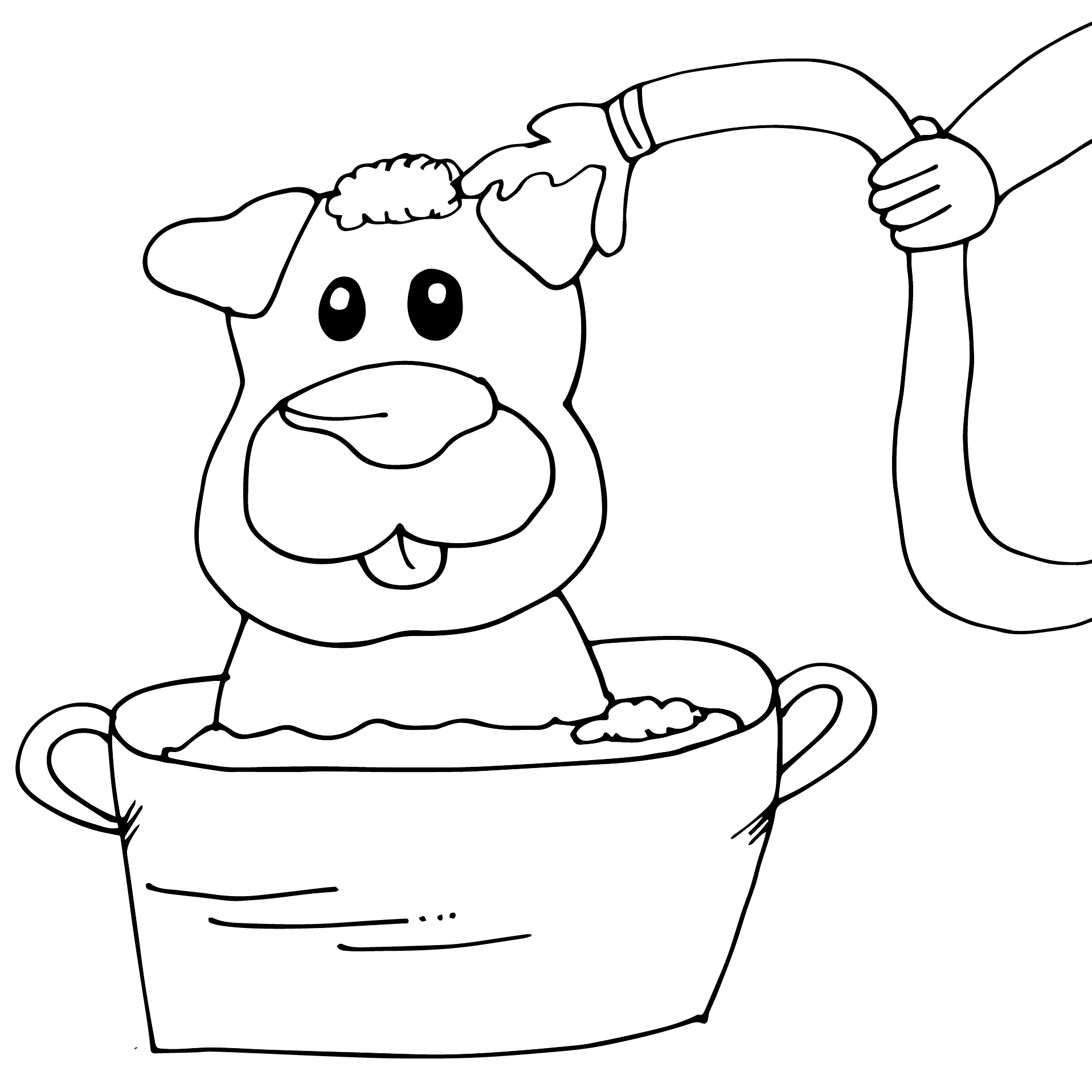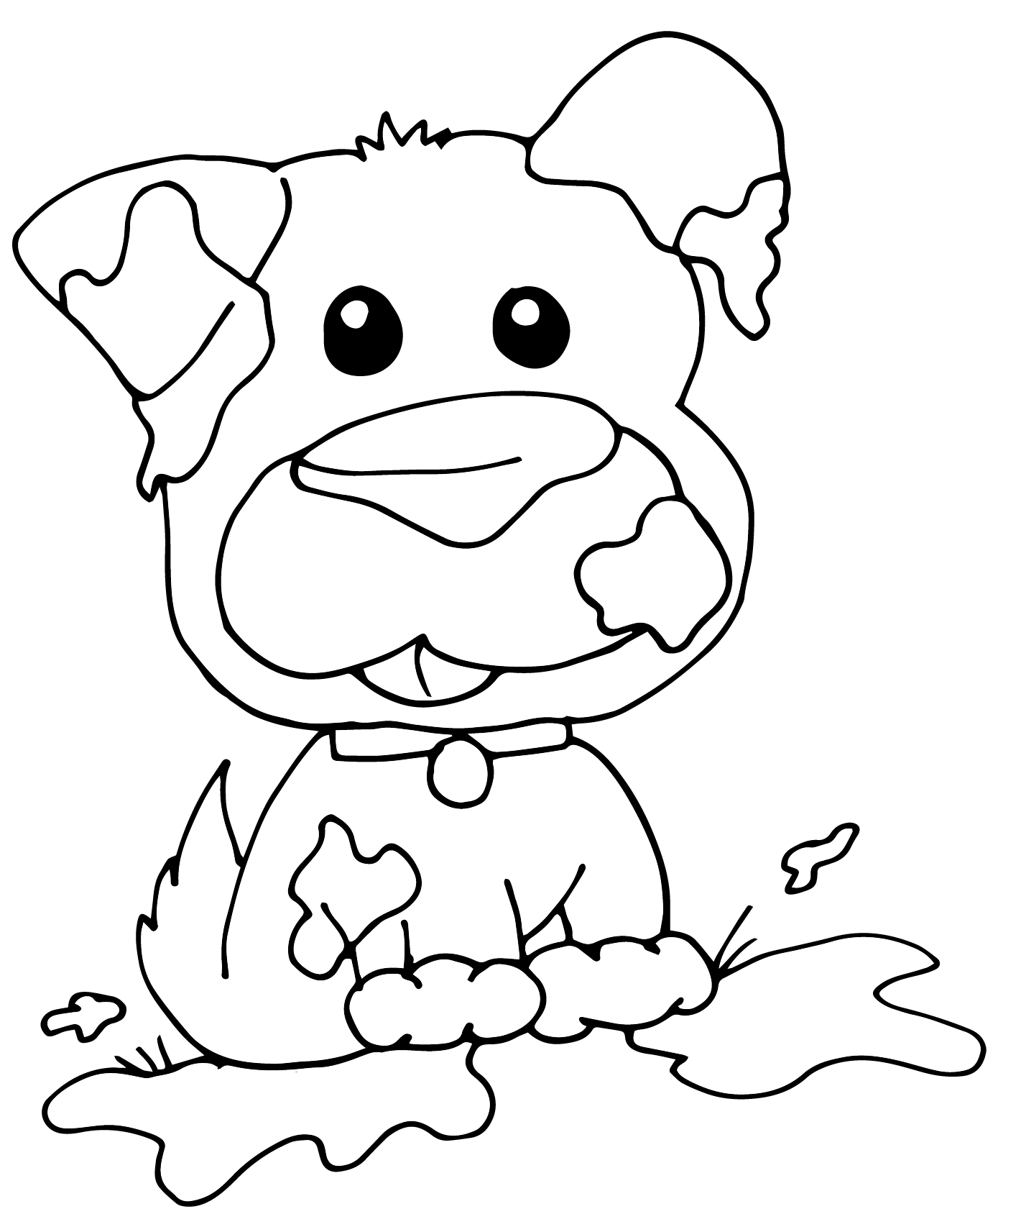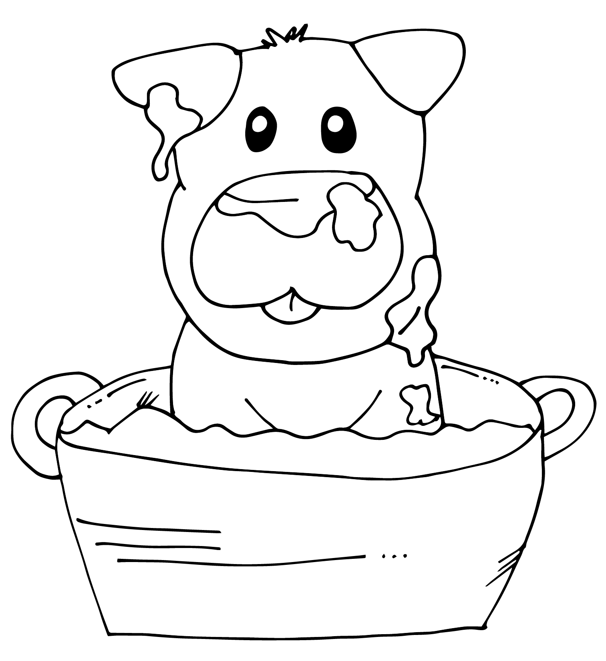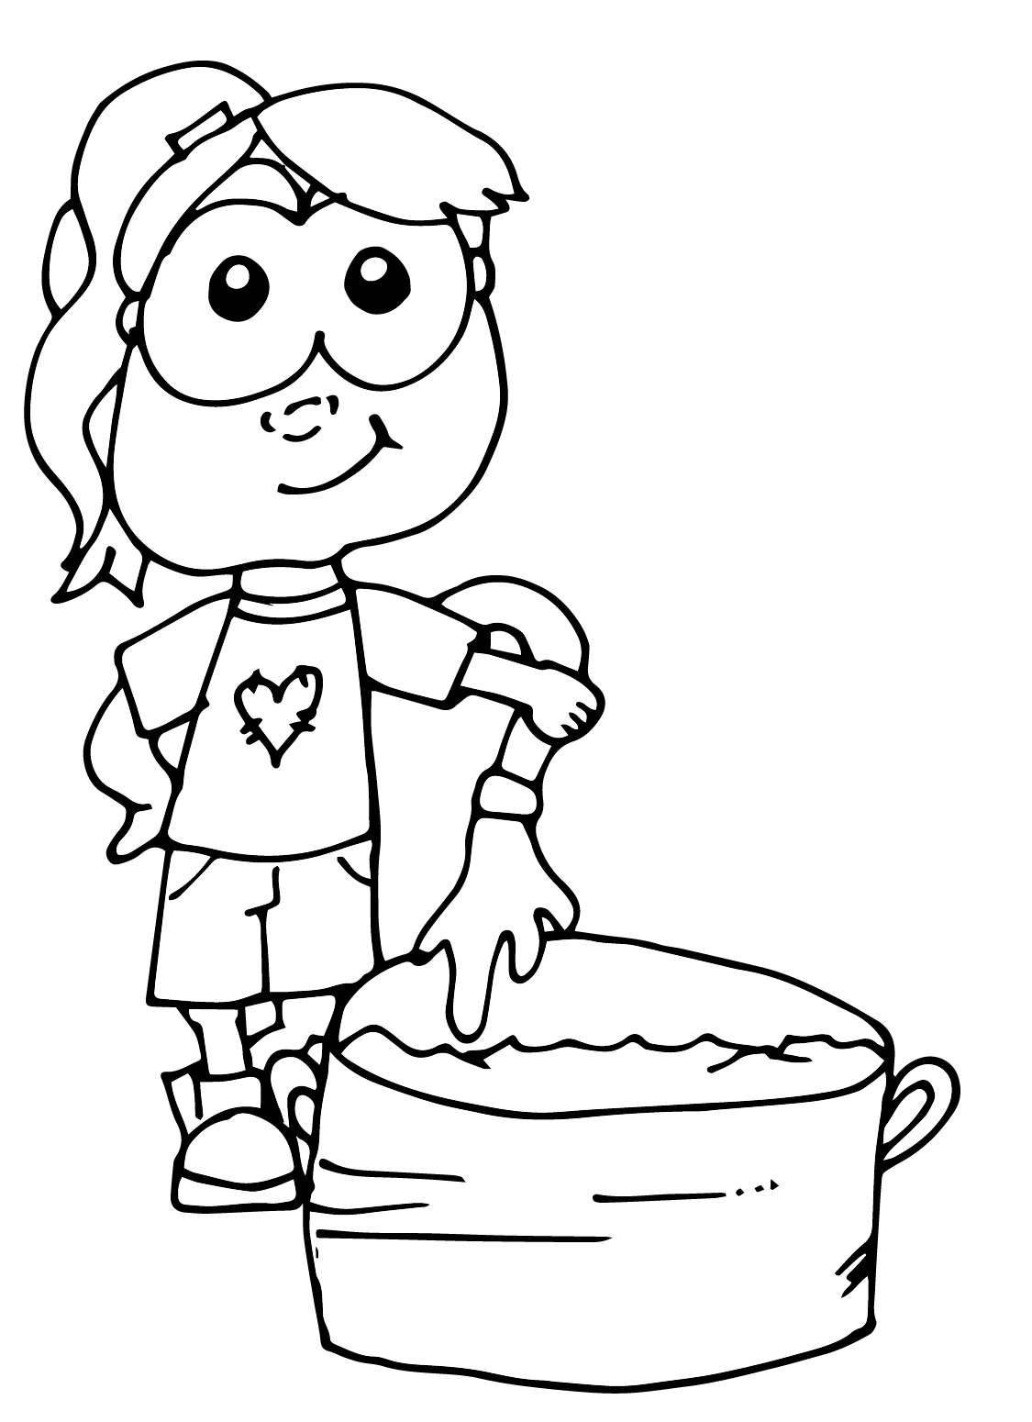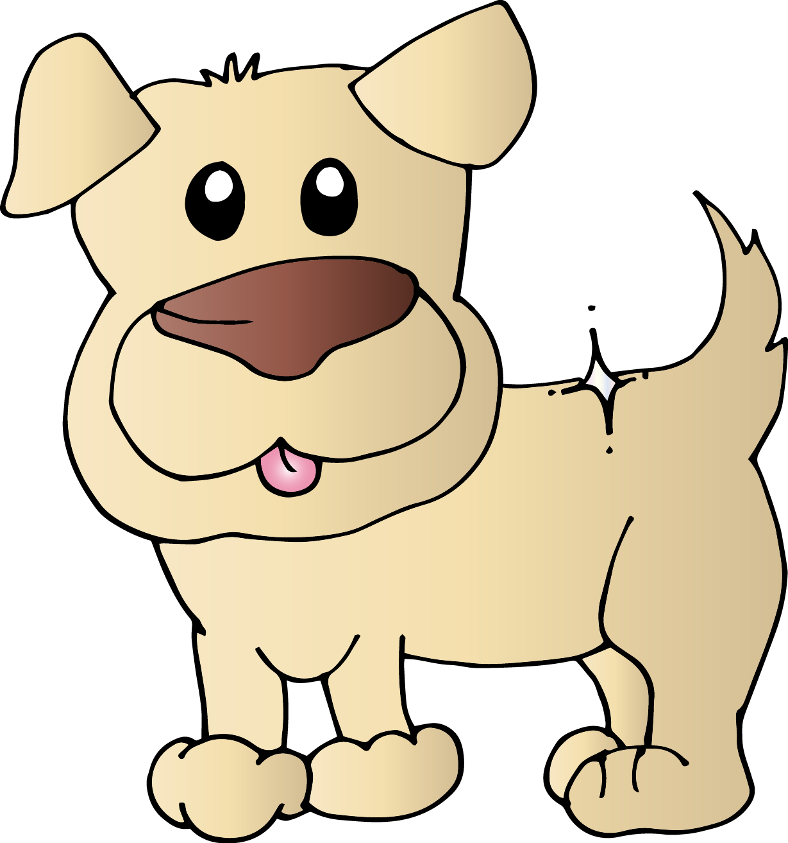

1. First, Beth sees her dog is muddy.
2. So, she fills a tub with water.
3. Next, she puts her dog in the soapy water.
4. Then, she rinses him off with a hose.
5. Finally, Lynn has a clean dog.

|  |  |  |  |  |
| --- | --- | --- | --- | --- |
|  |  |  |  |  |