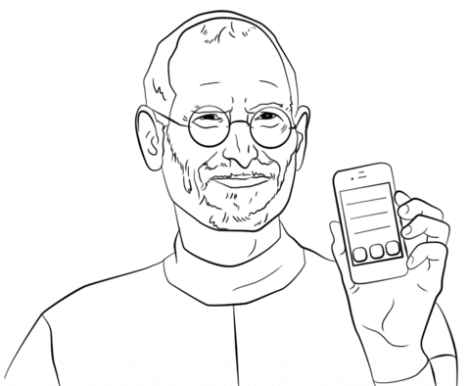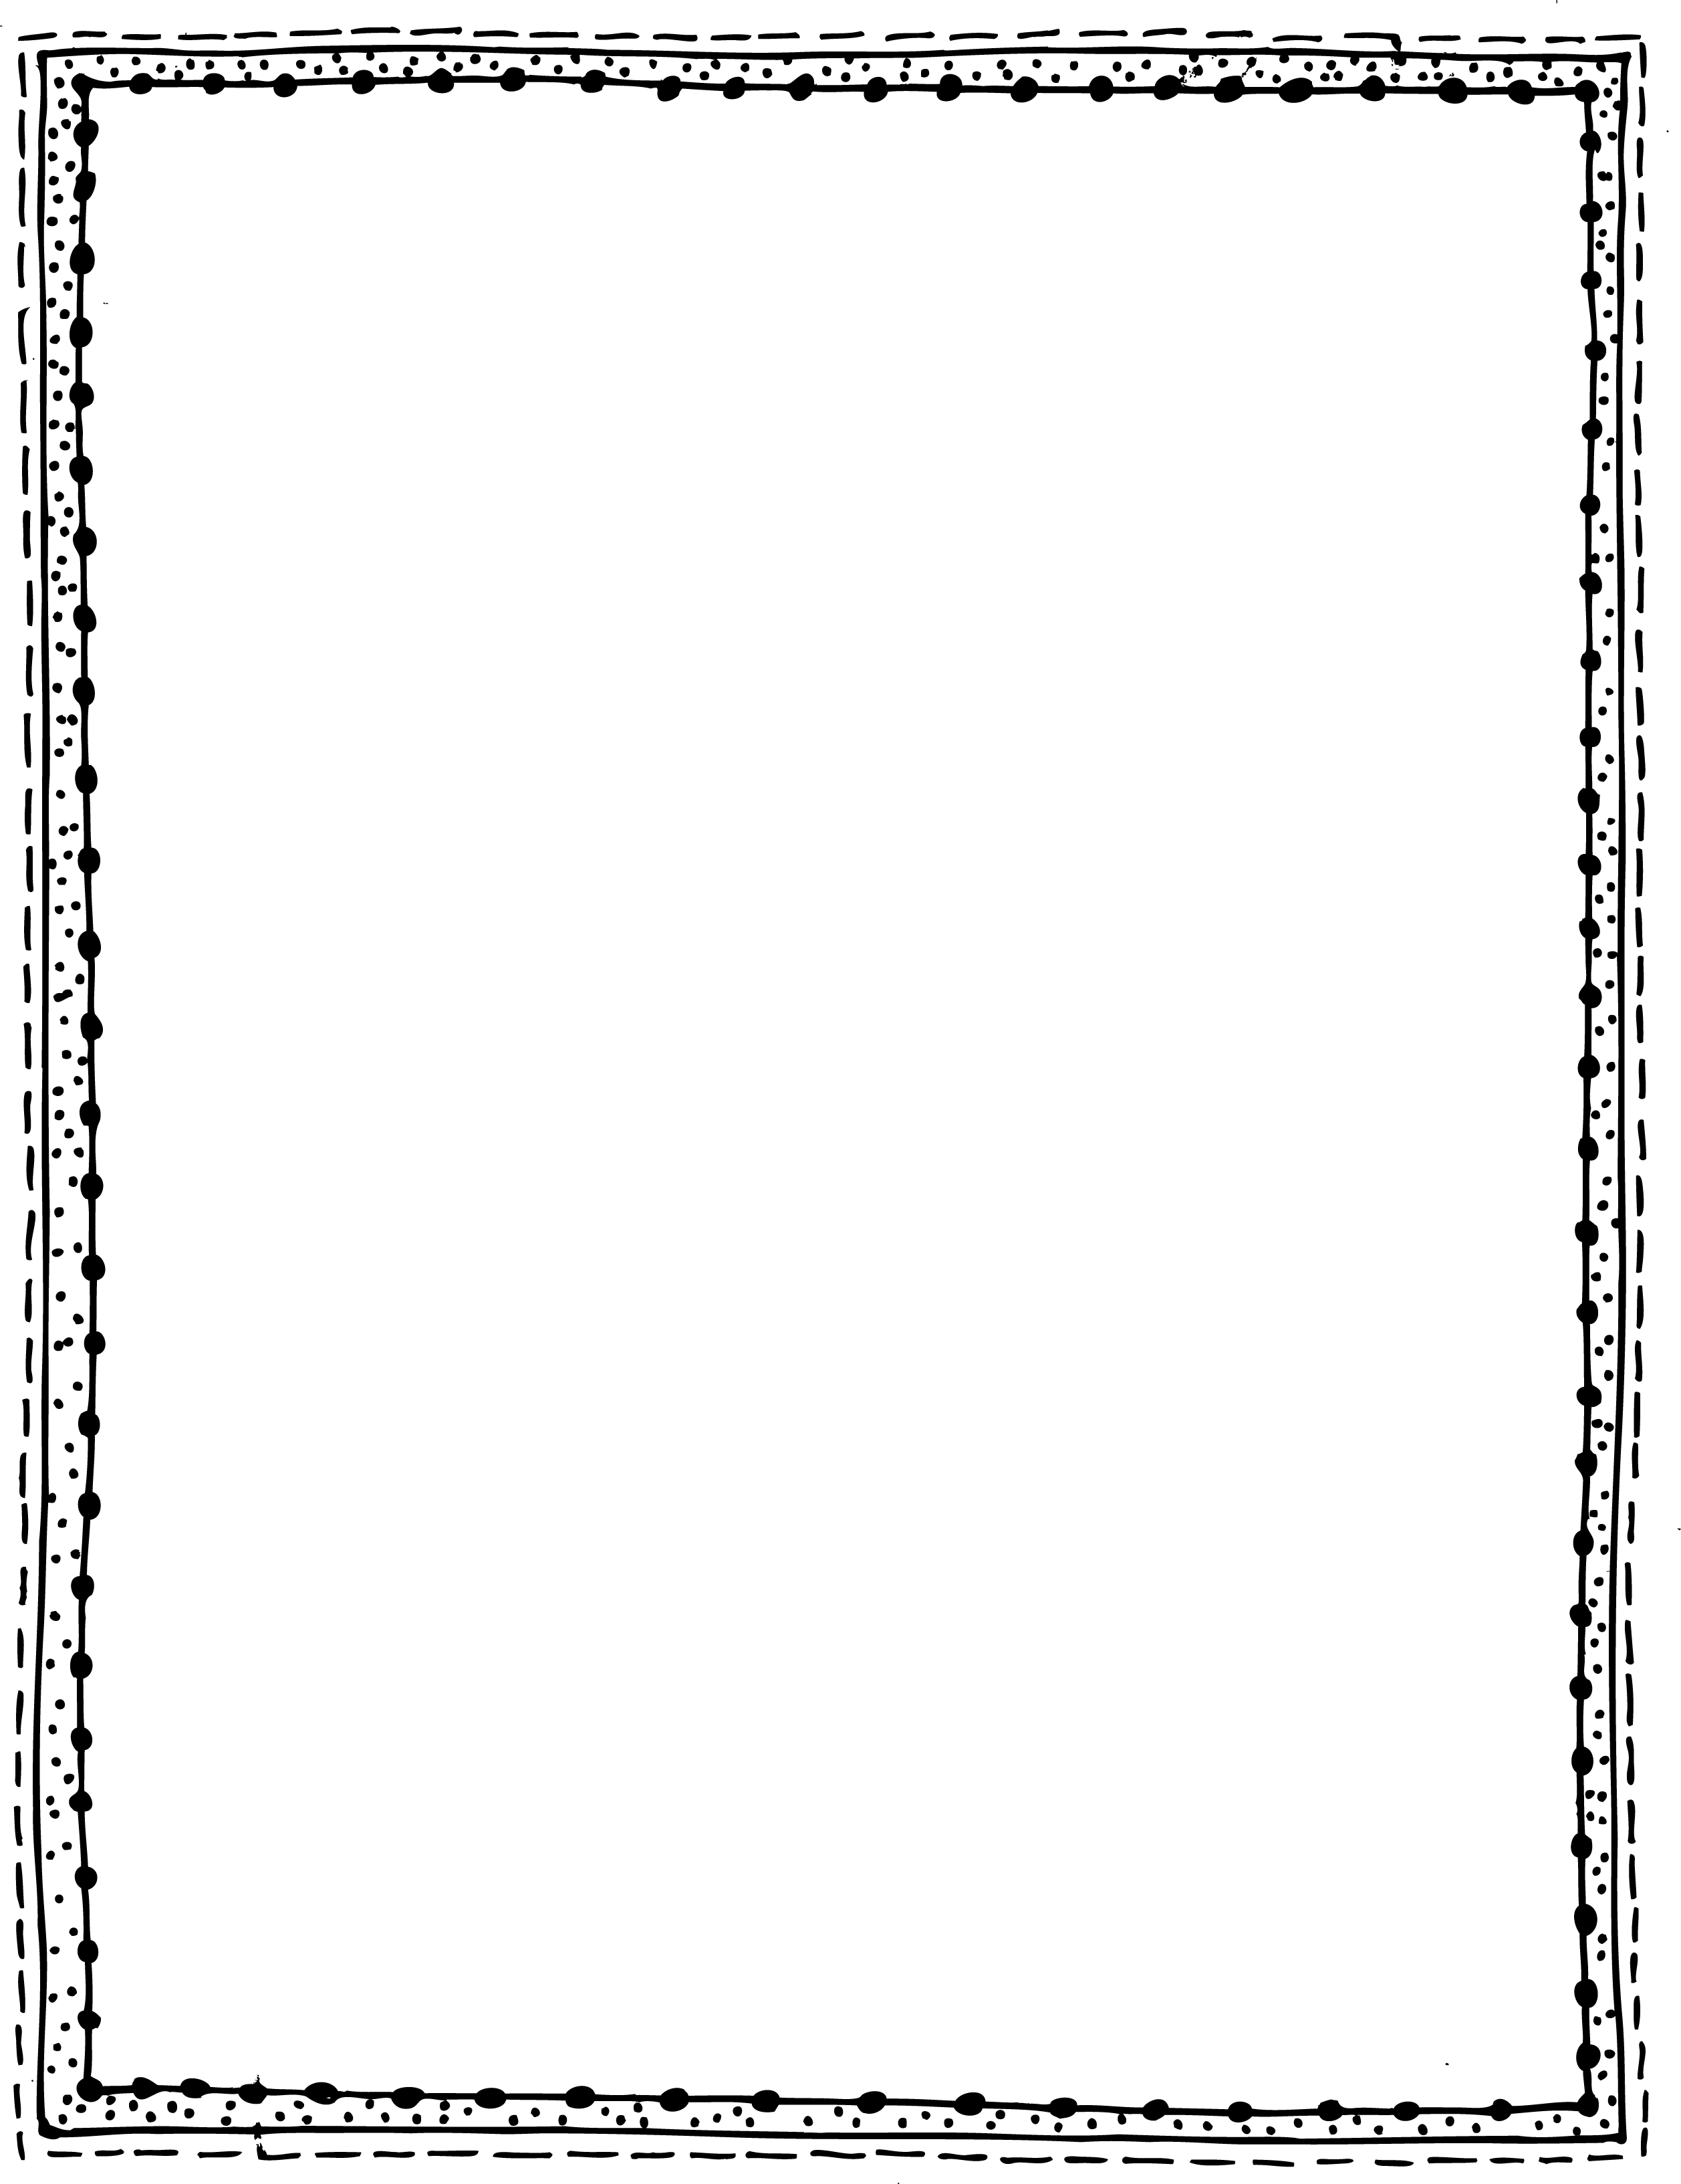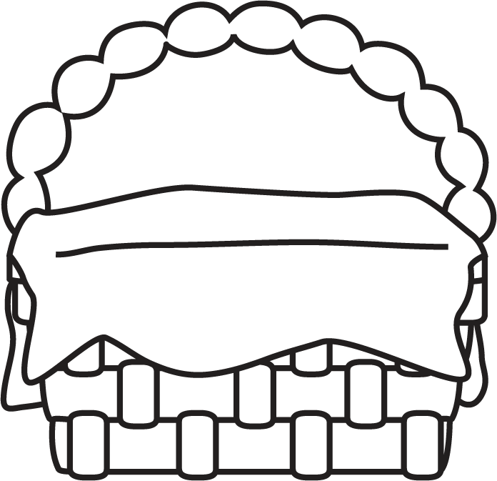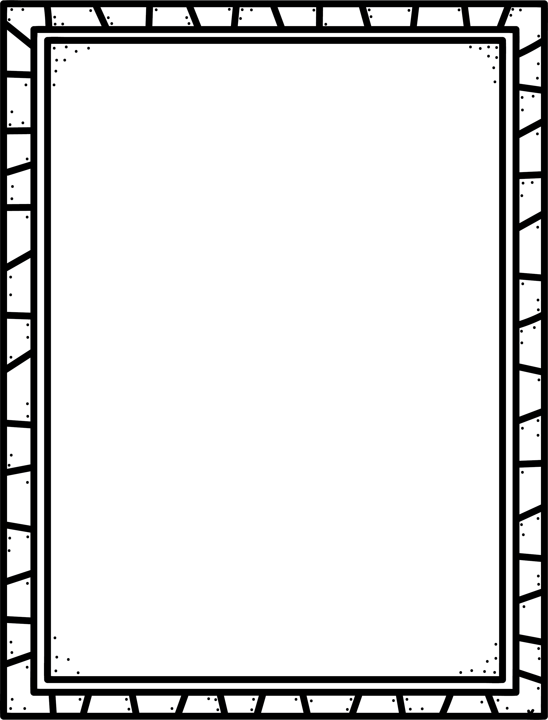

**Characteristics of Biography**

* The Story of a real person’s life, told by someone else.
* Told in date order.
* Accurate details about the person’s life.
* Research is needed to write this.
* Usually the person has done something special in their life.
* Often includes real photographs or documents that belong to the person, or are related to the person.

Biography

**Some biographies I know are:**

**Author’s Purpose:**

**To entertain and to inform**

**Keep track of the biographies you read here!**

**Name:___________________________**

**Good Readers Know About Genres**