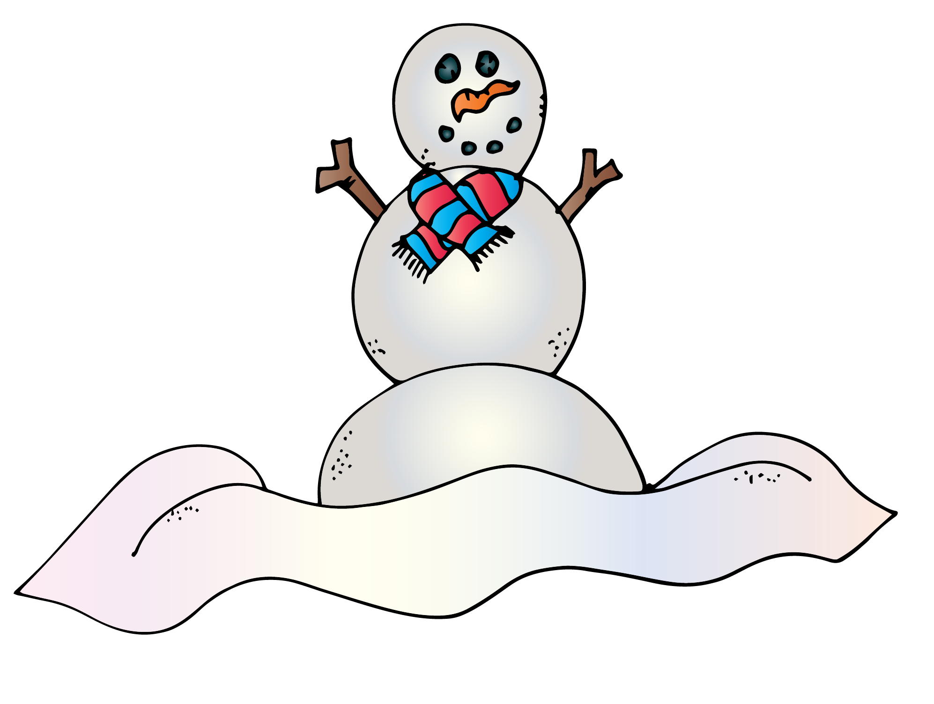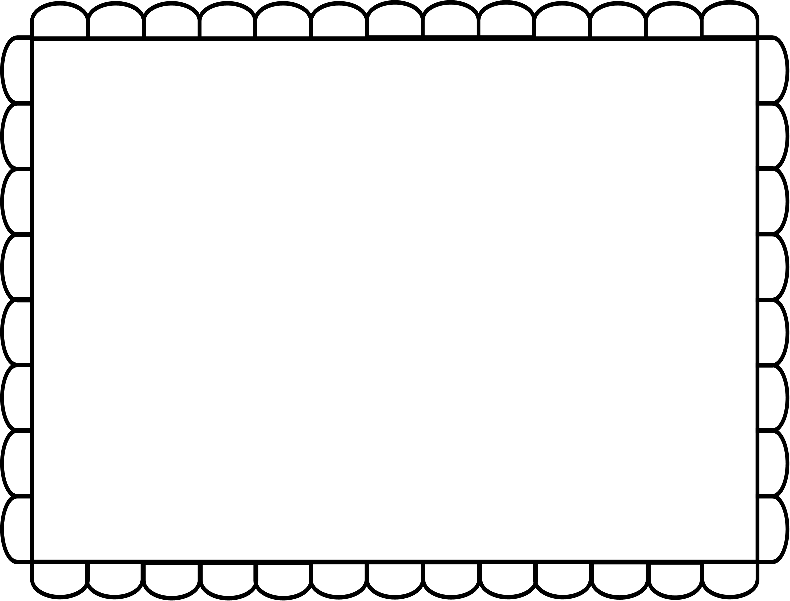

**Build a Snowman**

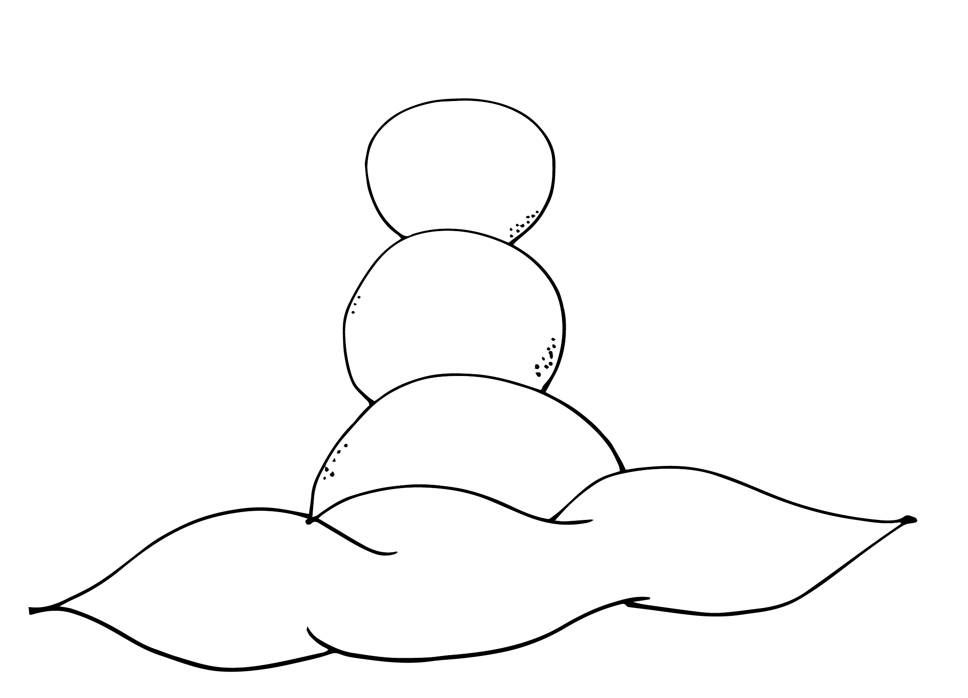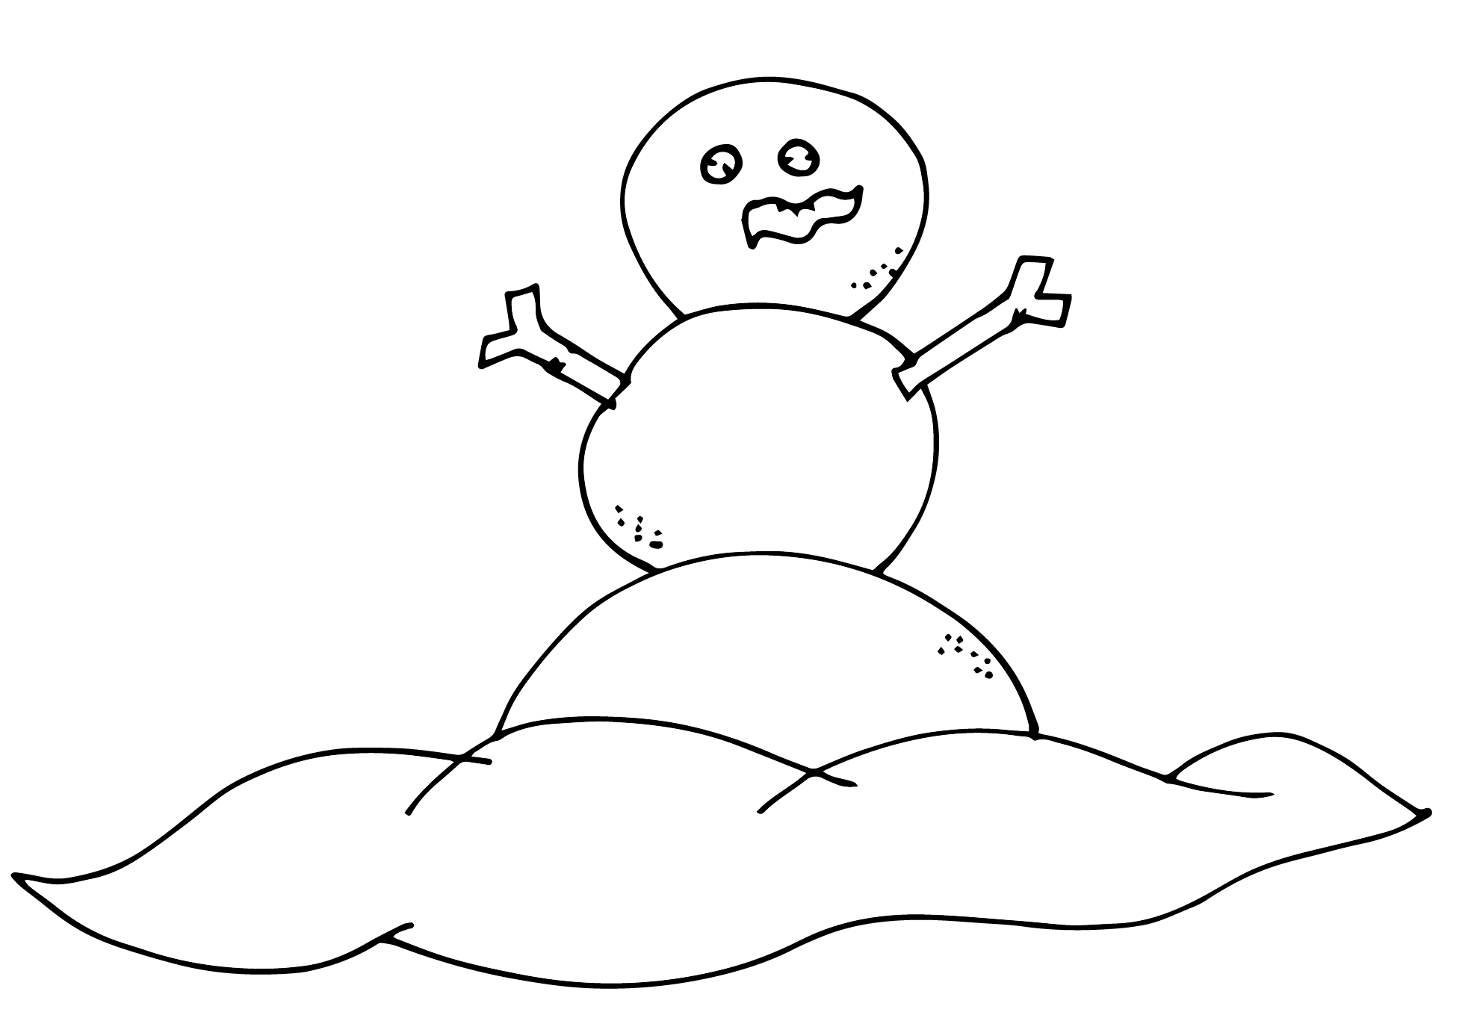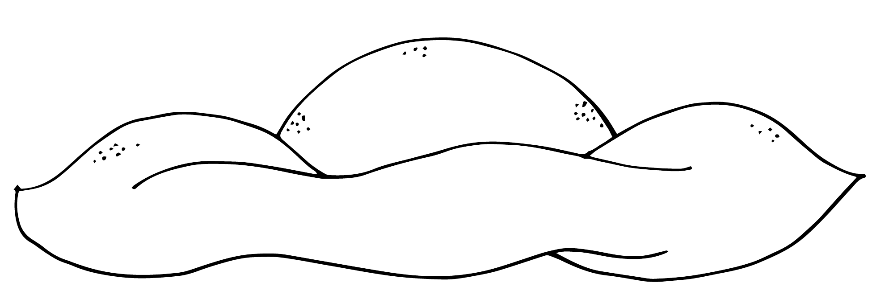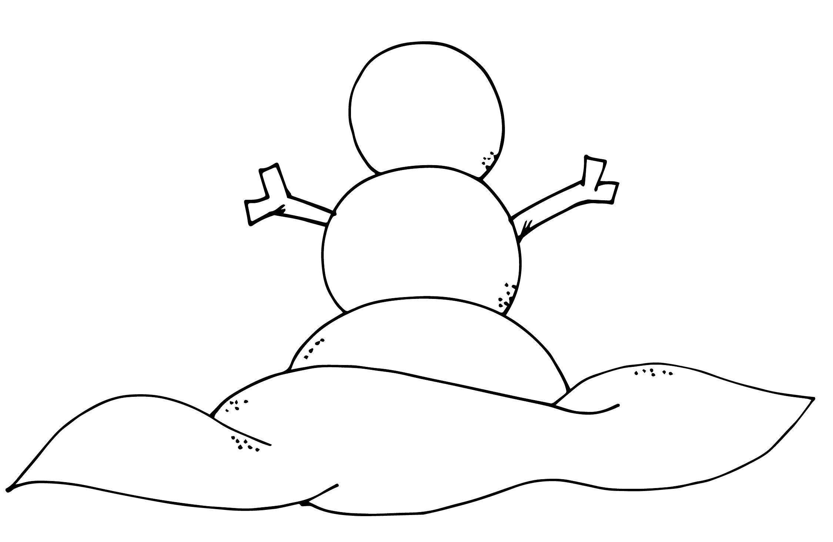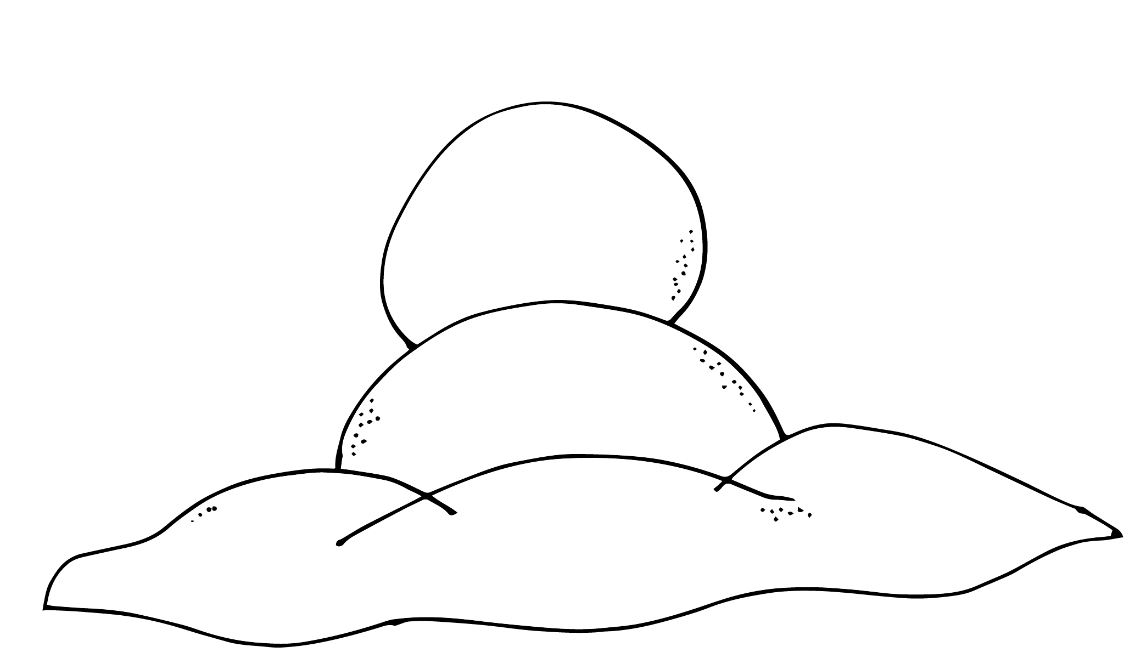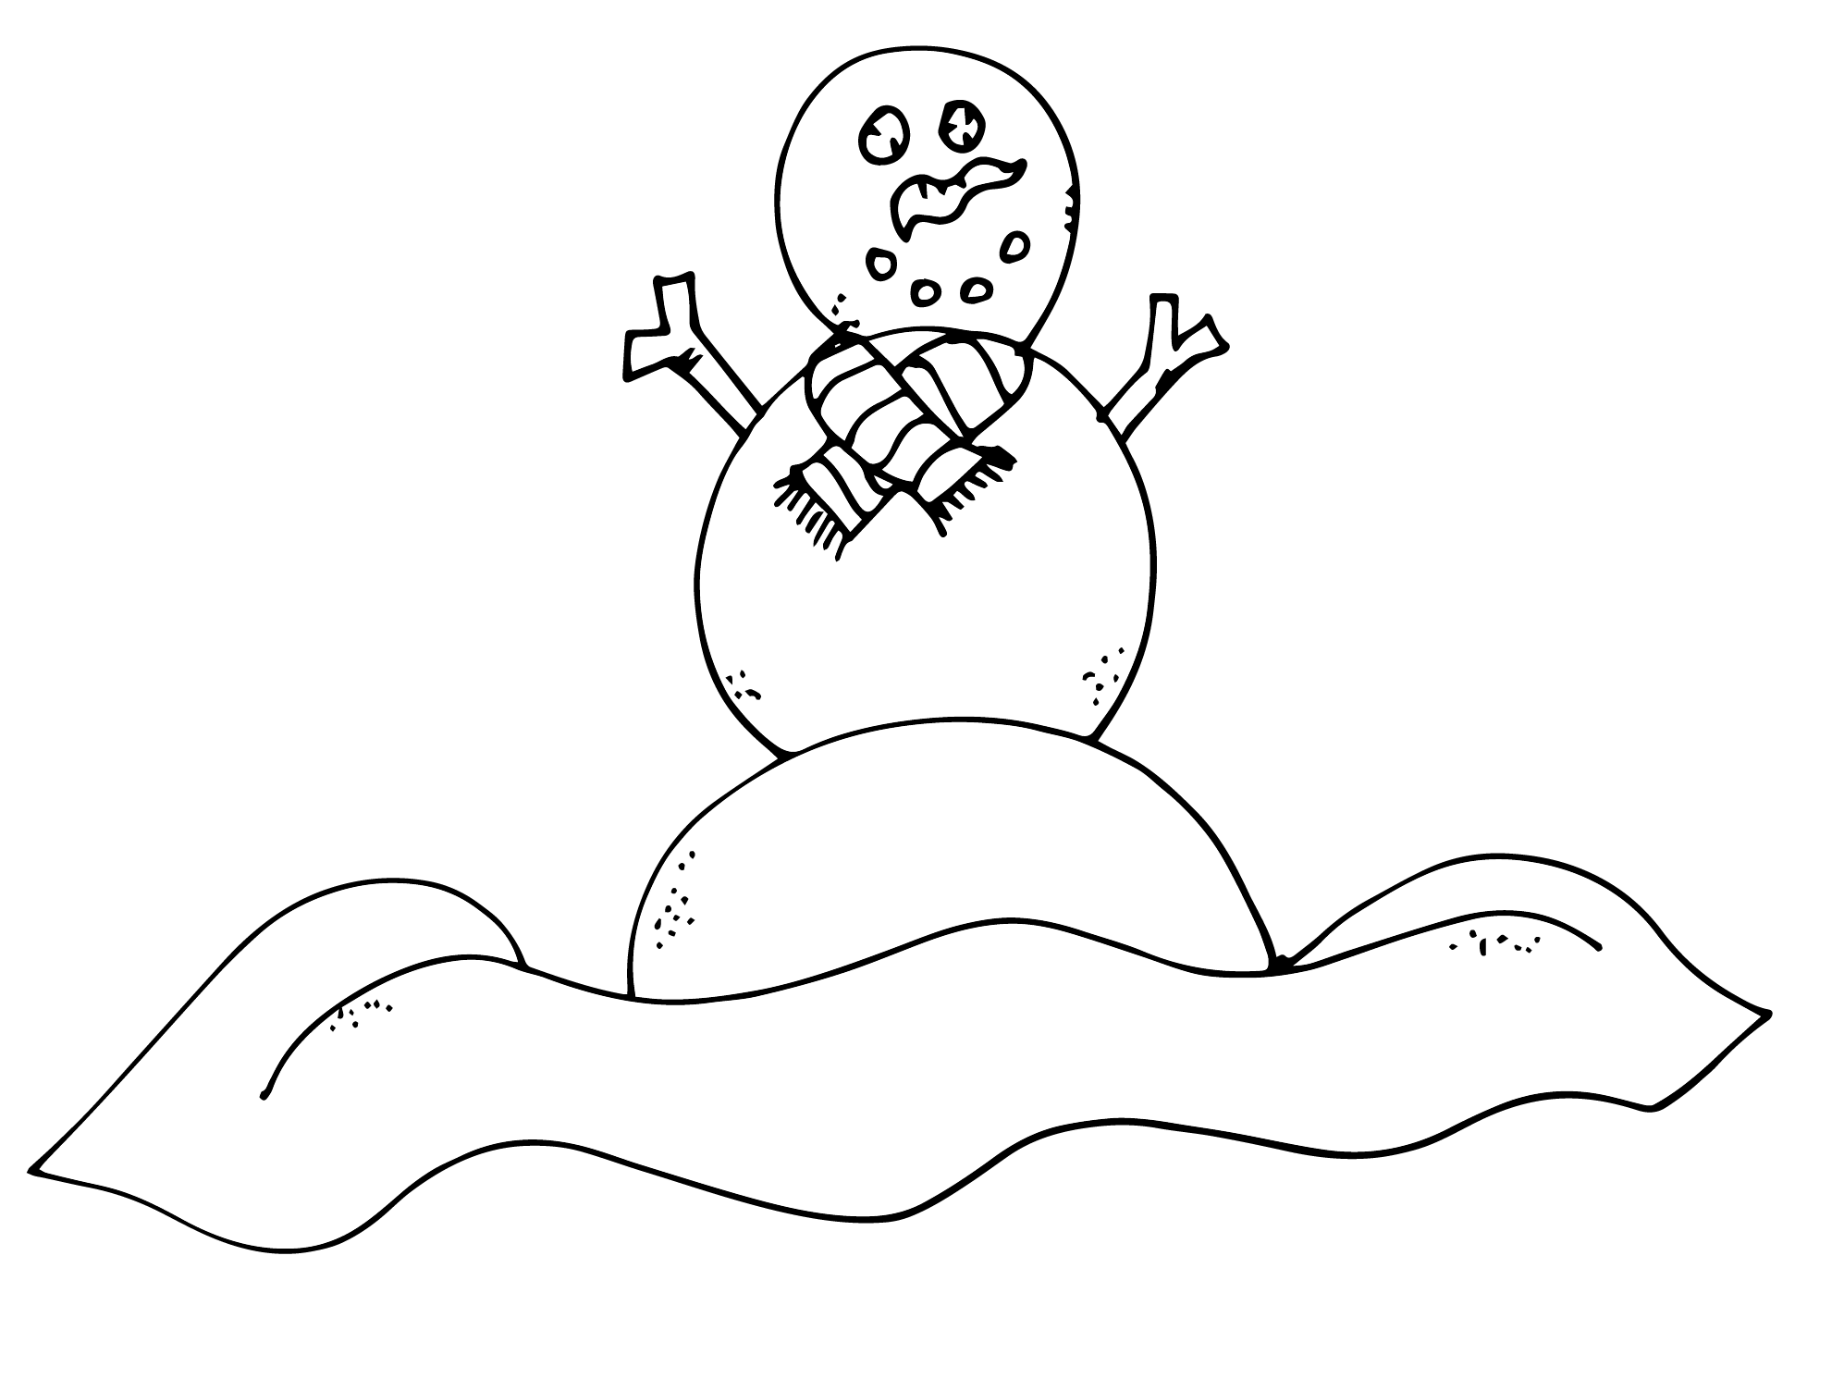

|  |  |  |  |  |  |
| --- | --- | --- | --- | --- | --- |
|  |  |  |  |  |  |

1. **First, roll one big snowball.**
2. **Next, roll a second smaller snowball put it on top.**
3. **Then, roll a third small snowball and stack it on the very top.**
4. **Next, add sticks for the arms.**
5. **Then, add some eyes and a nose.**
6. **Finally, add the mouth and a scarf.**