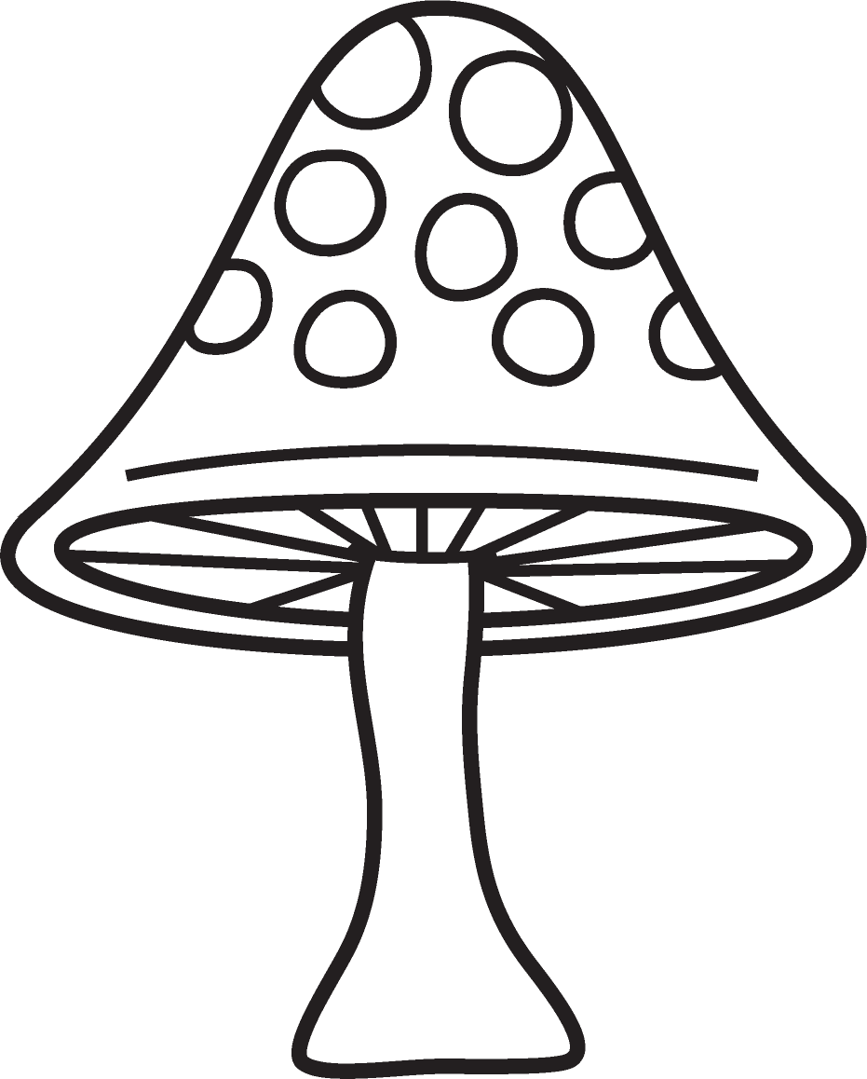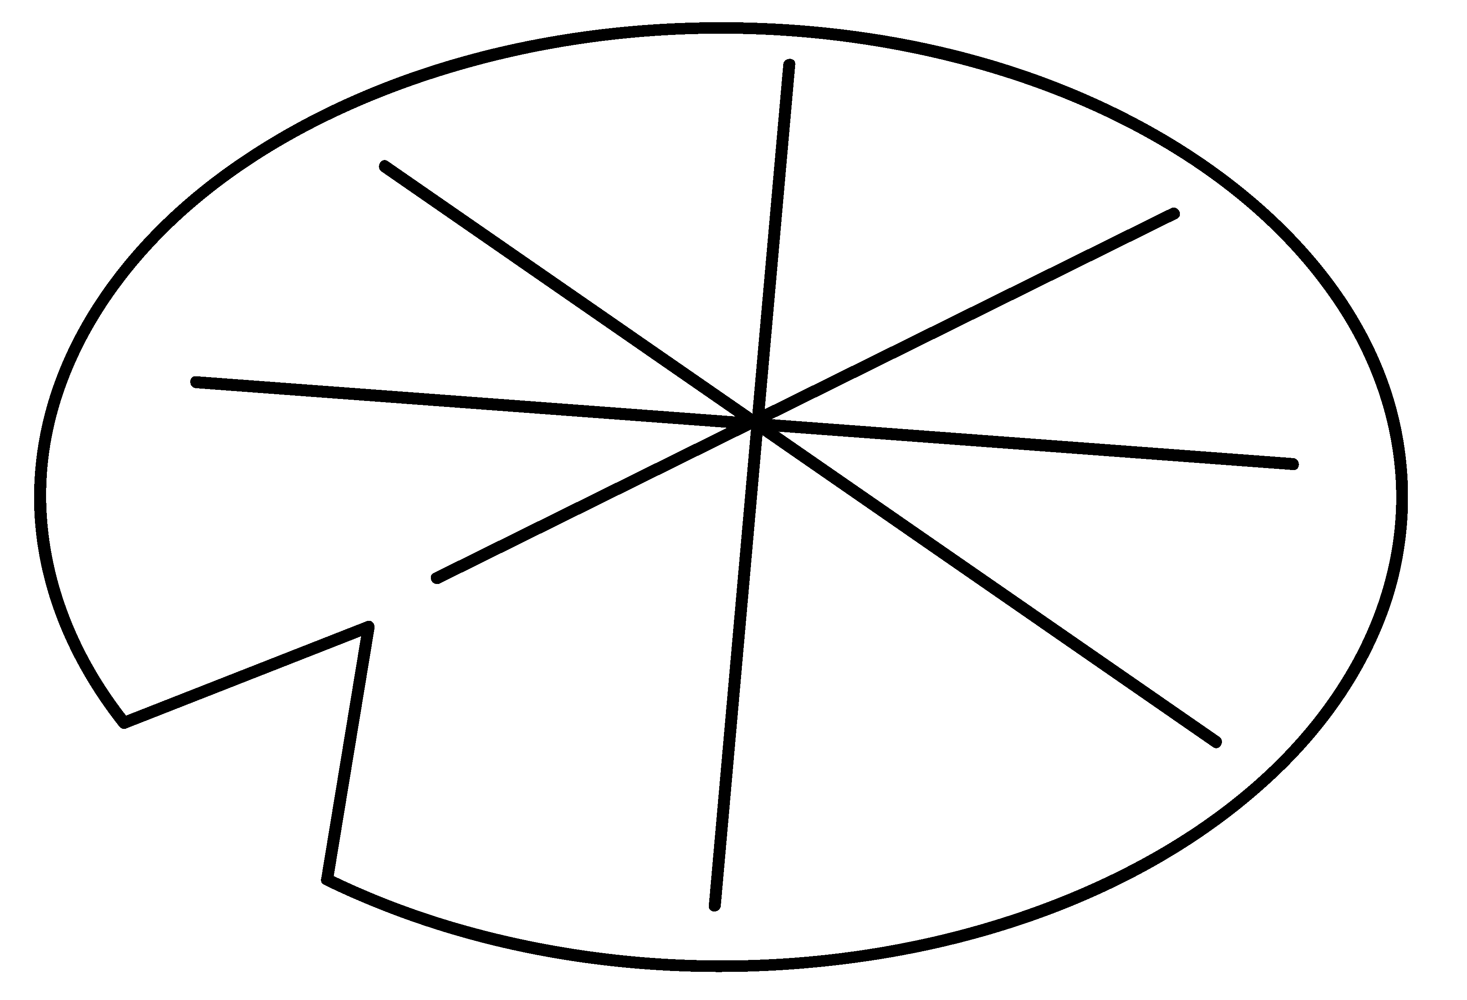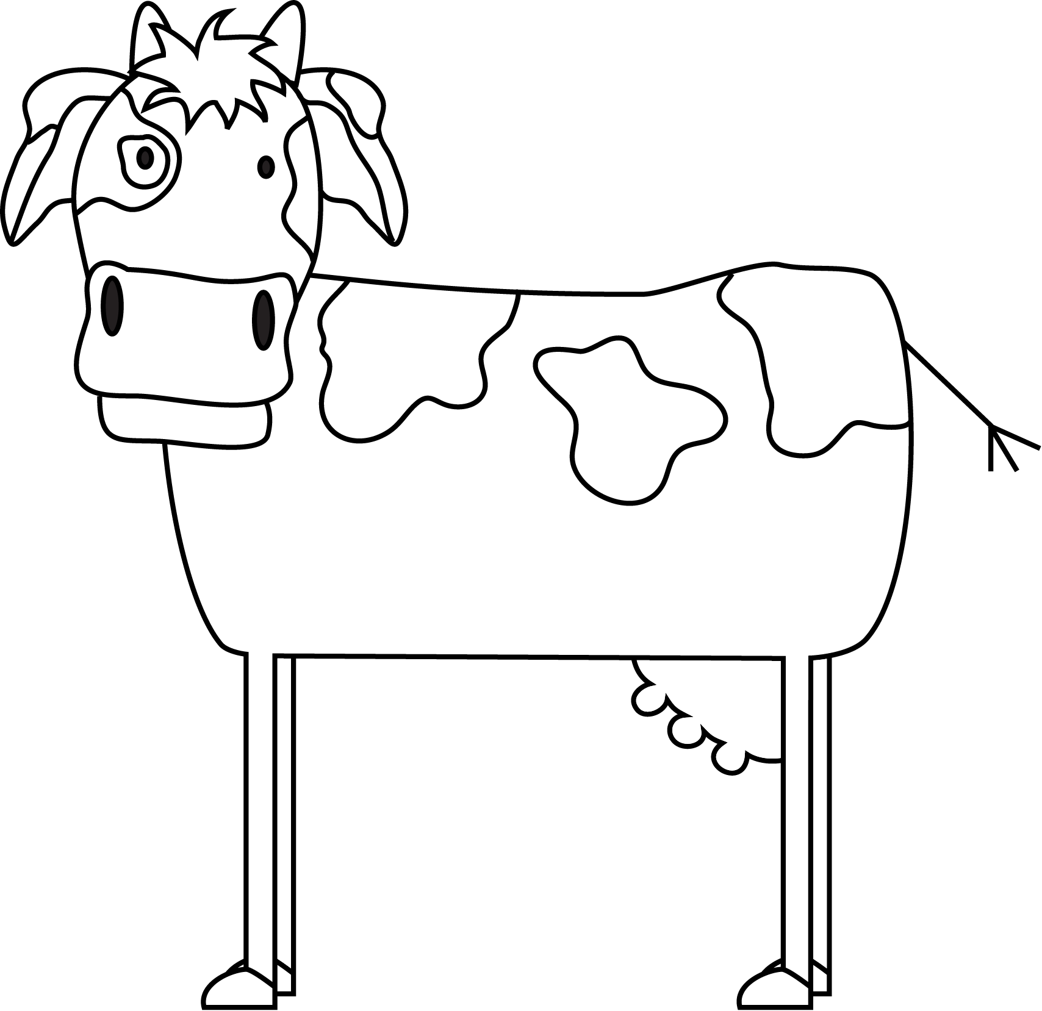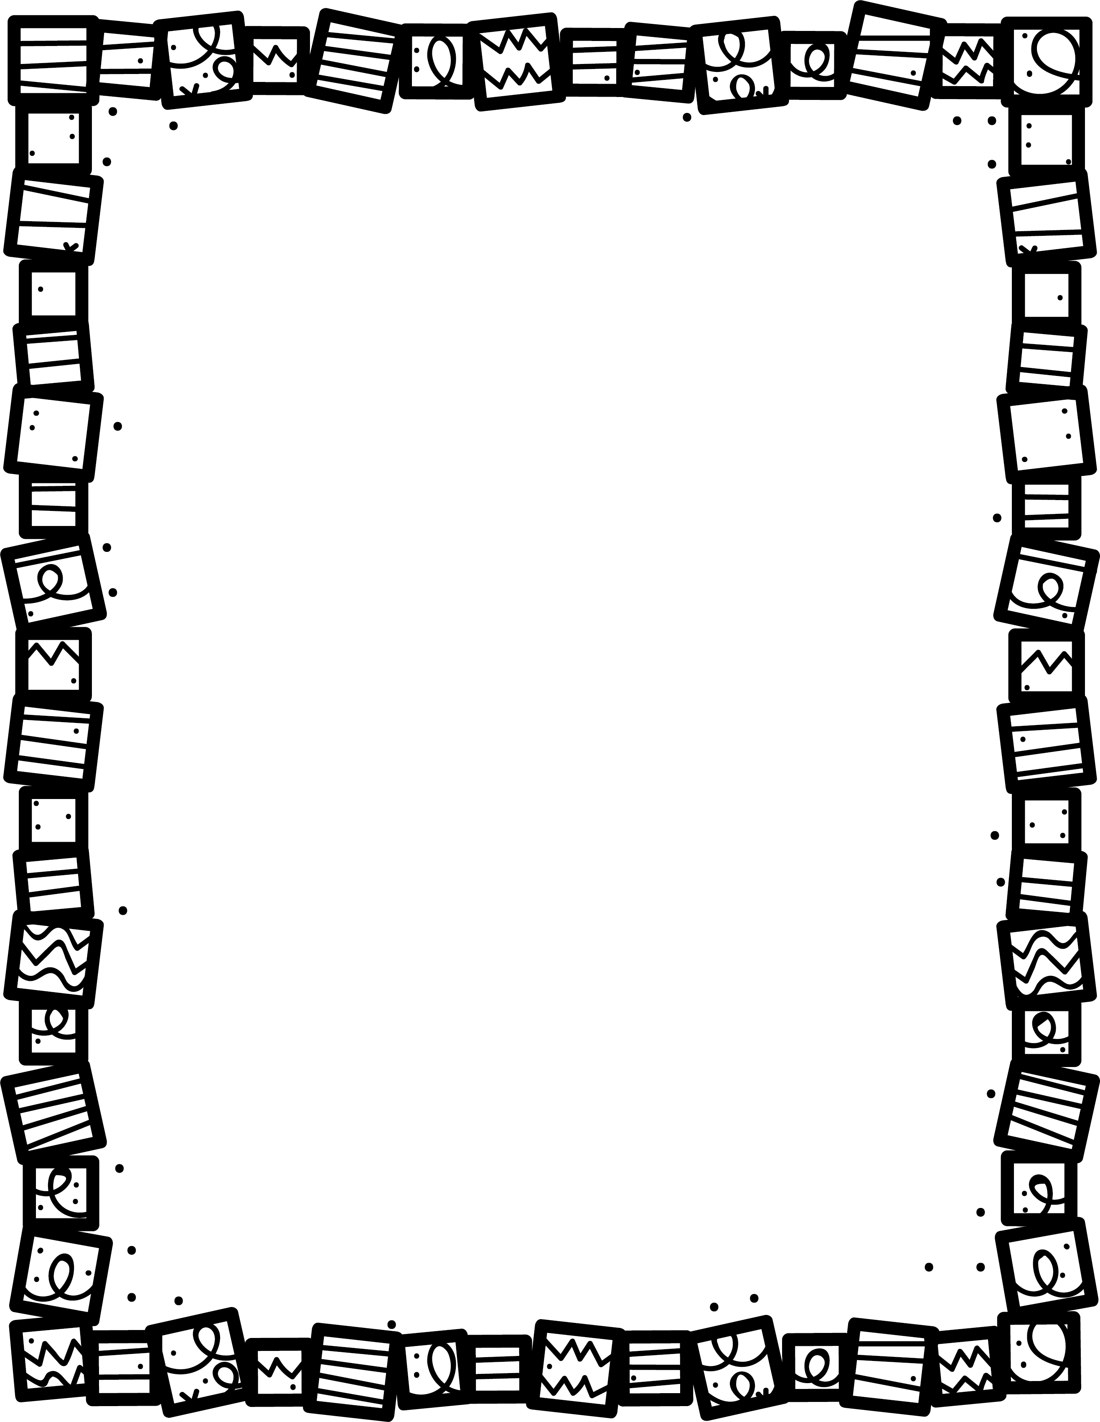

**List some make-believe characters or objectives.**

**Explain any threes or sevens you find.**

**Good**

**Evil**

**Find examples of good and evil.**

**Explain how the story ends. Is there a lesson?**

**What is the setting?**

**Do the characters live happily ever after?**

**Book Title:**

**Name:___________________________**

**My Little Activity Book About**

Fairy Tales