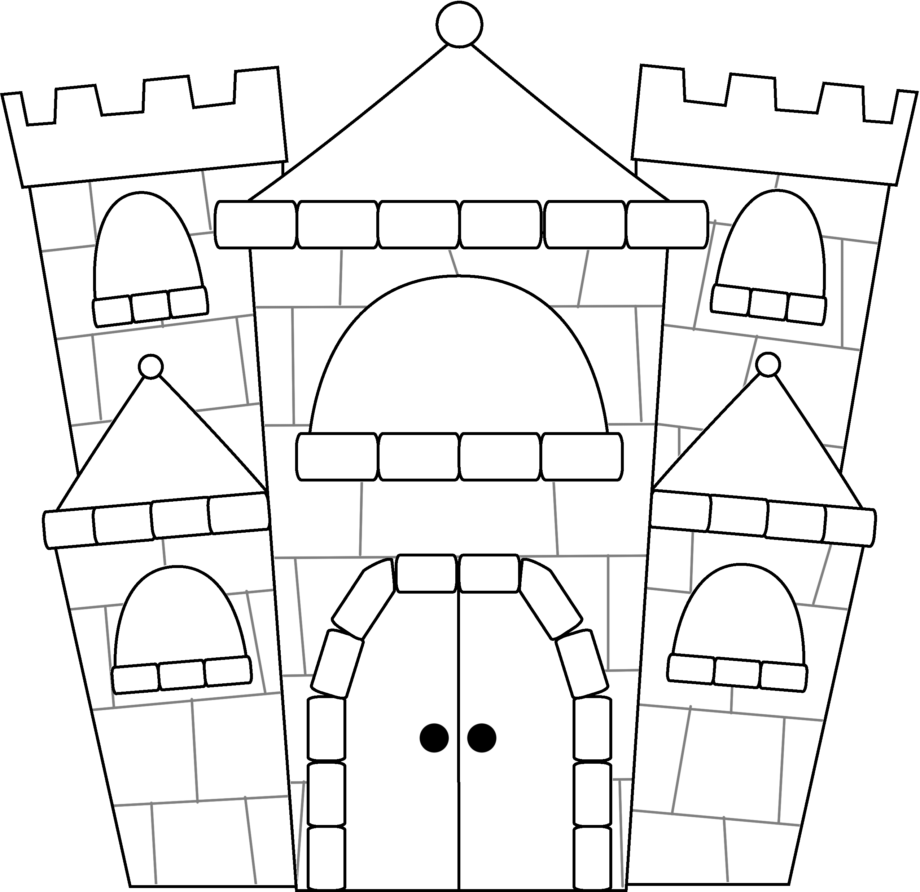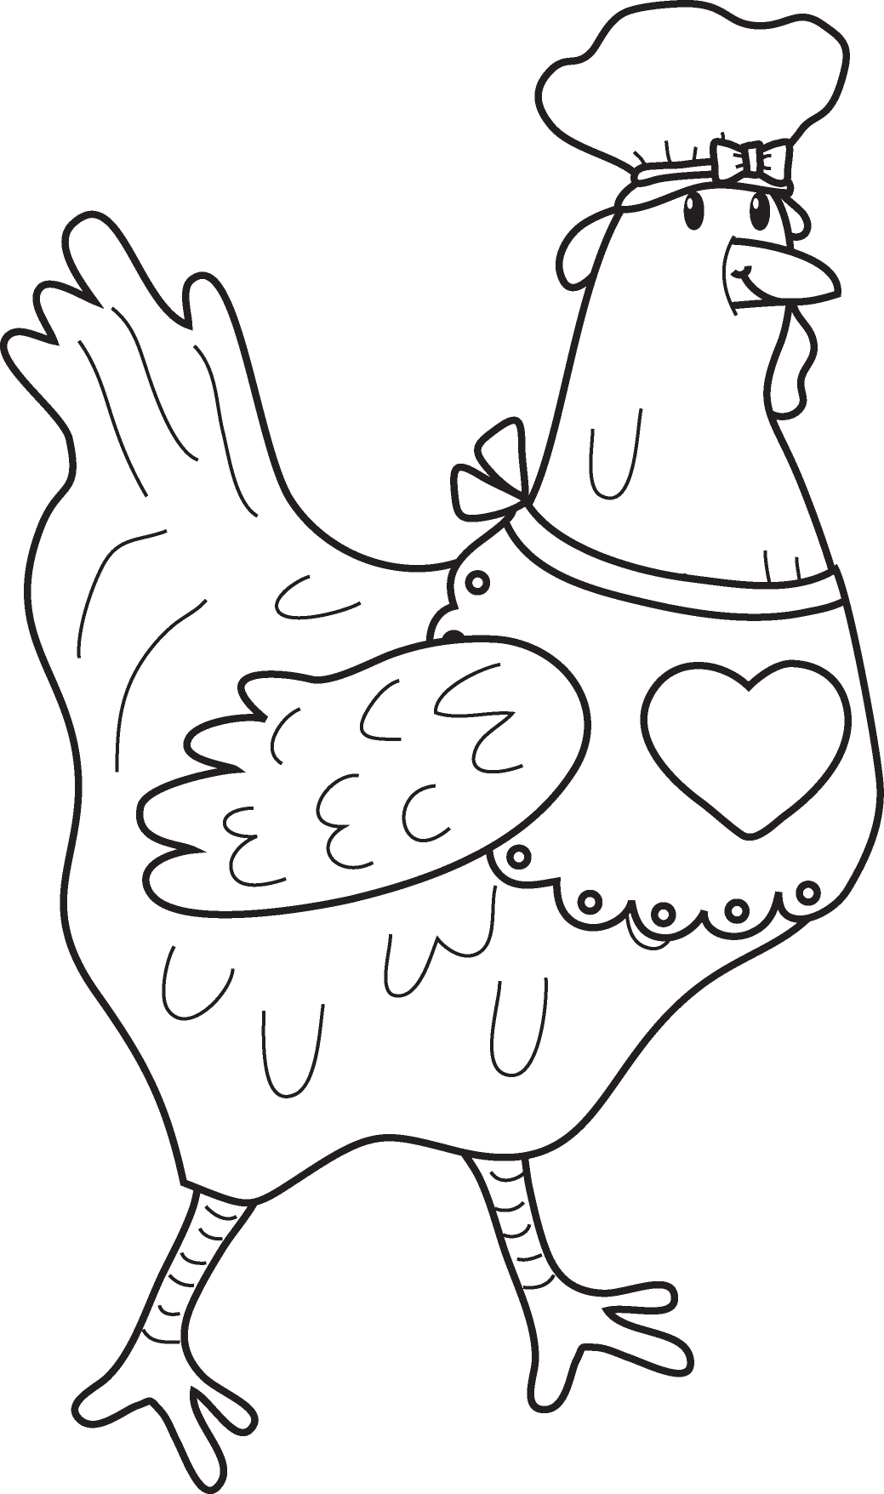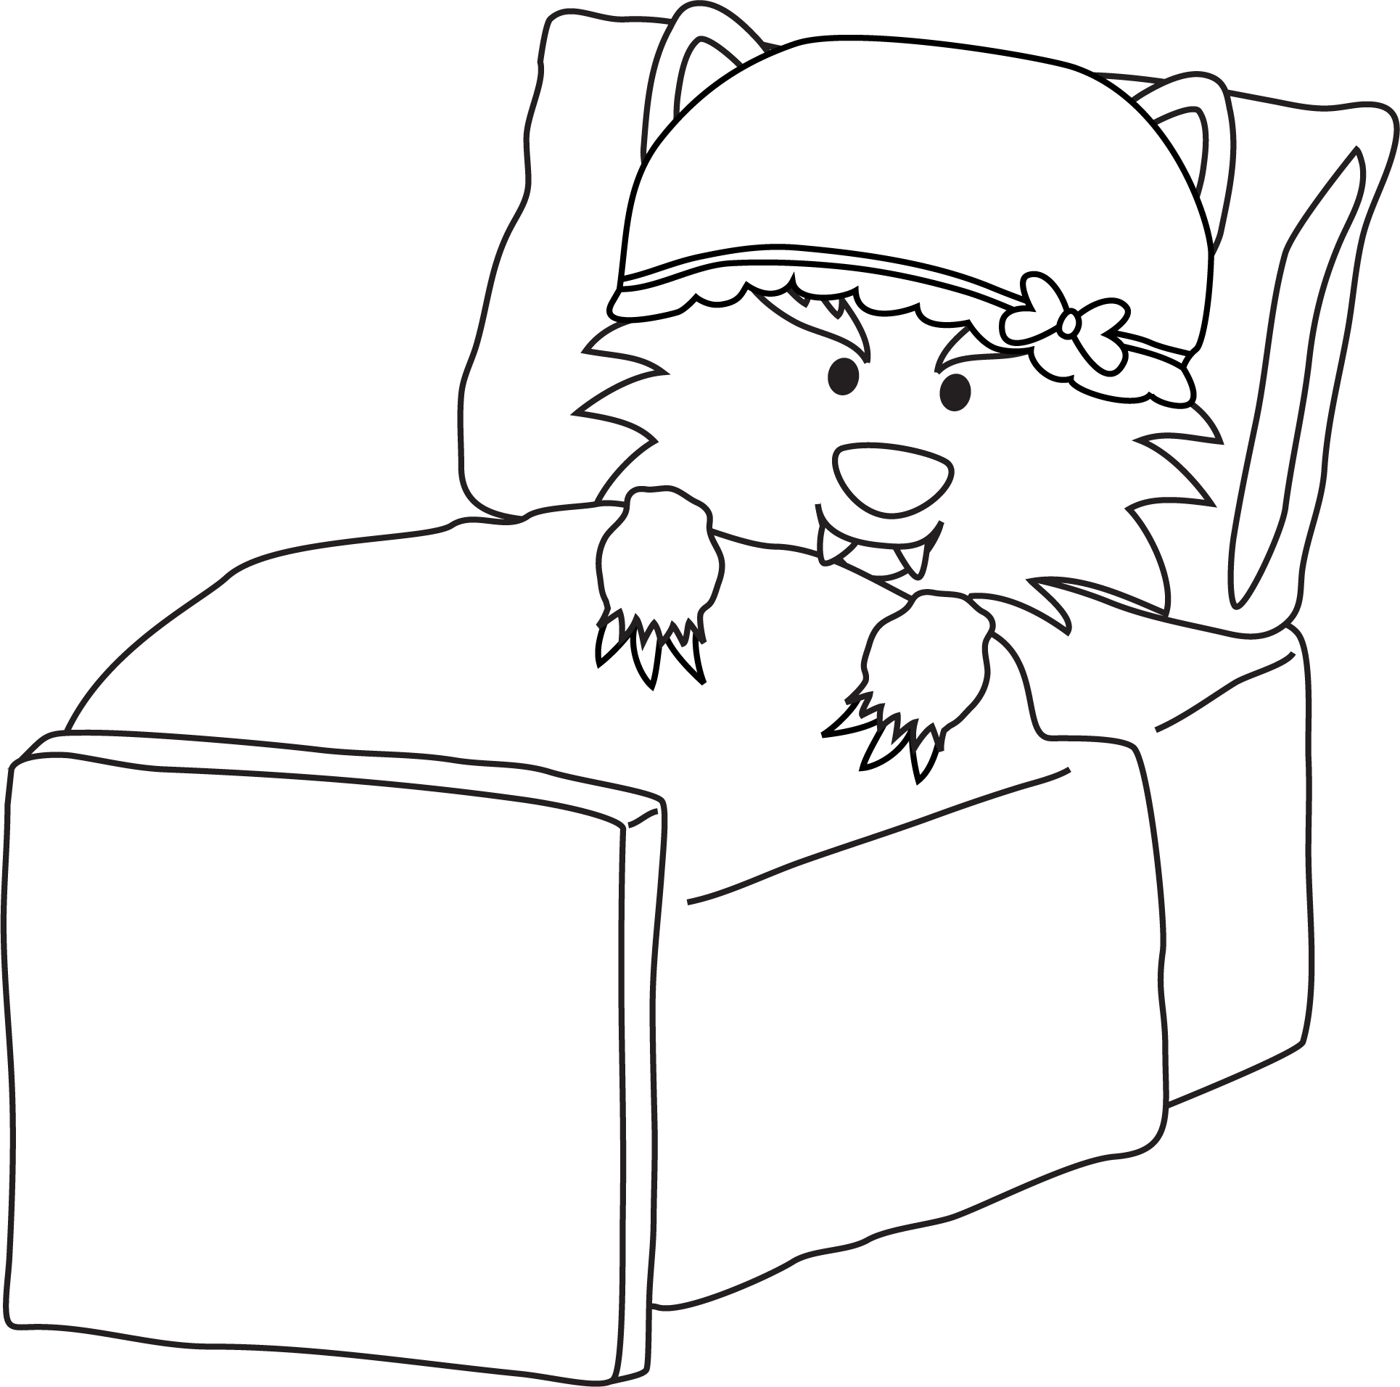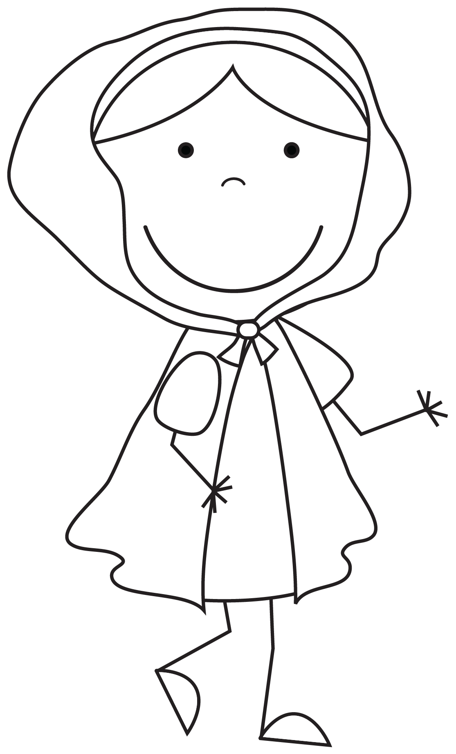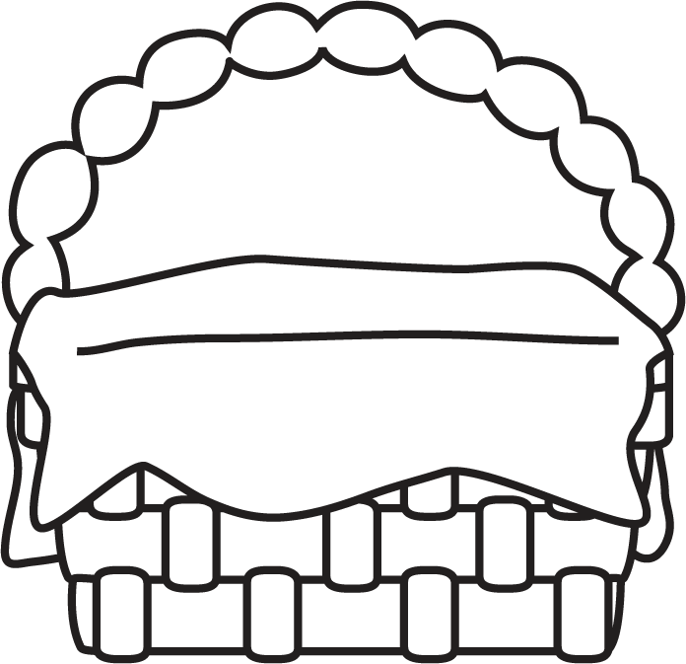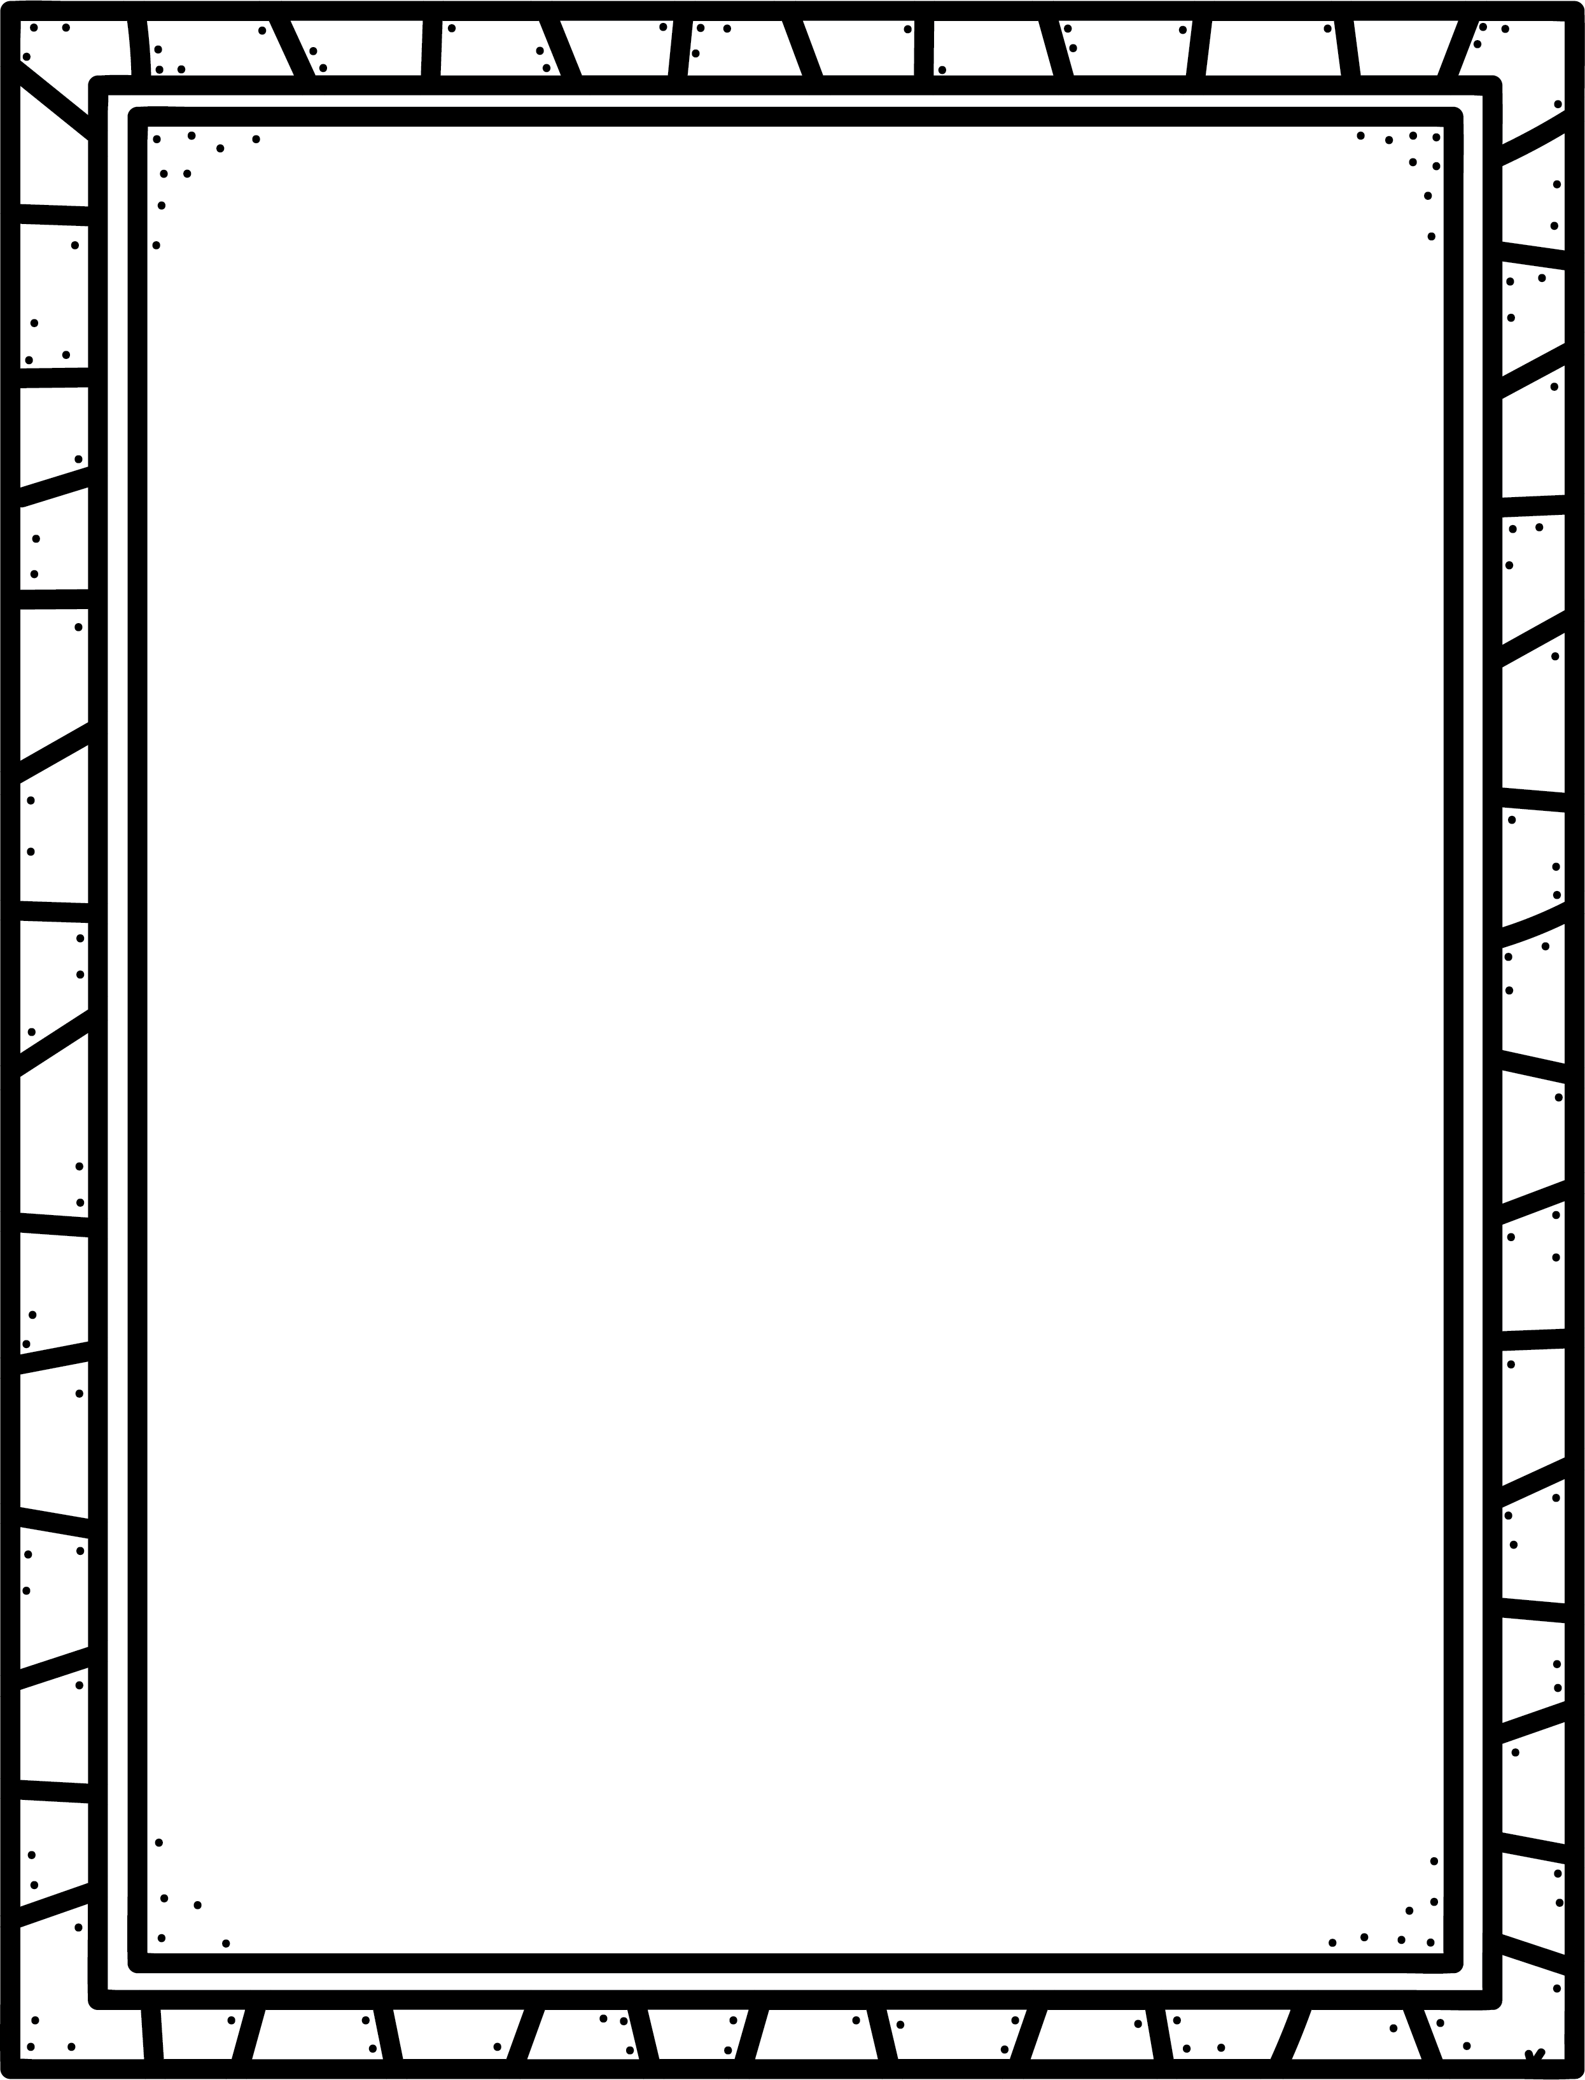

**Some Fairy Tale books I know are:**

**Characteristics of Fairy Tale Books**

* Usually have a theme of good against evil.
* Set in the past, ‘Once upon a time…’
* Sometimes includes fantasy, magic, royalty and/or poverty.
* Sometimes there is a trickster that tries to fool the hero.
* Usually something repeats or happens in threes or sevens.
* There may be a lesson in the story.
* The characters usually live ‘…happily ever after’.

**Author’s Purpose:**

**To entertain**

**Keep track of the Fairy Tale books you read here!**

**Name:___________________________**

Fairy Tales

**Good Readers Know About Genres**