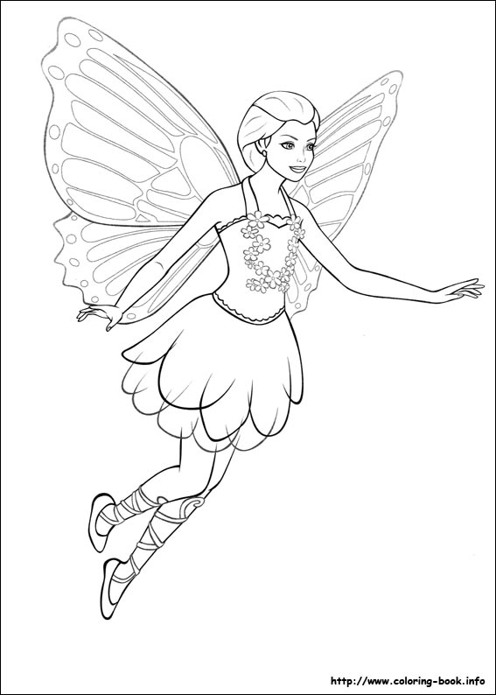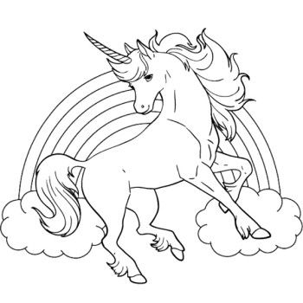

**Characteristics of Fantasy Stories**

* Strange characters and settings that do not exist in our world.
* Usually includes magic.
* Often there is a journey or quest of some sort.

Fantasy

**Author’s Purpose:**

**To entertain.**

**Some fantasy stories I know are:**

**Keep track of the fantasy stories you read here!**

**Name:___________________________**

**Good Readers Know About Genres**