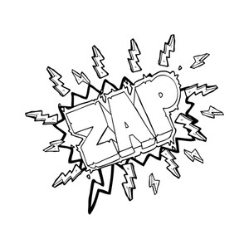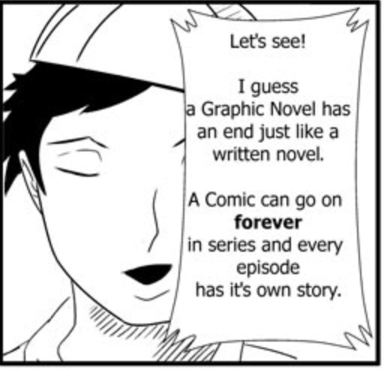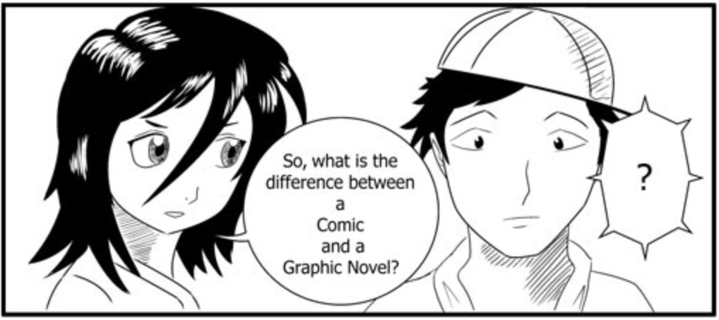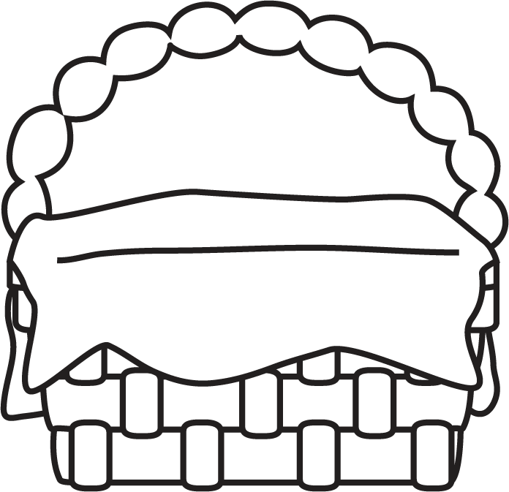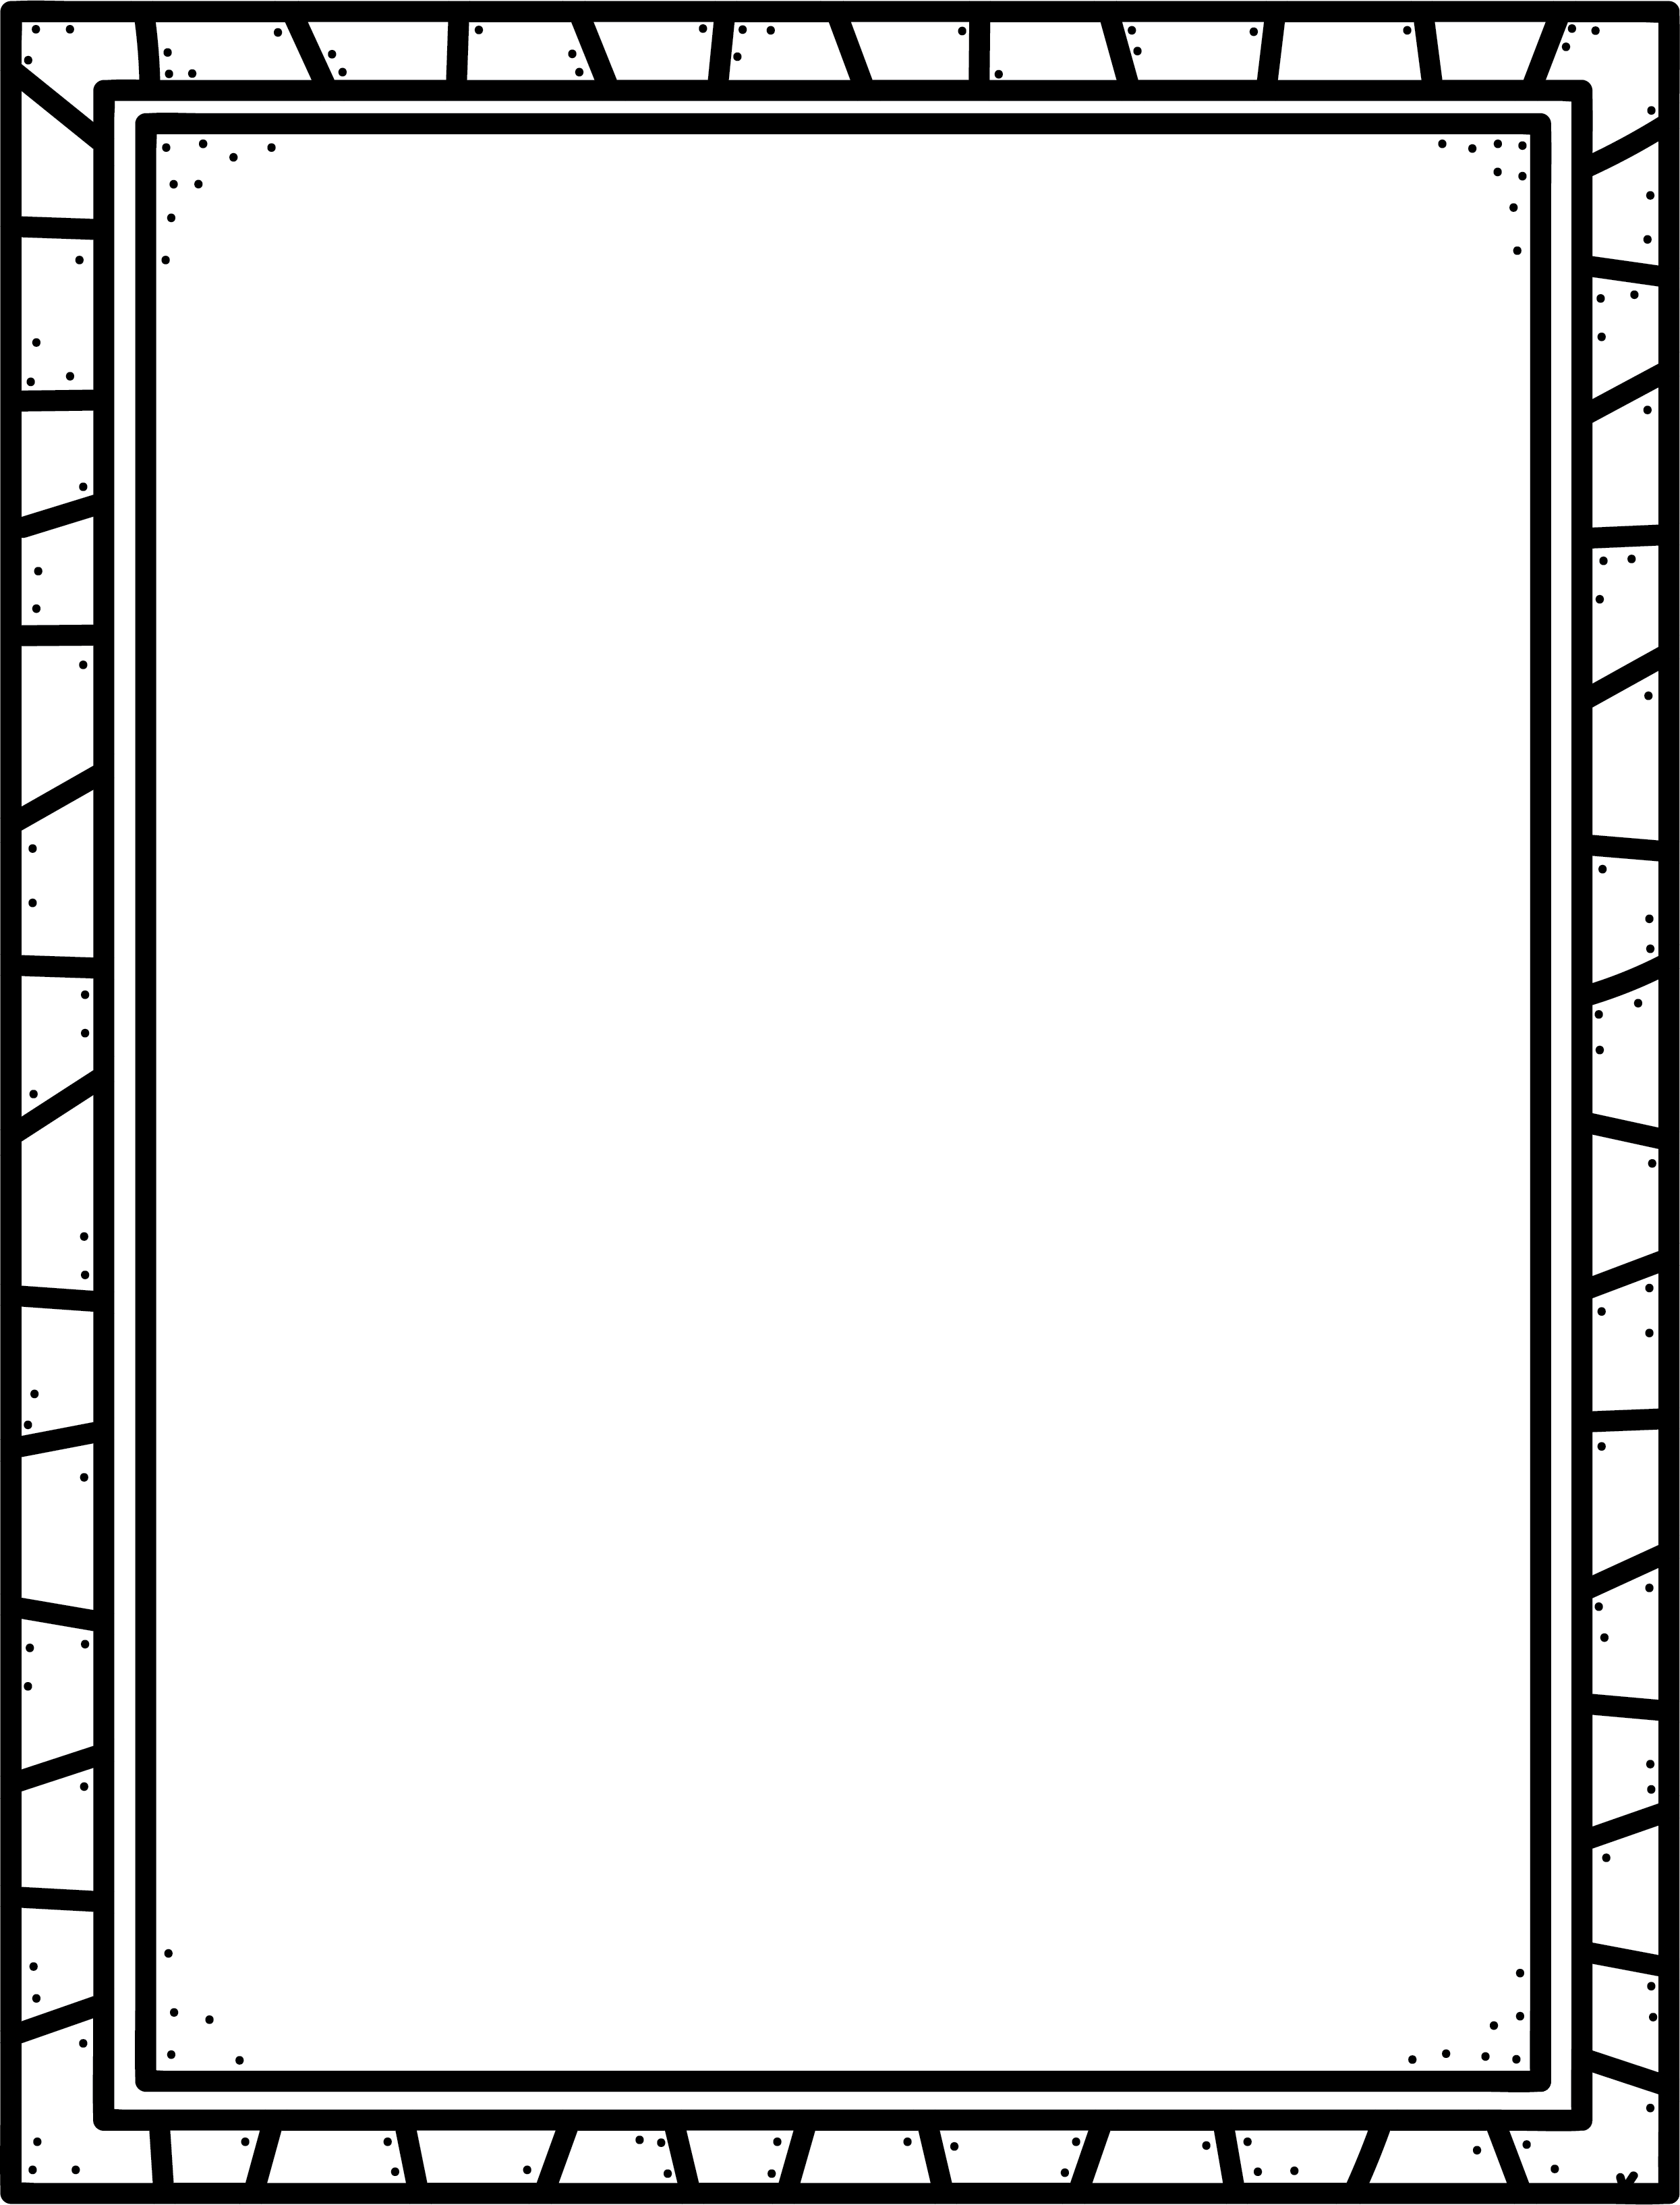

**KAPOW!**

**Characteristics of Graphic Novels**

* Use text and pictures to tell a story.
* Like comics, but longer, more detailed story.
* Story is in rectangles called frames.
* Use speech and thought bubbles to show dialogue (characters talking and thinking) Read these from top to bottom in each frame.
* Use Text boxes (captions) to tell about the story.
* Sometimes show sound effects.

**Author’s Purpose:**

**To entertain**

**Some graphic novels I know are:**

**Keep track of the graphic novels you read here!**

**Name:___________________________**

Graphic

Novels

**Good Readers Know About Genres**