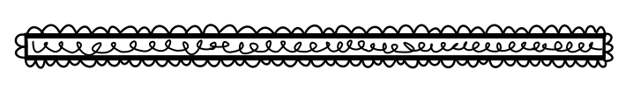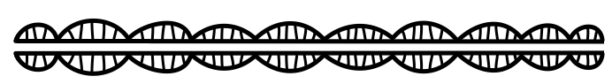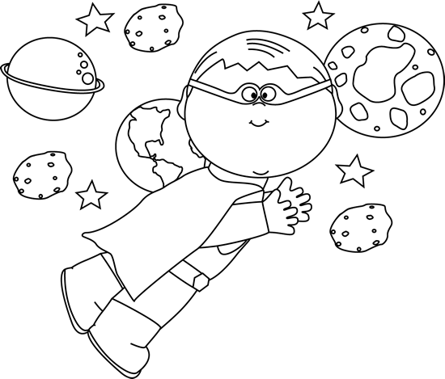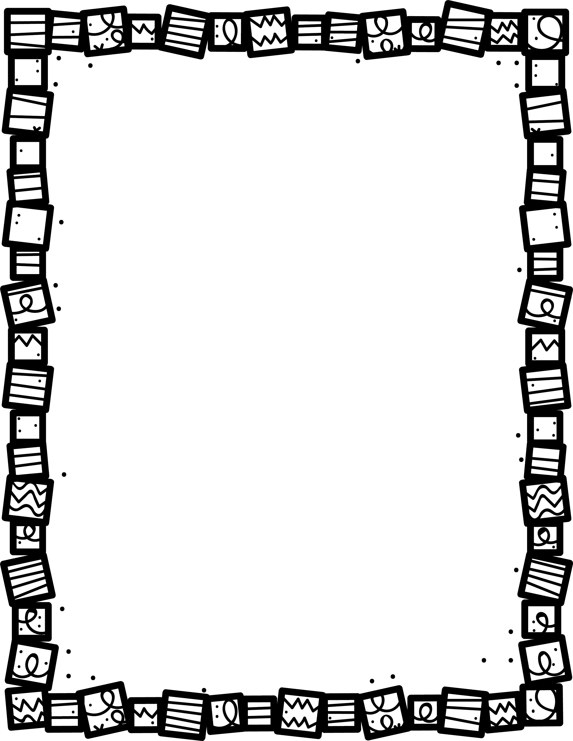

**Does the main character look the way you think he/she should? What would you change?**

**Describe the setting.**

**Describe the plot. What is the story about?**

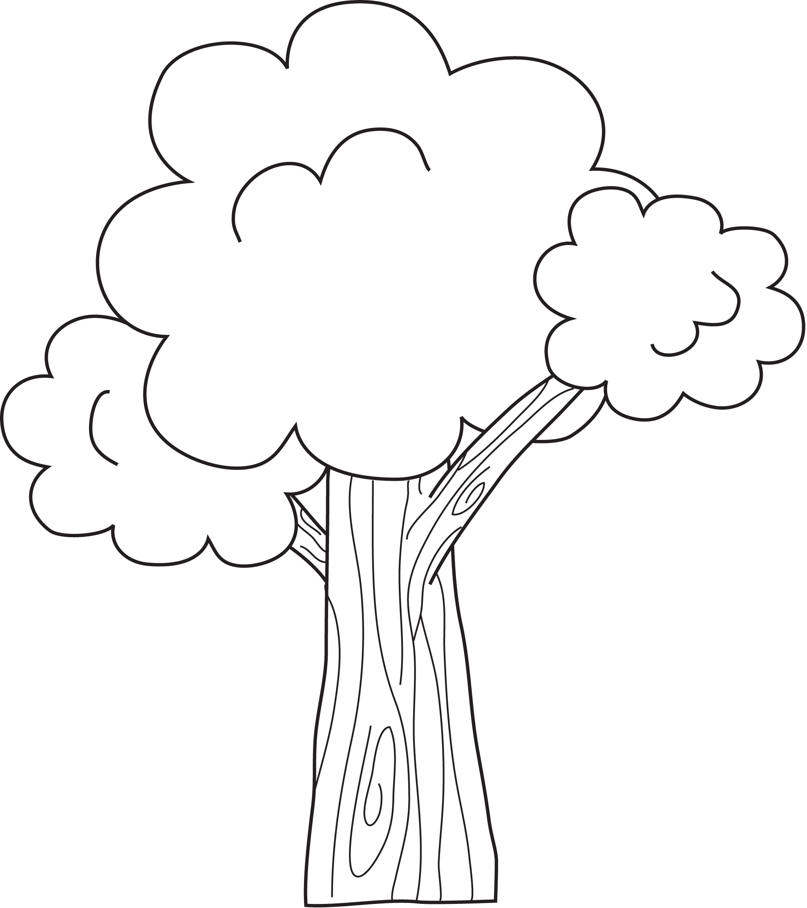

**Describe the main character.**

**How do the pictures help you understand the story?**

**What was your favourite part? Why?.**

**Book Title:**

**Name:___________________________**

**My Little Activity Book About**

Graphic

Novels