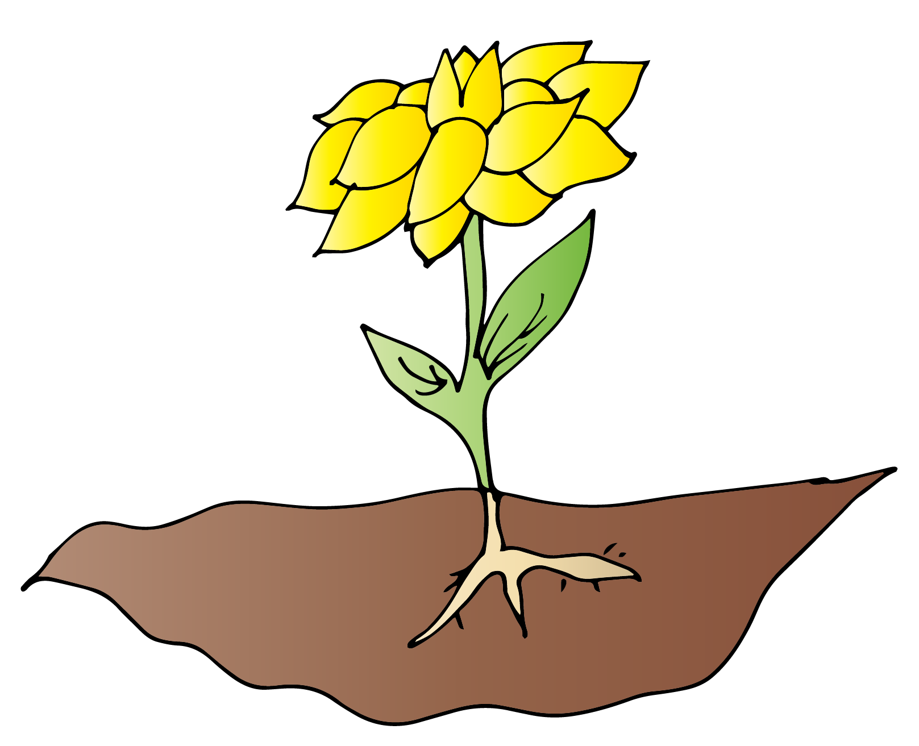

**Grow a Flower**

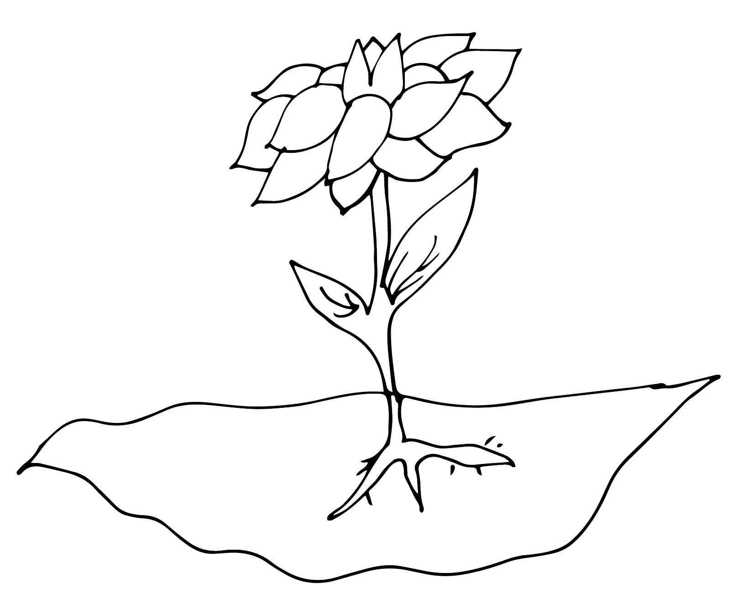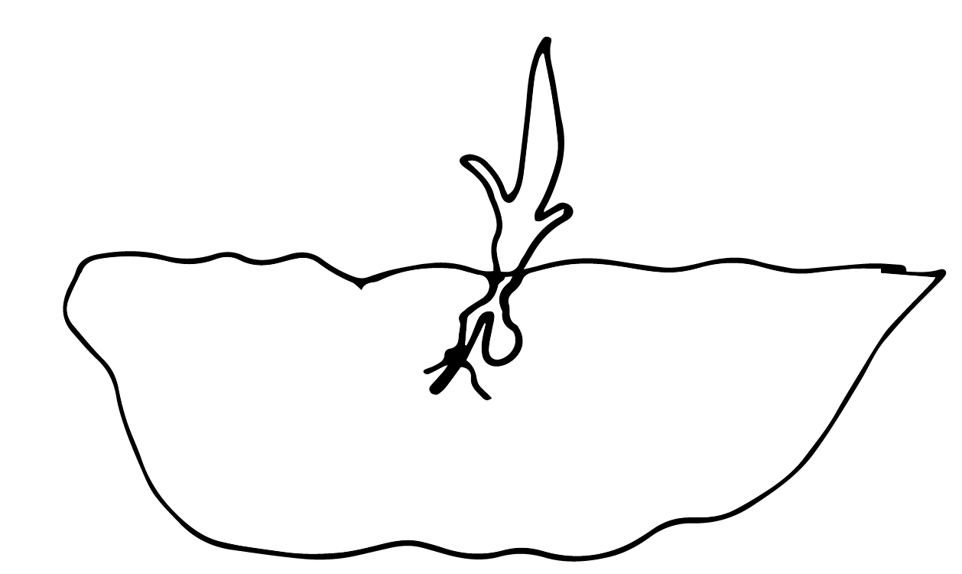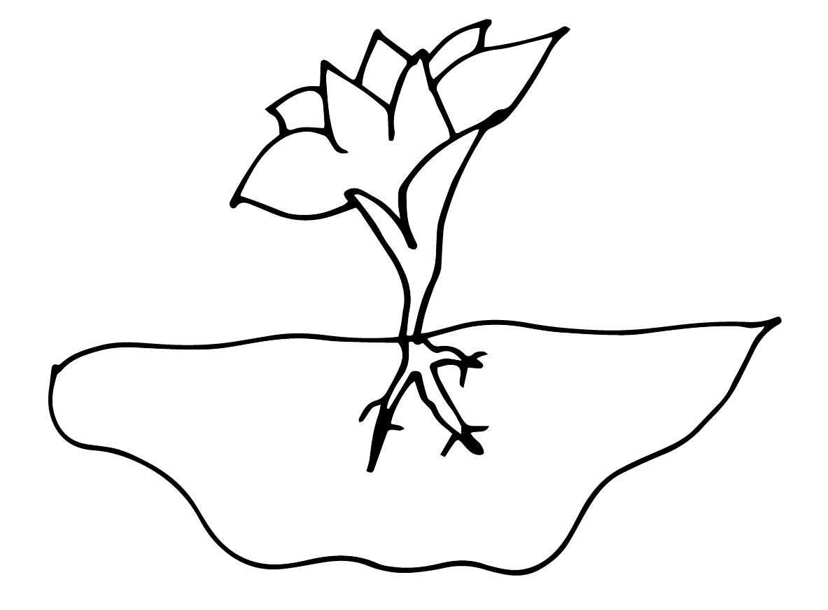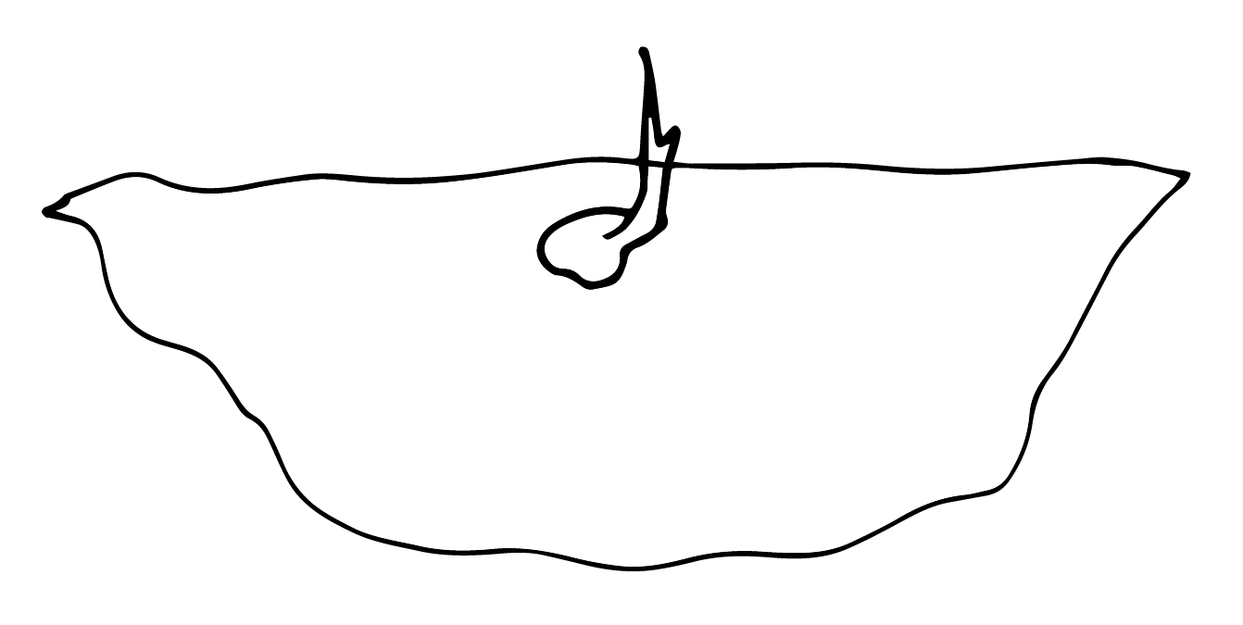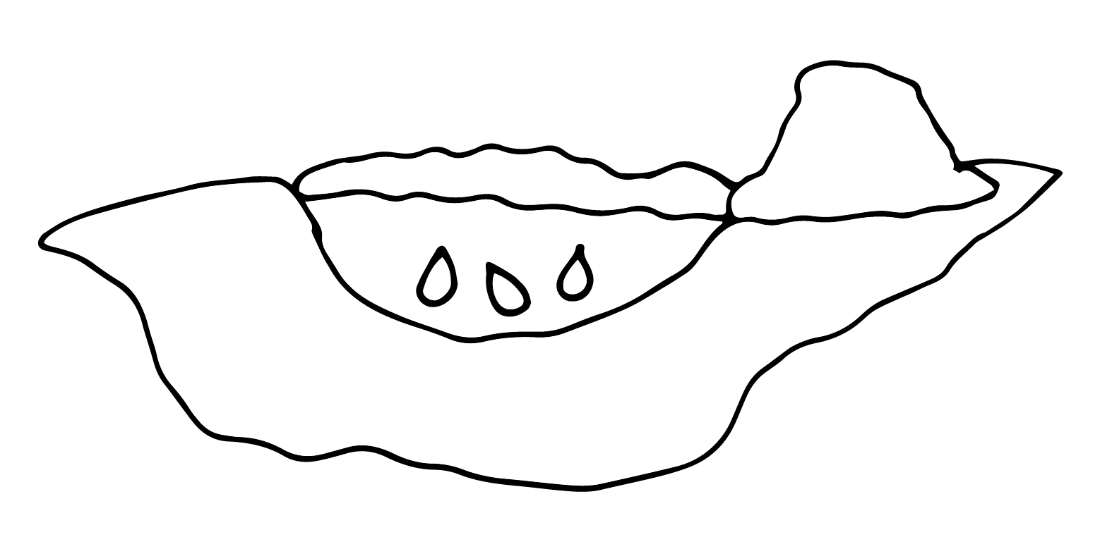

1. **First, dig a hole and plant your seeds.**
2. **Next, cover your seeds with dirt.**
3. **Then, water your seeds and one or all will begin to sprout.**
4. **Next, watch a stem begin to form a flower bud.**
5. **Then, the bud slowly opens.**
6. **Finally, the flower is fully open, and the leaves are growing.**

|  |  |  |  |  |  |
| --- | --- | --- | --- | --- | --- |
|  |  |  |  |  |  |