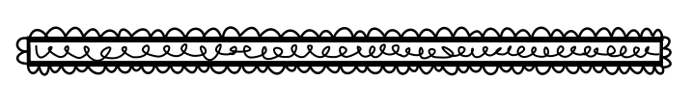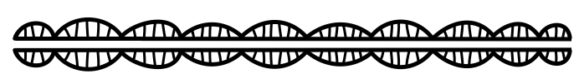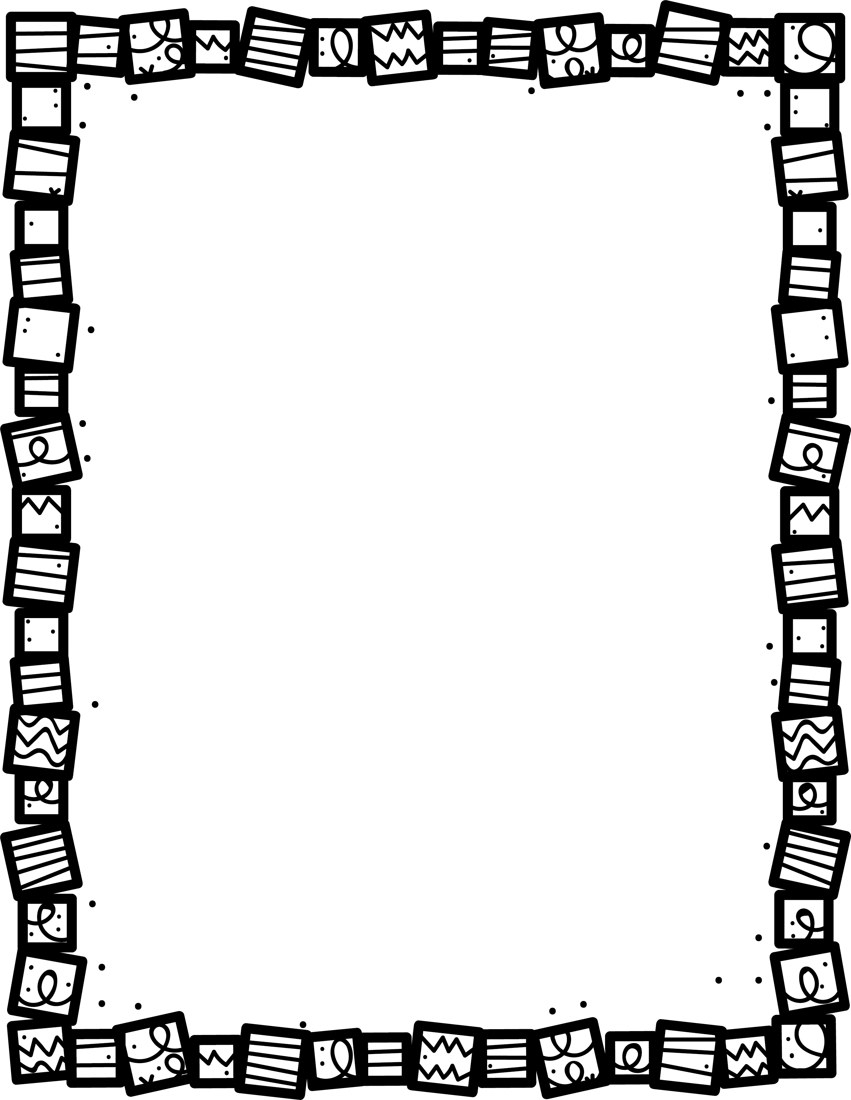

**When does the story take place? What historical places are included?**

**What did you learn about life in the past?**

**What is most interesting to you?**

Historical Fiction

**Describe the plot. What happens in the story?**

**Who are the main characters?**

**What real historical events are included?**

**Book Title:**

**Name:___________________________**

**My Little Activity Book About**