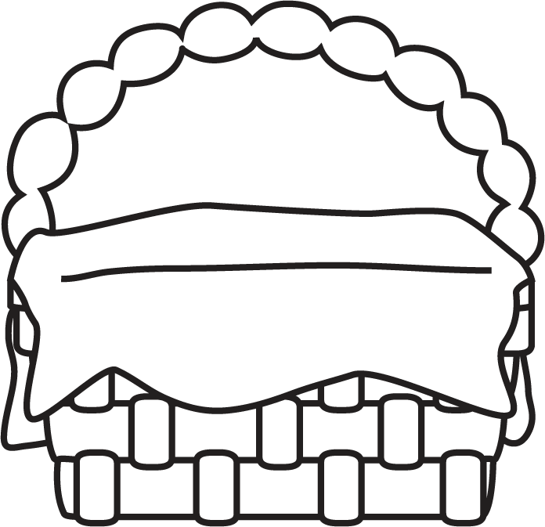

**Author’s Purpose:**

**To entertain and to inform.**

**Characteristics of Historical Fiction**

* Setting, characters and events are realistic and believable.
* A story that could have happened in real life, ina time period long past.
* May include a real place, time or past event.
* Details help you really visualise the places and characters at the time in history.
* May help to teach us about life in the past.

**Some historical fiction stories I know are:**

Historical Fiction

**Keep track of the historical fiction stories you read here!**

**Name:___________________________**

**Good Readers Know About Genres**