

**Let’s make an ice cream Sundae**

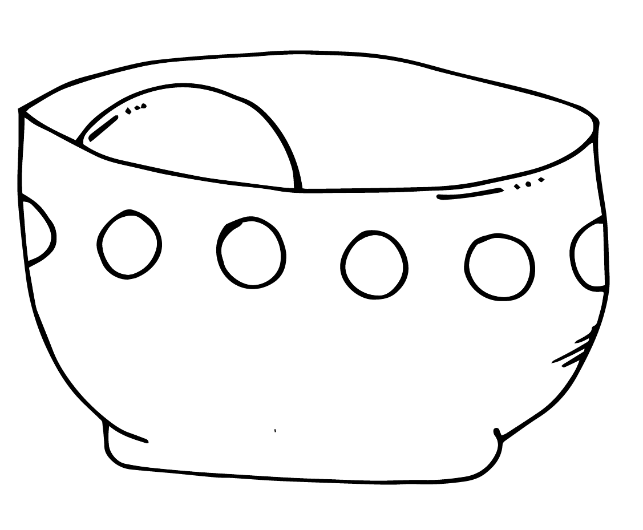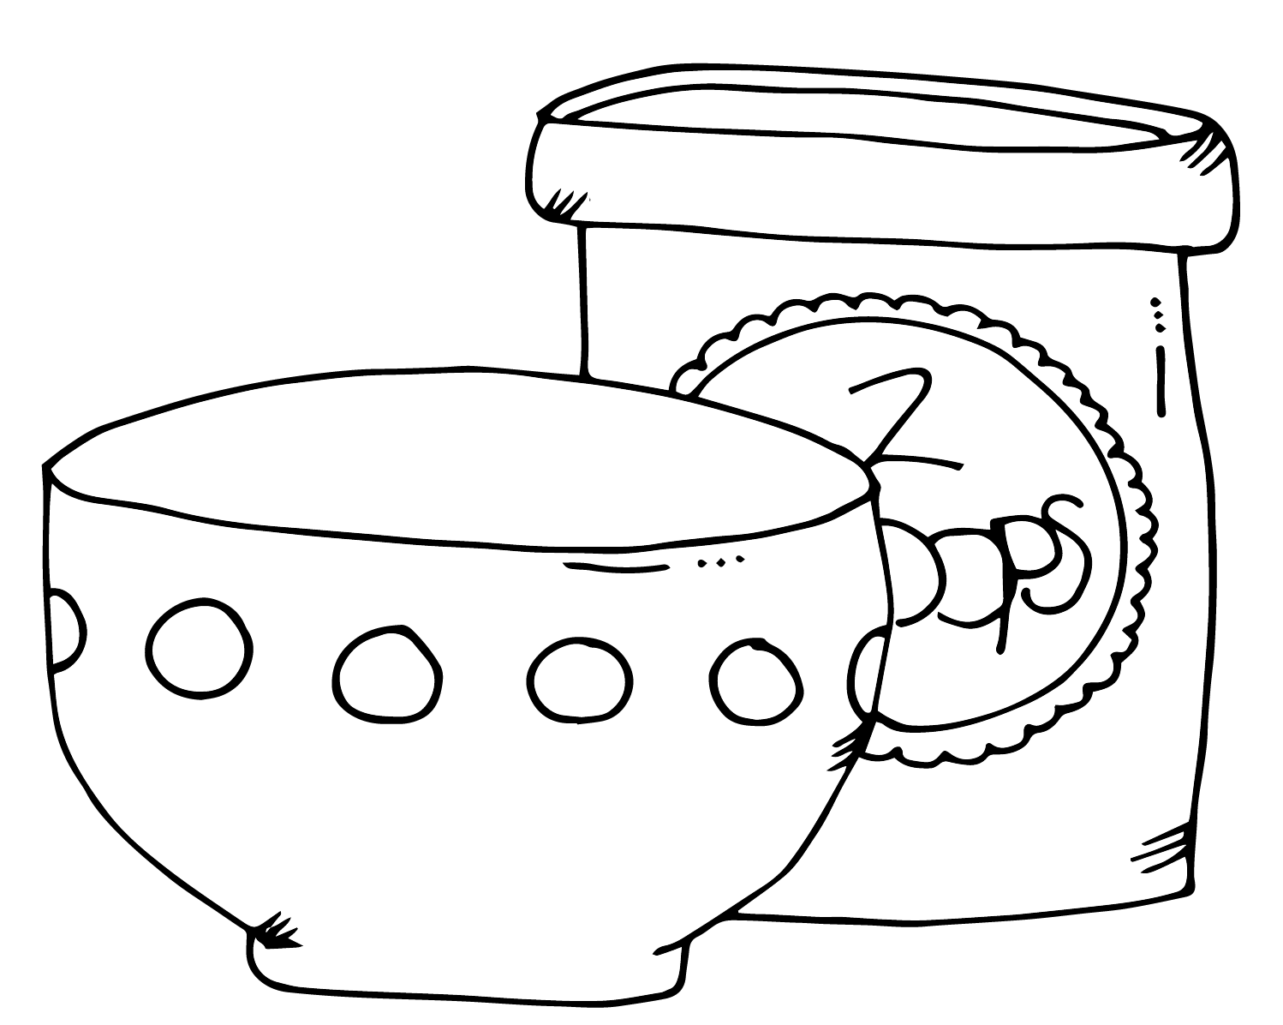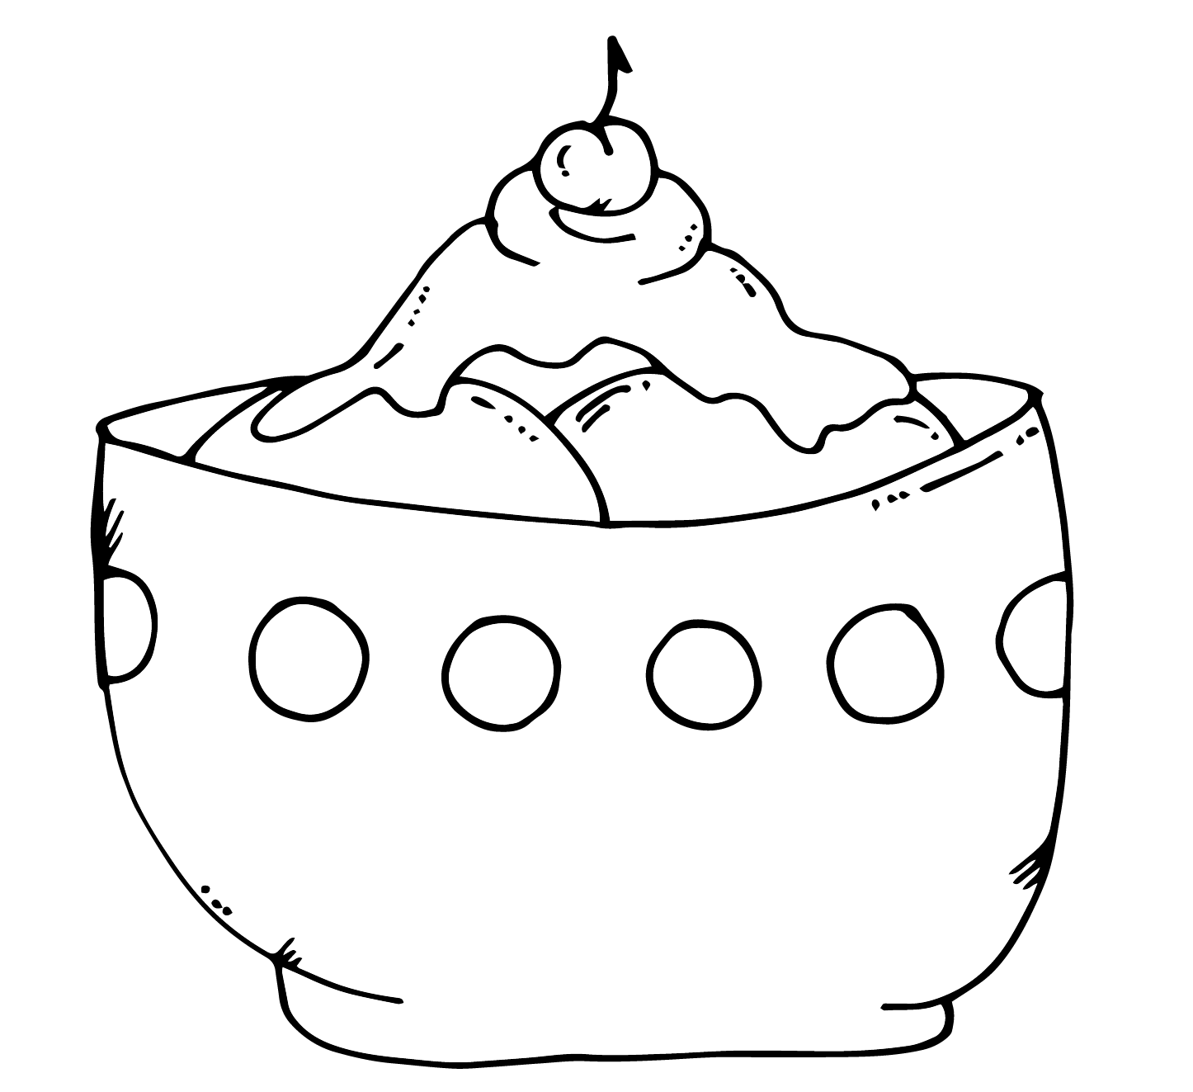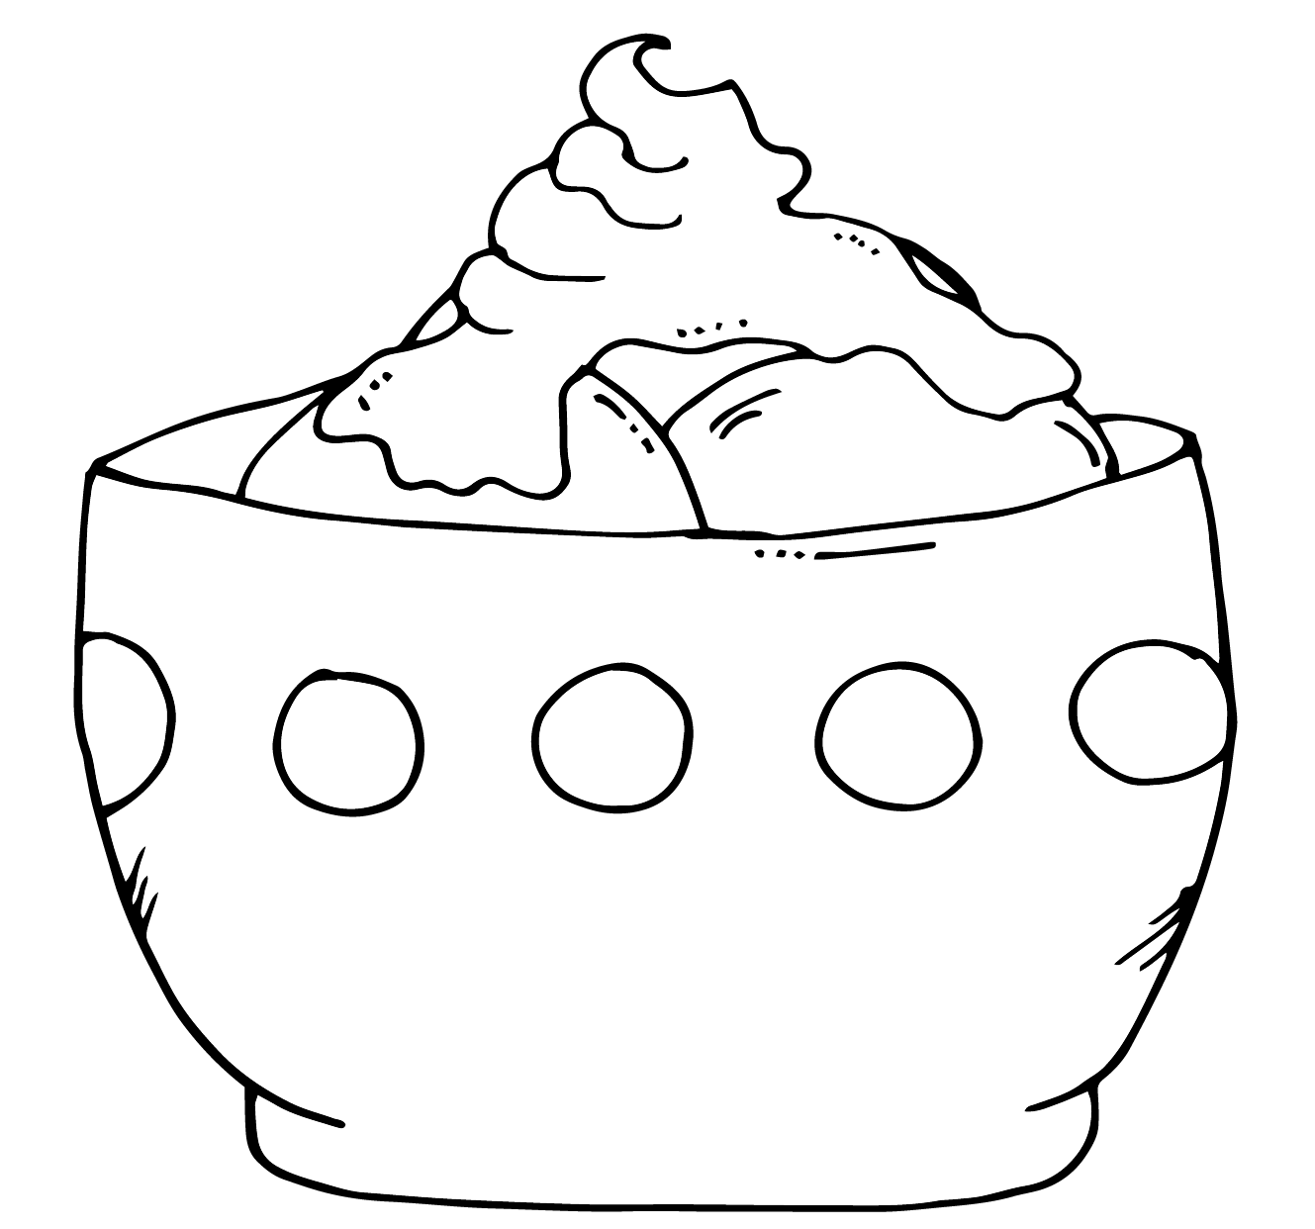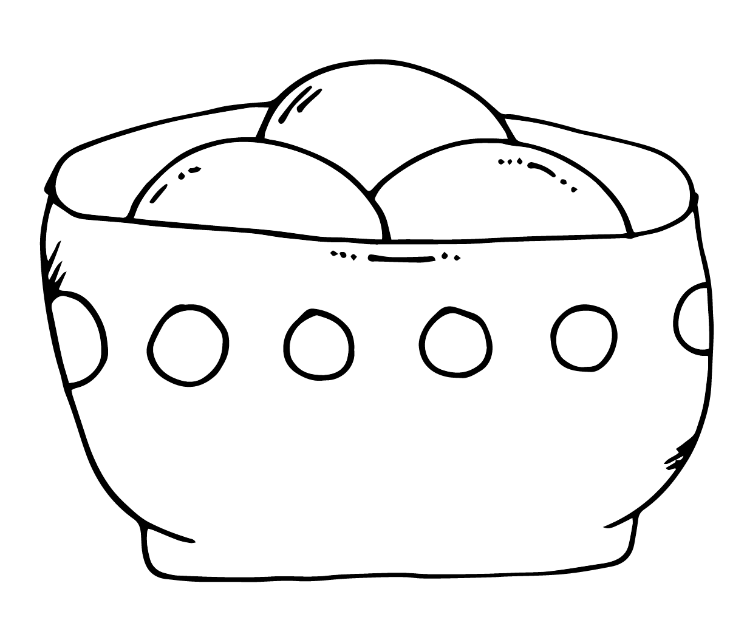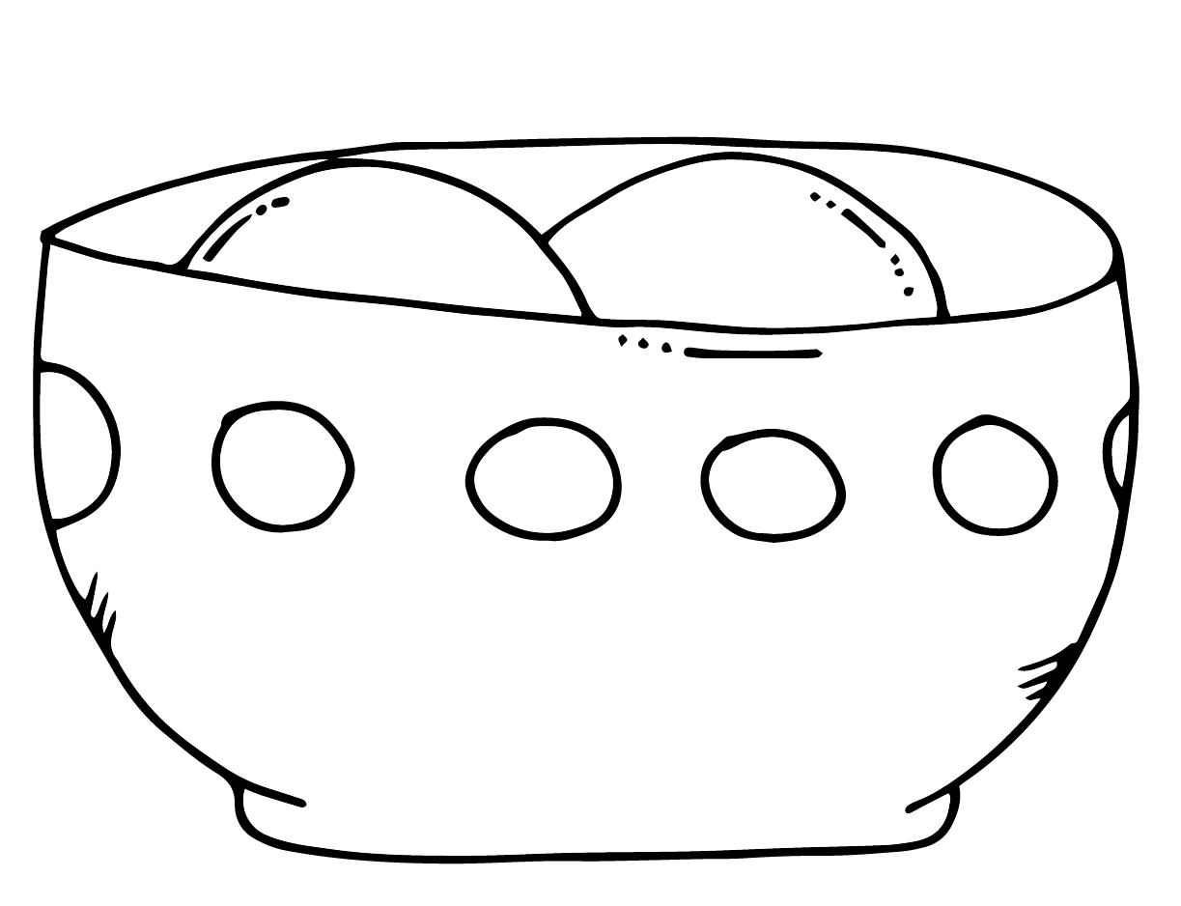

1. **First, get a bowl and some ice cream.**
2. **Next, put a scoop of ice cream in the bowl.**
3. **Then, add another scoop.**
4. **Next, why not, add a third scoop of ice cream.**
5. **Then, add whip cream.**
6. **Finally, because you deserve it, add a cherry on top.**

|  |  |  |  |  |  |
| --- | --- | --- | --- | --- | --- |
|  |  |  |  |  |  |