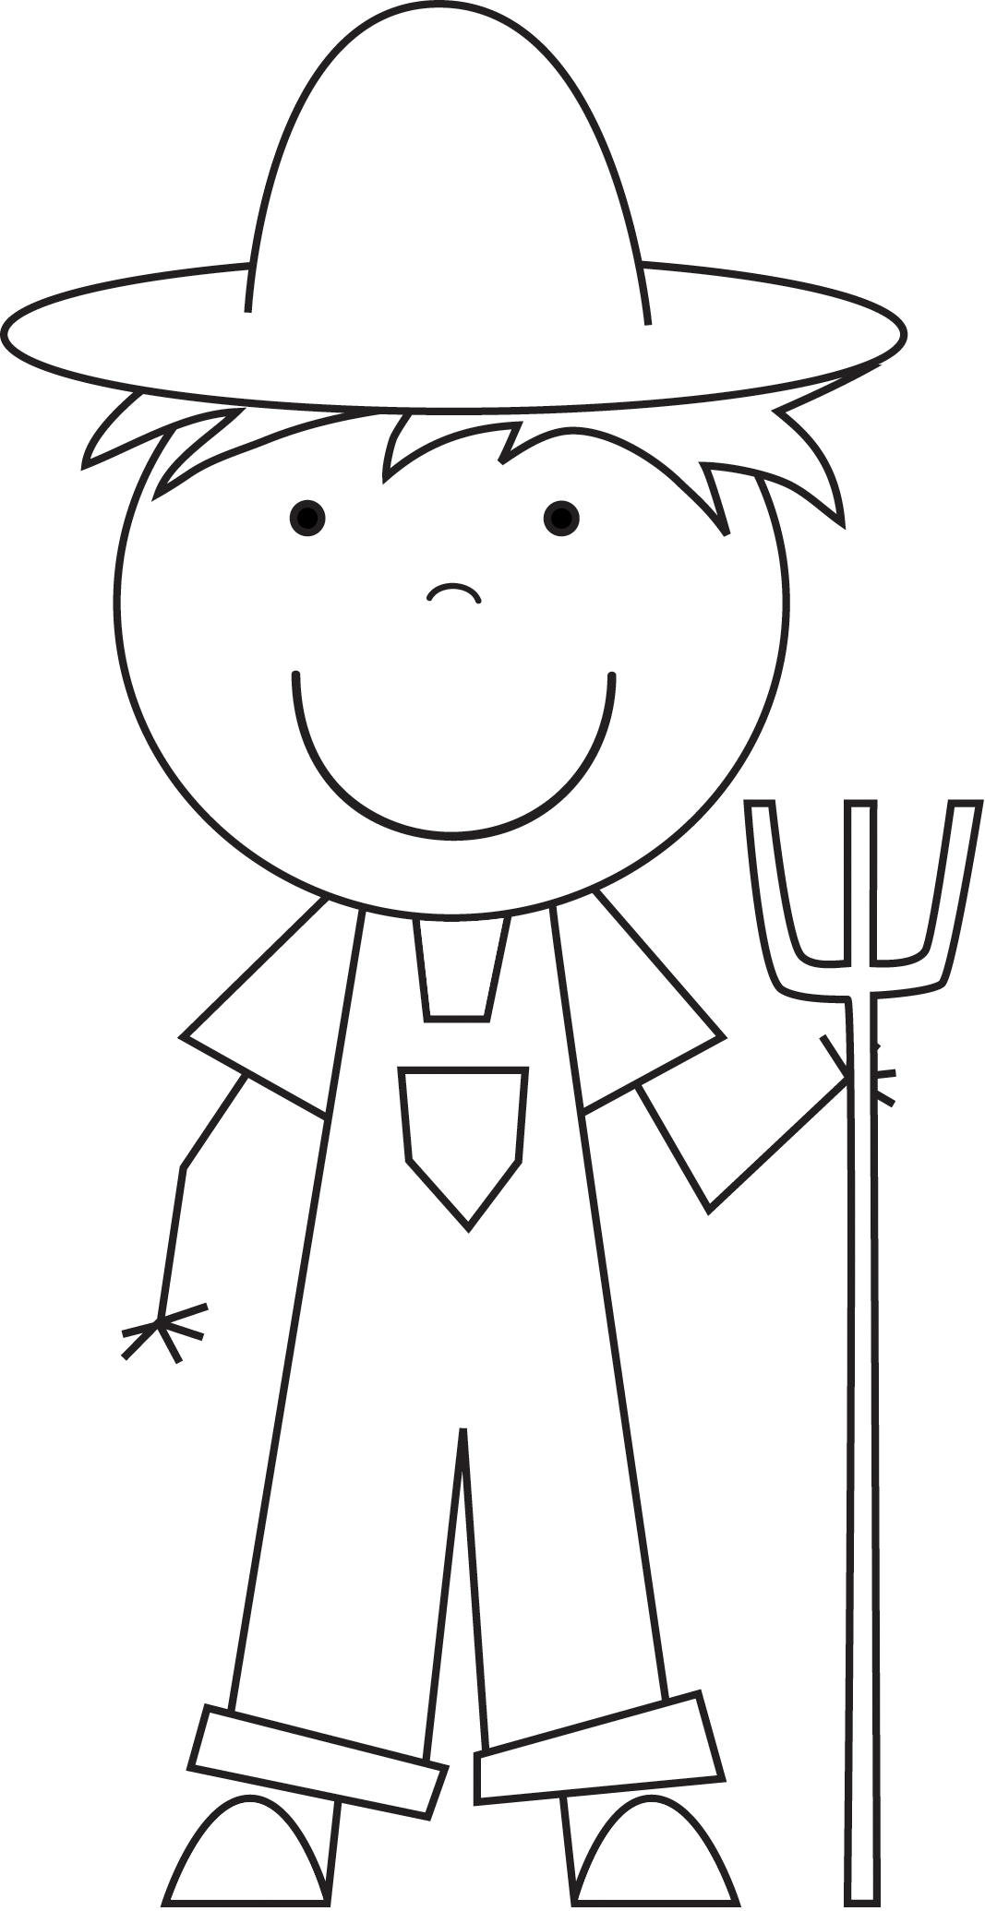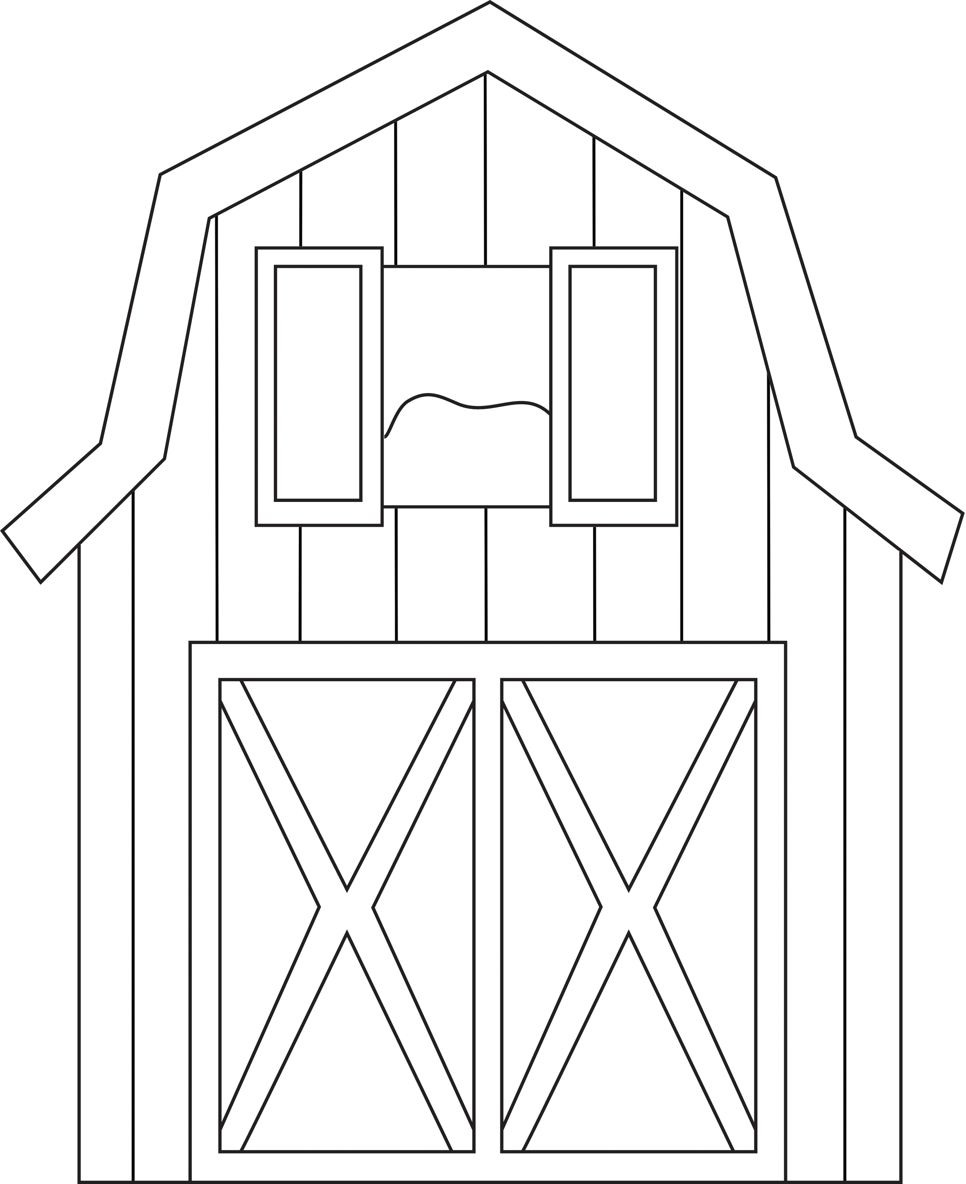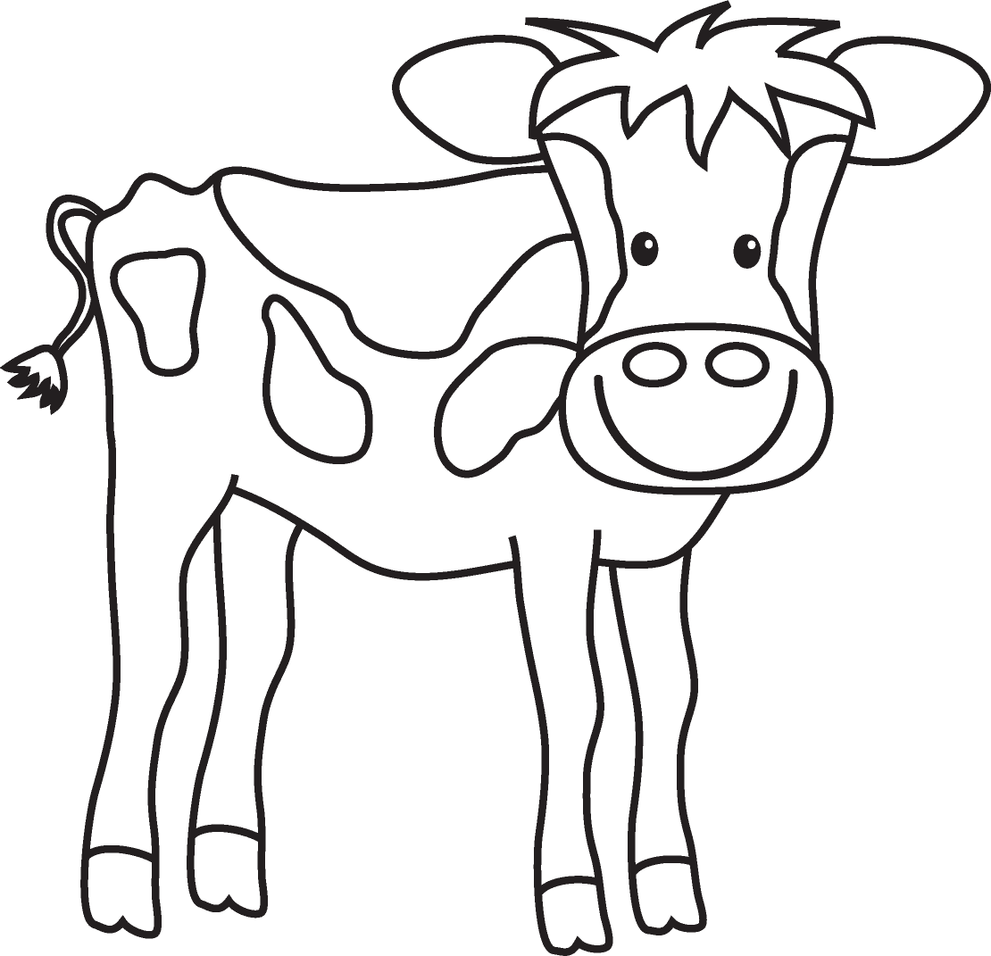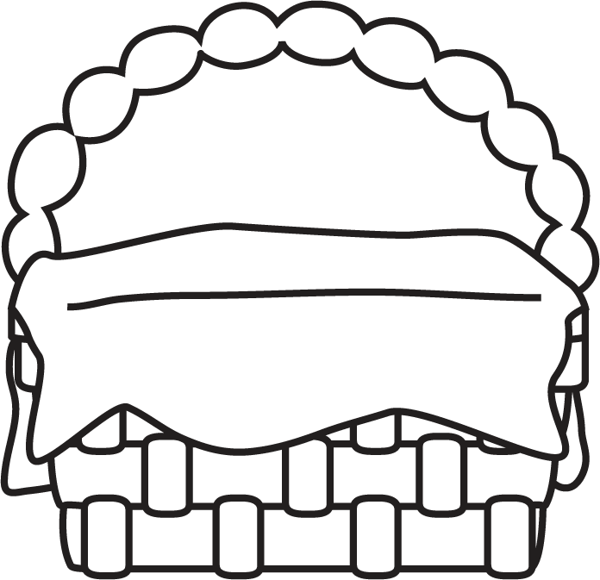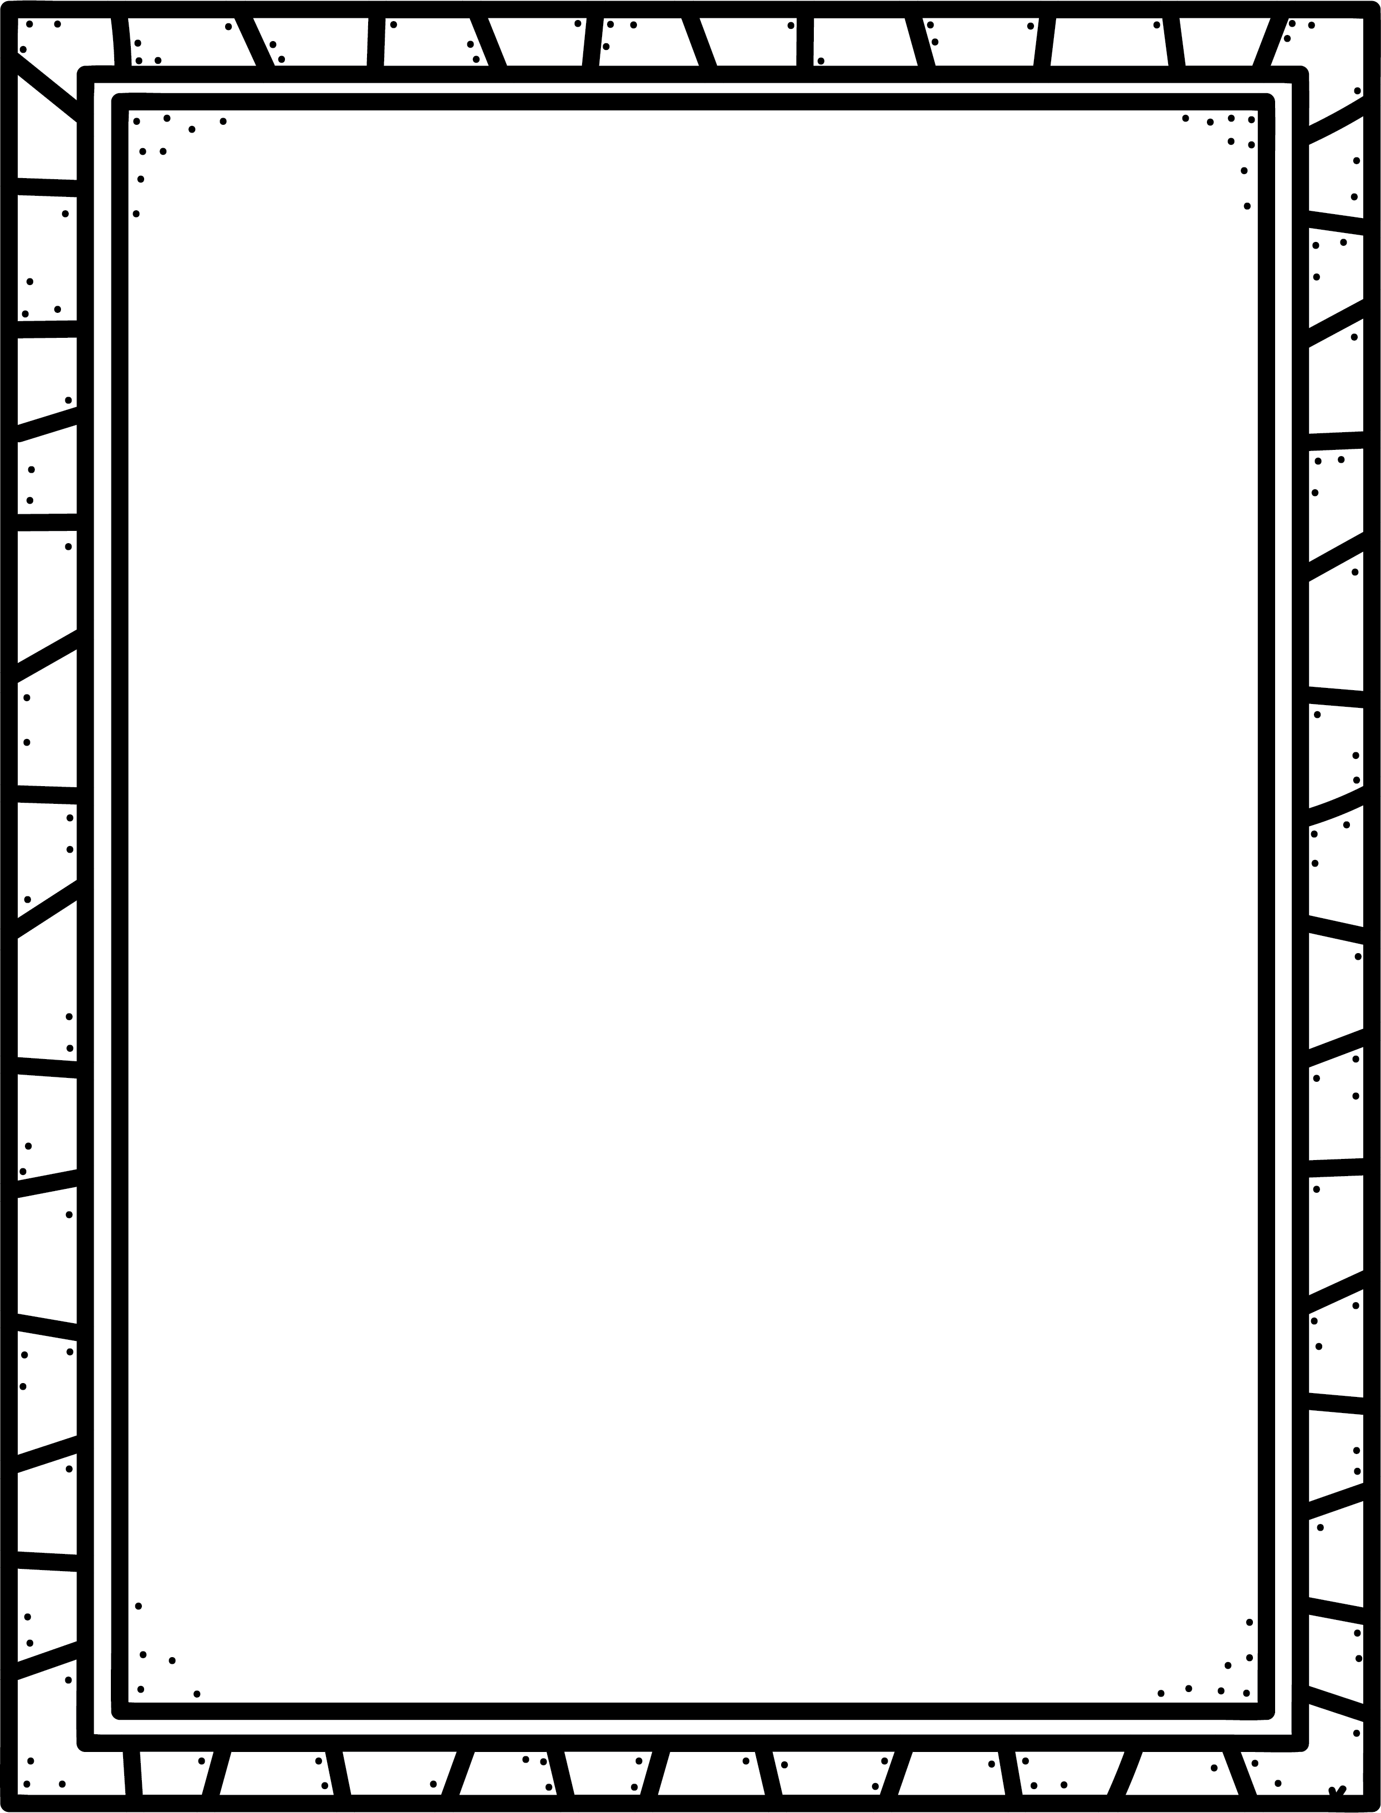

**Some informational texts I know are:**

**Characteristics of Informational texts**

* Give only facts from research.
* Are a type of non-fiction.
* Give information on a large group of things that will always be true and do not change over time.

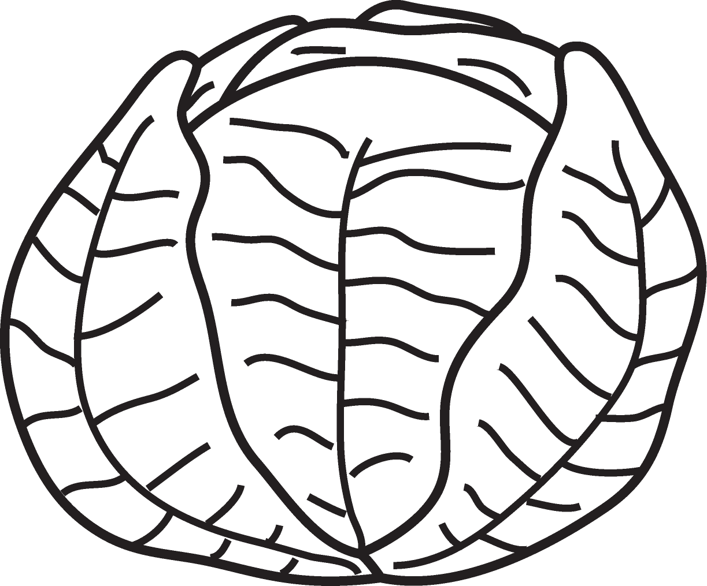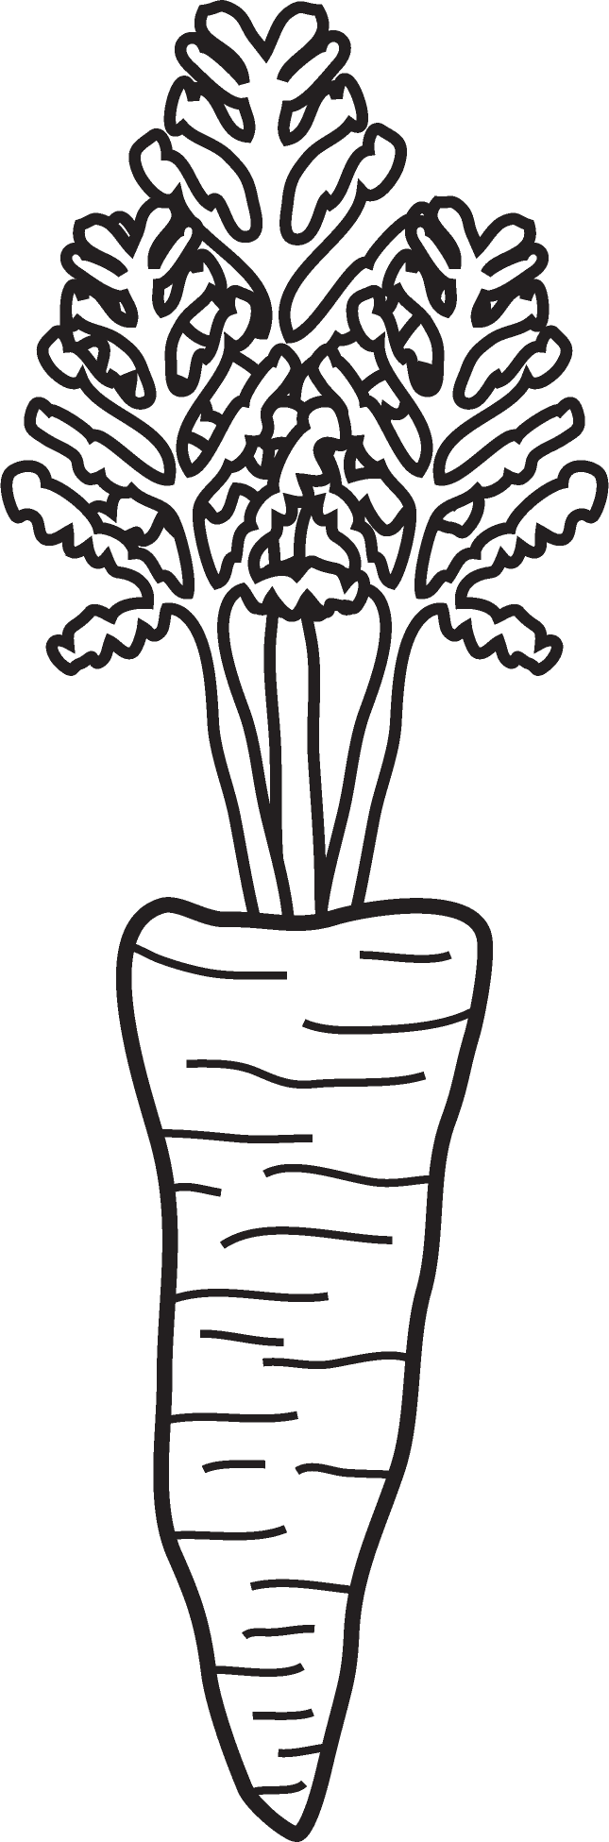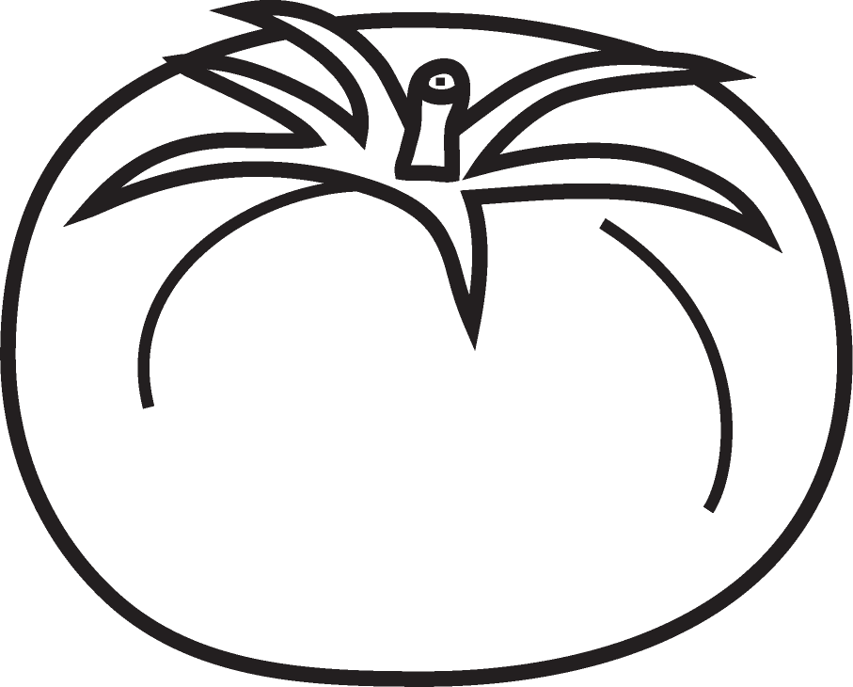

Informational

**Author’s Purpose:**

**To inform.**

**Keep track of the informational texts you read here!**

**Name:___________________________**

**Good Readers Know About Genres**