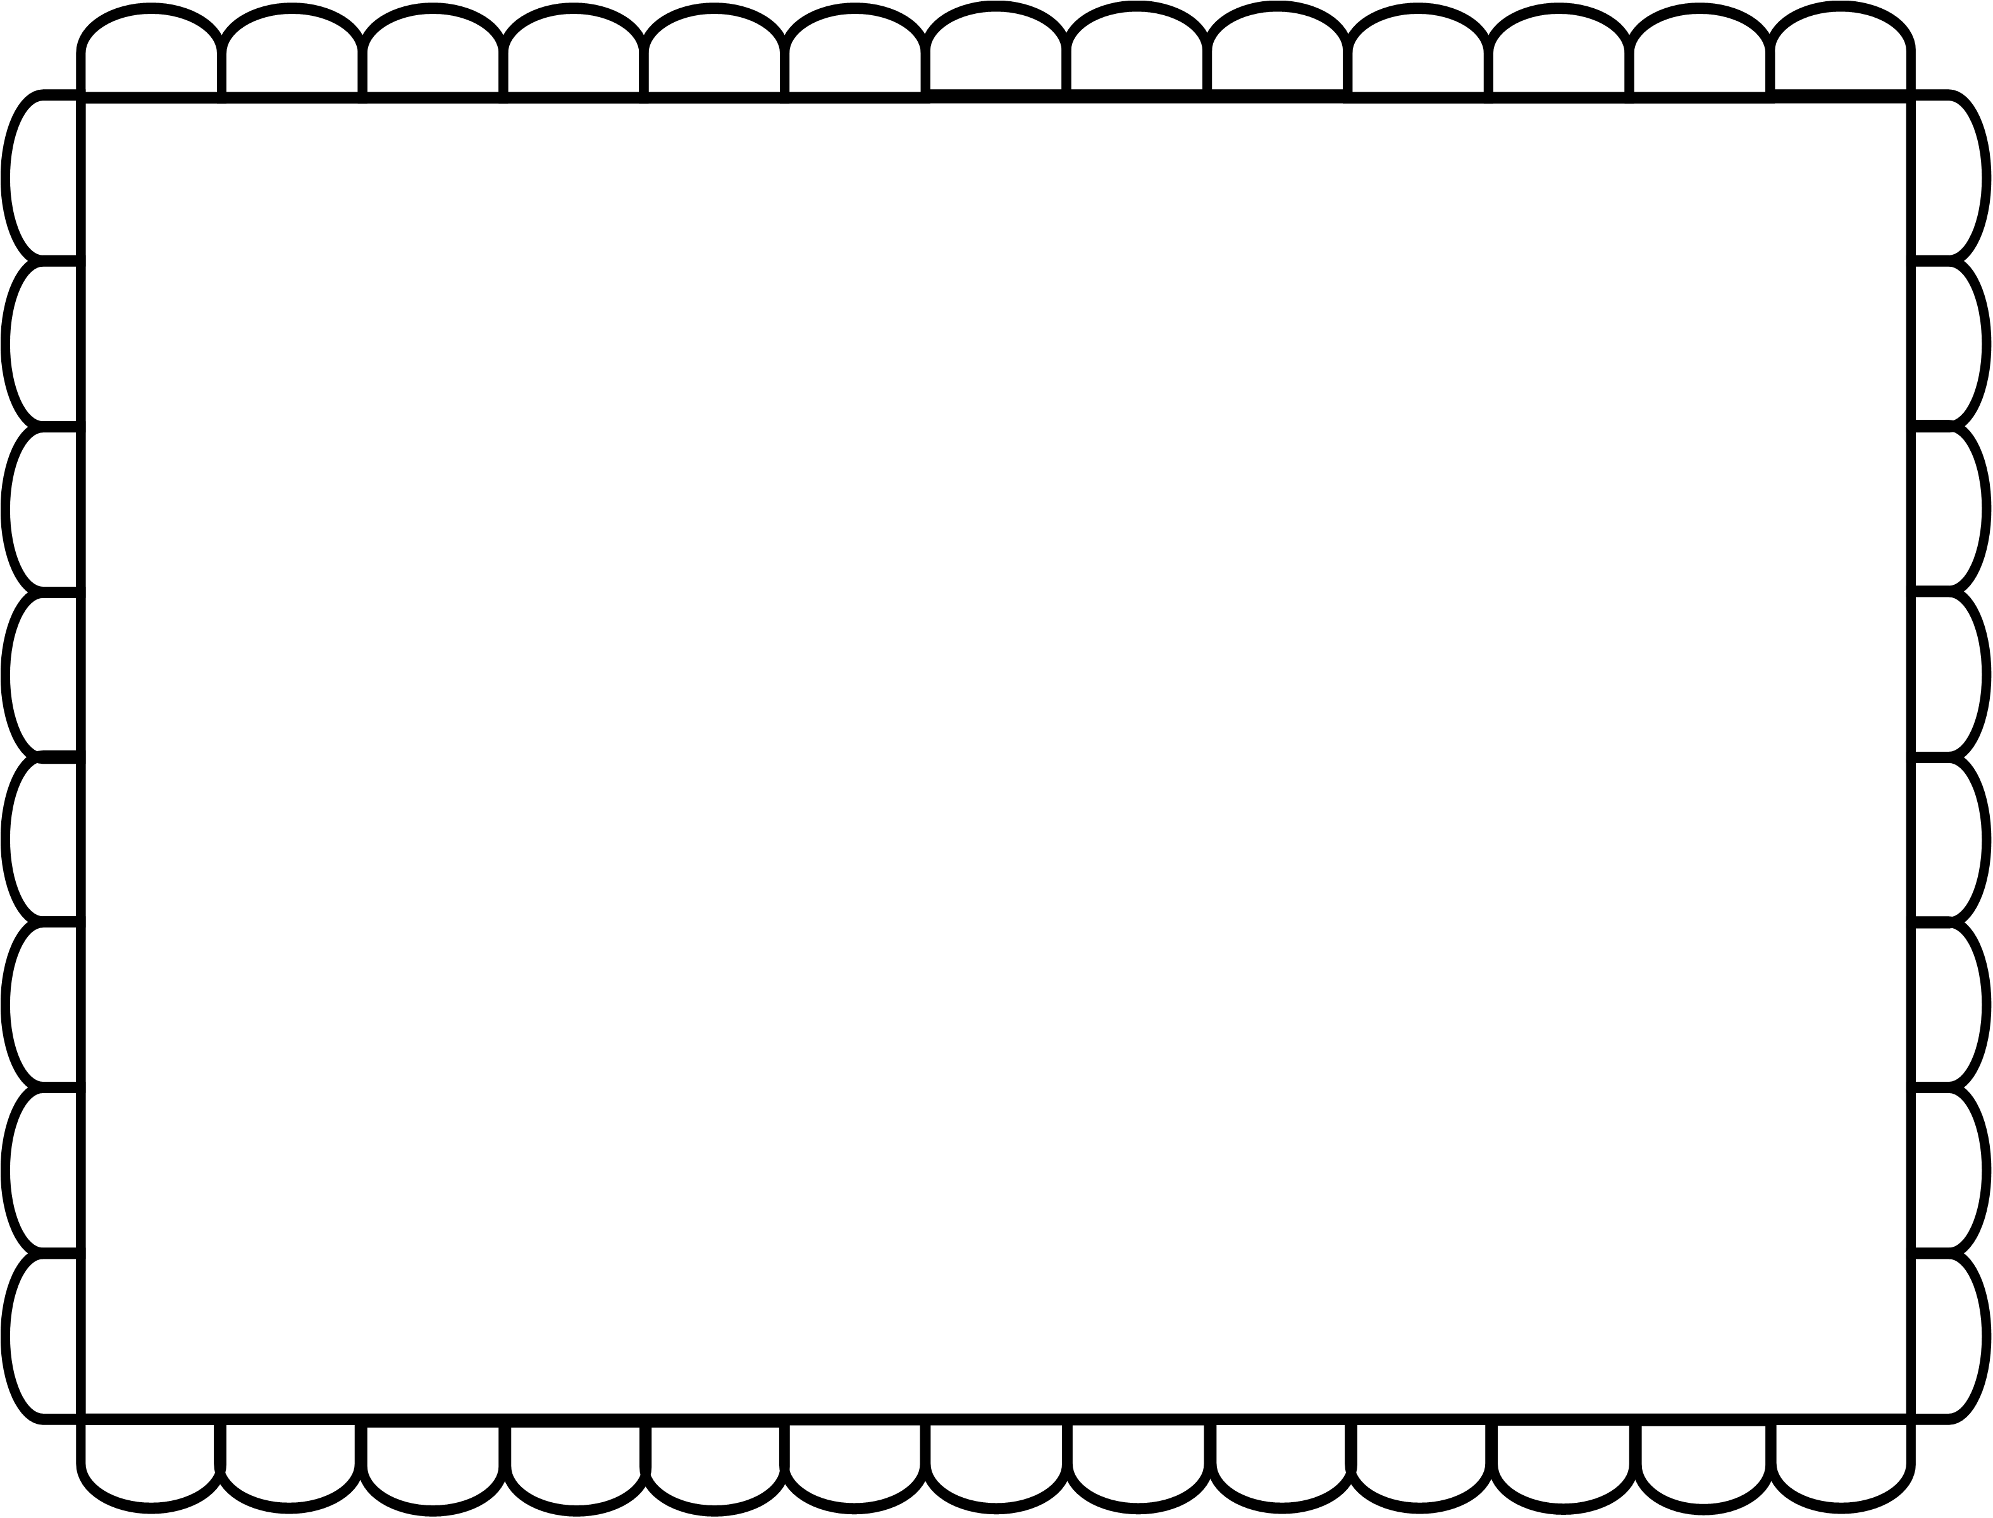

**Jane needs to clean her room.**

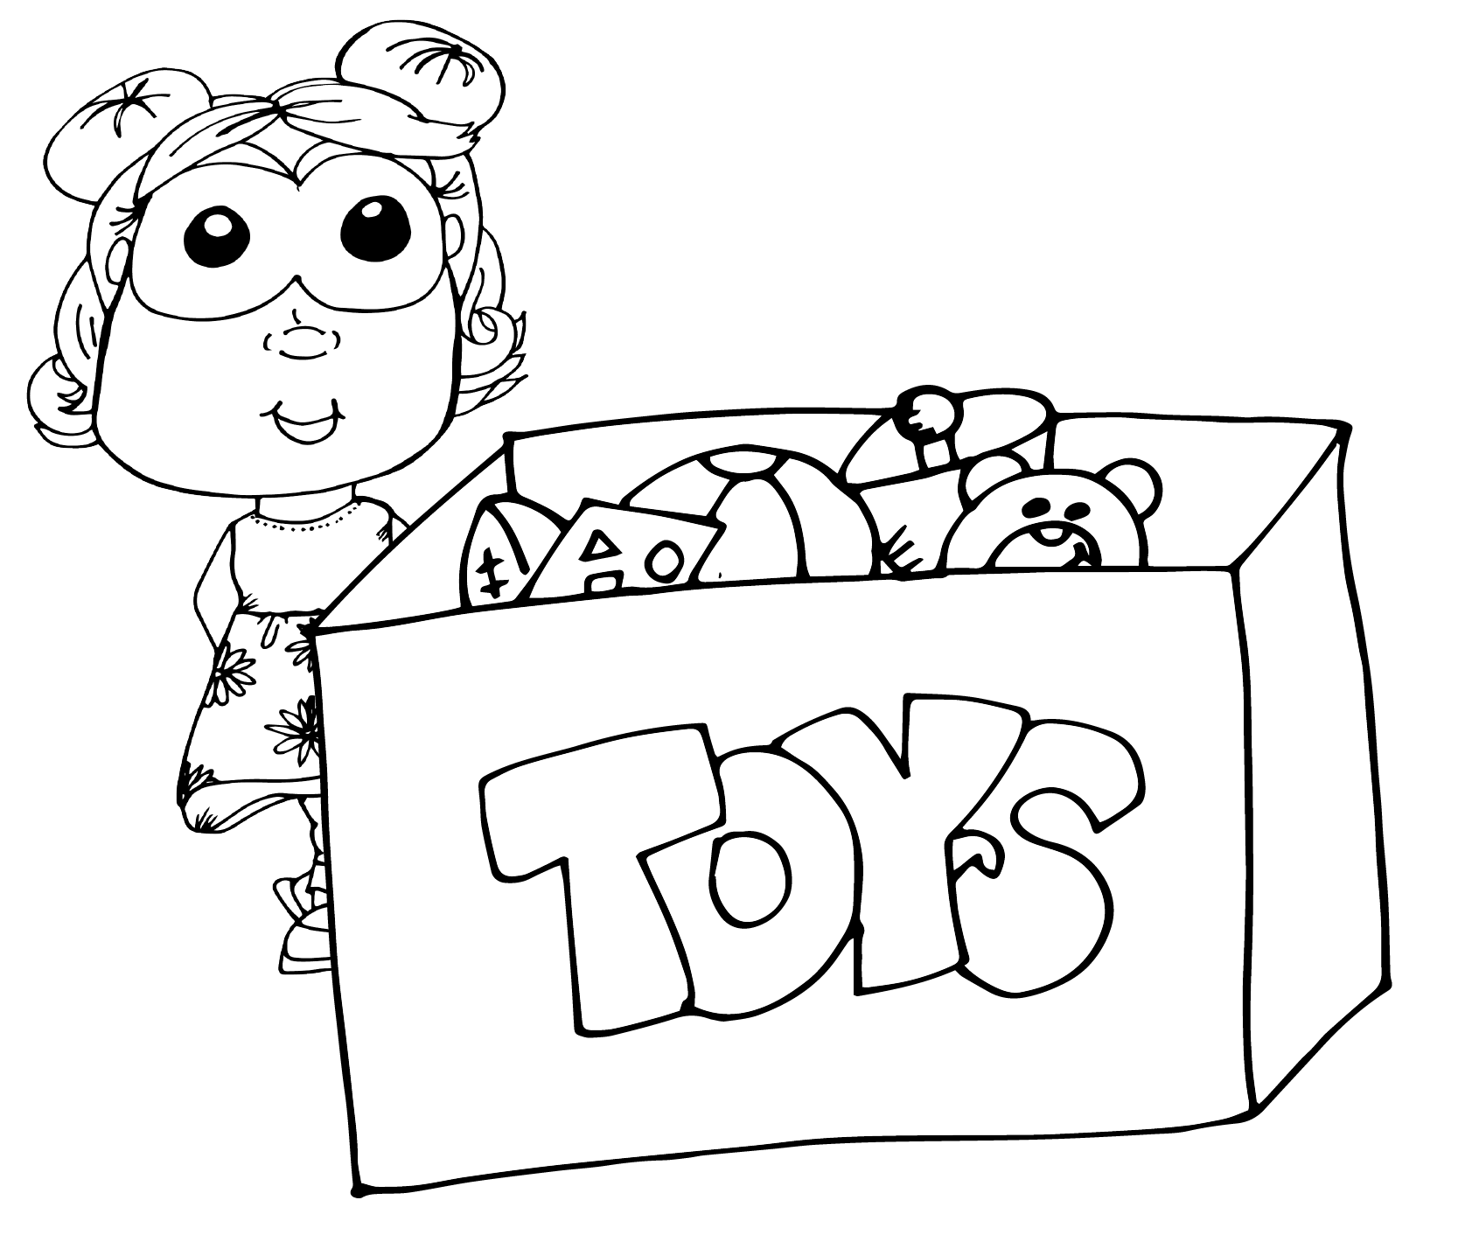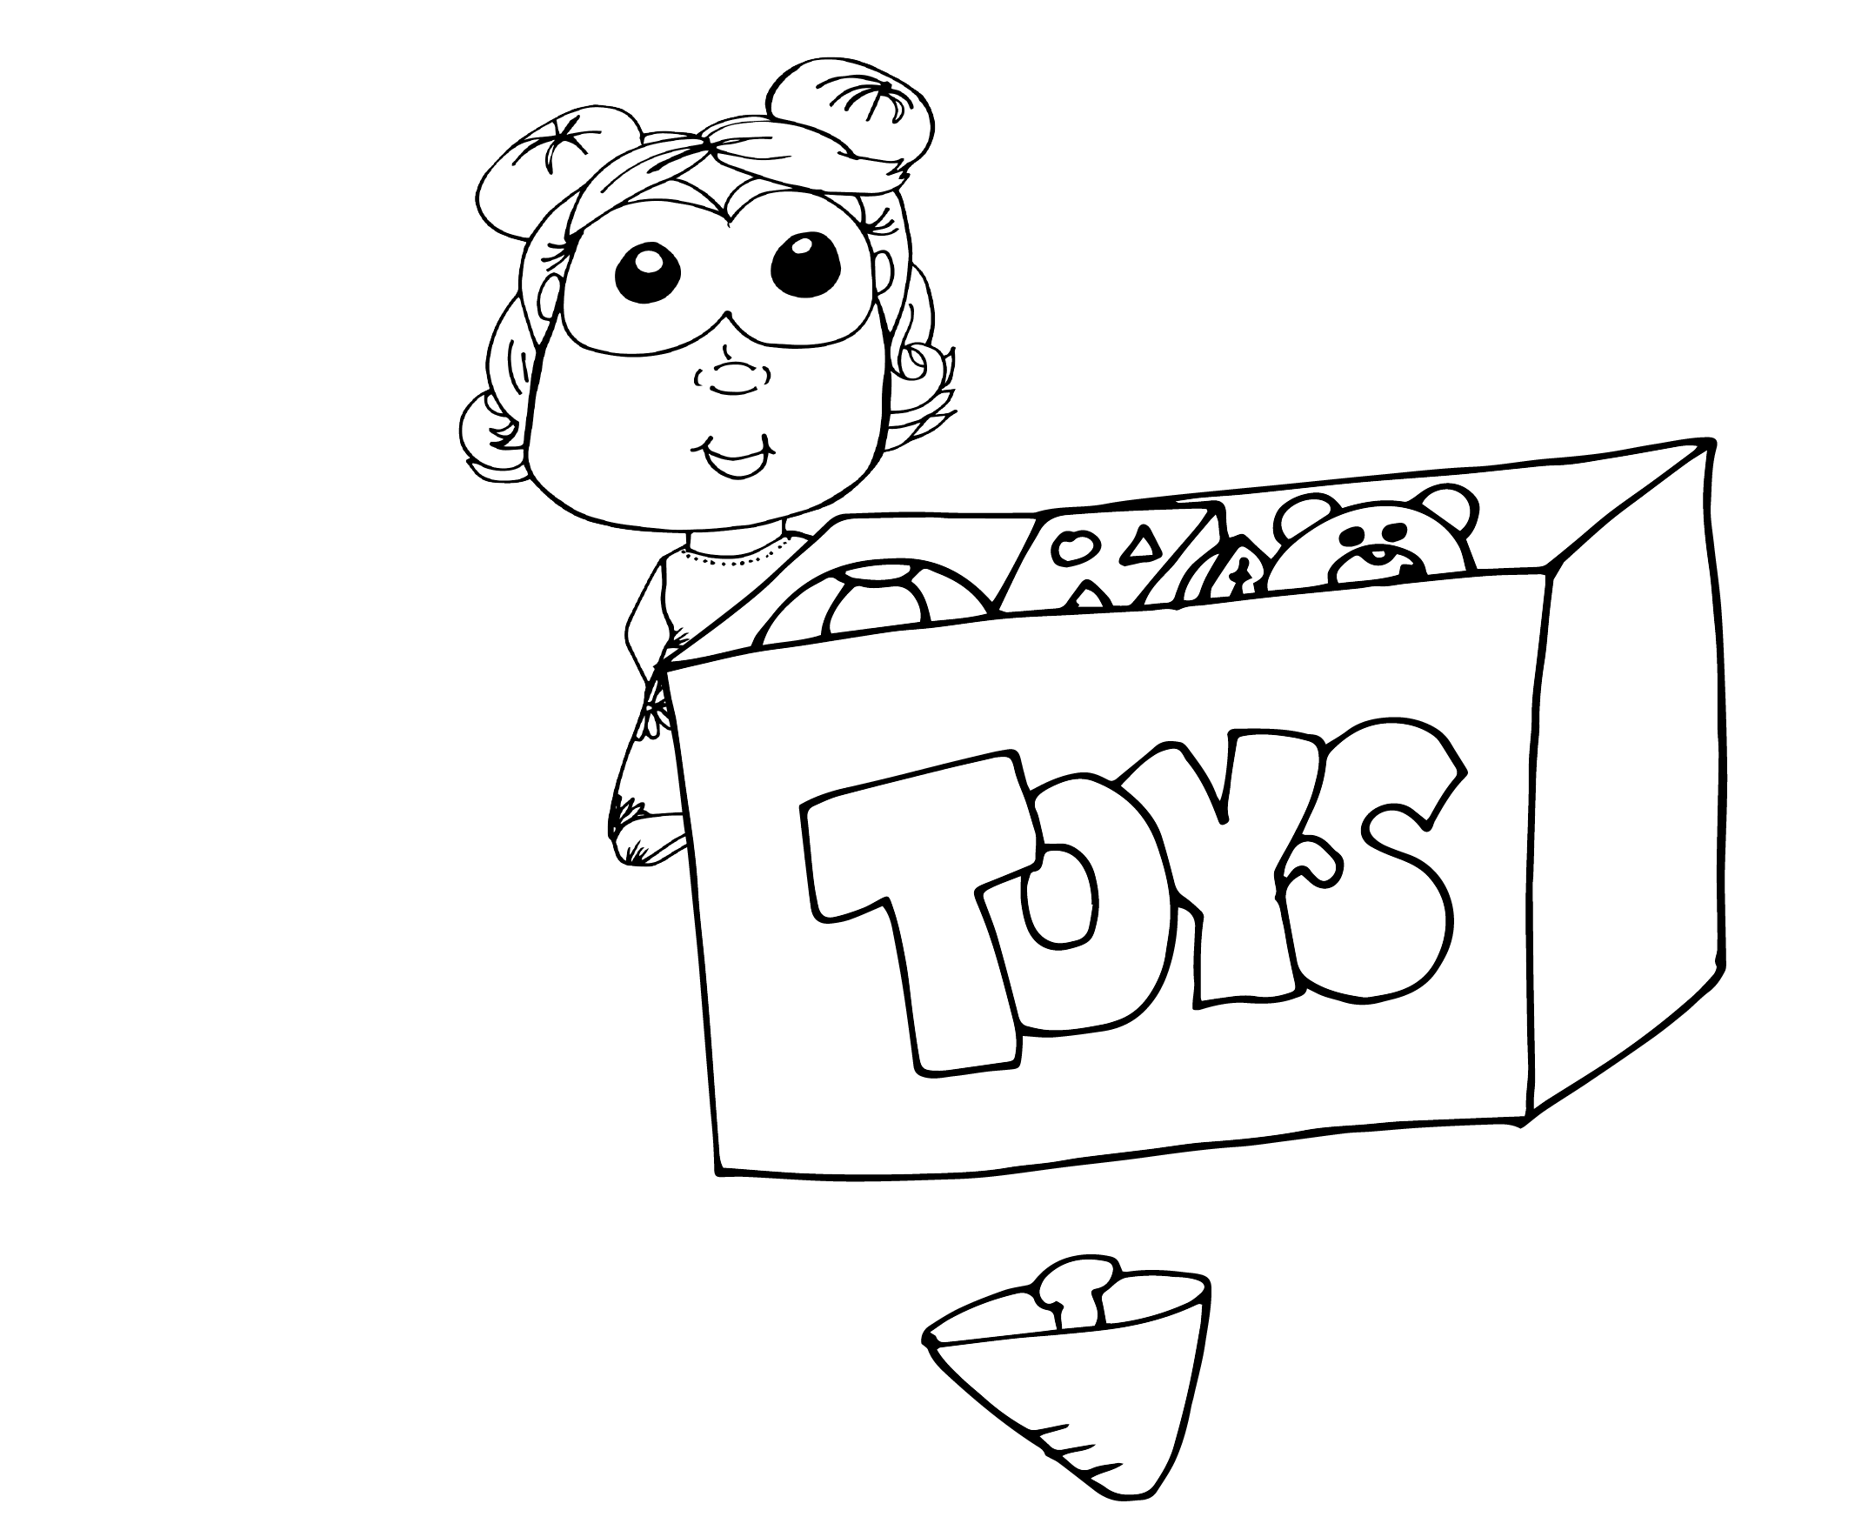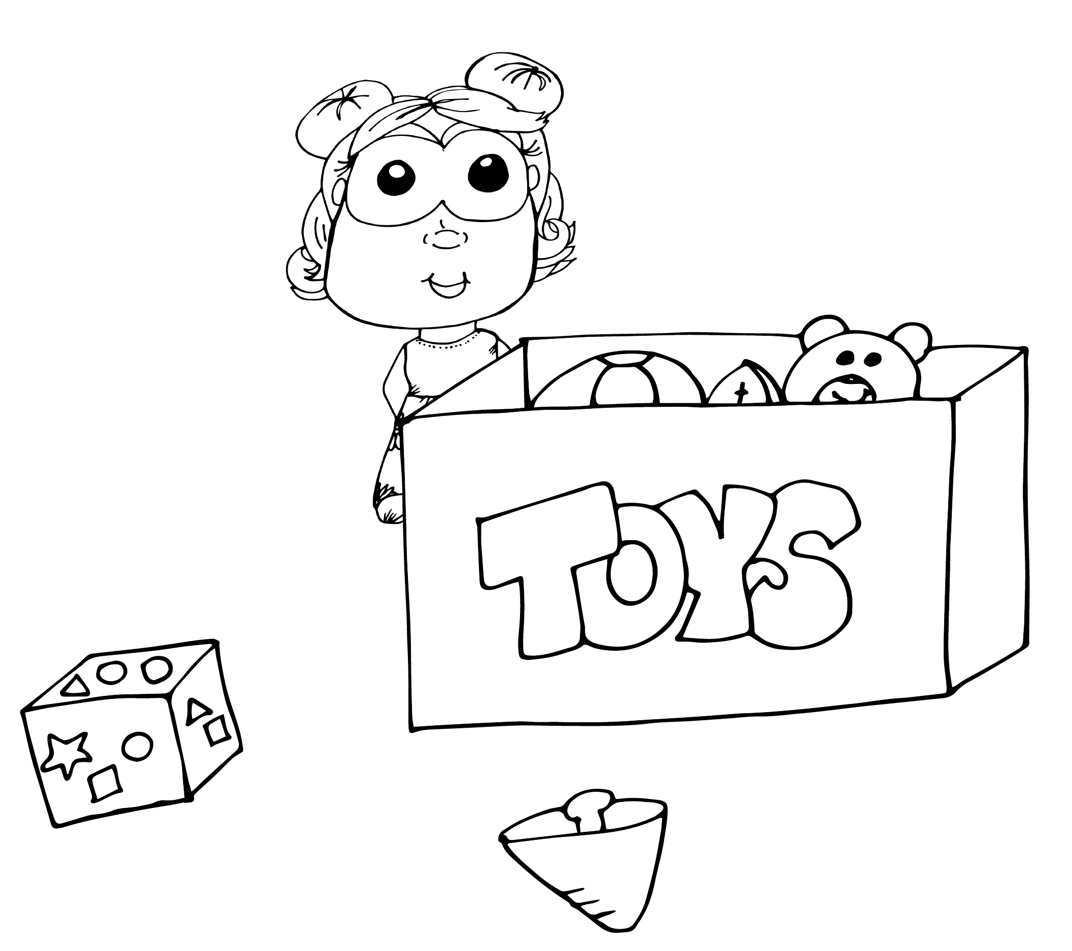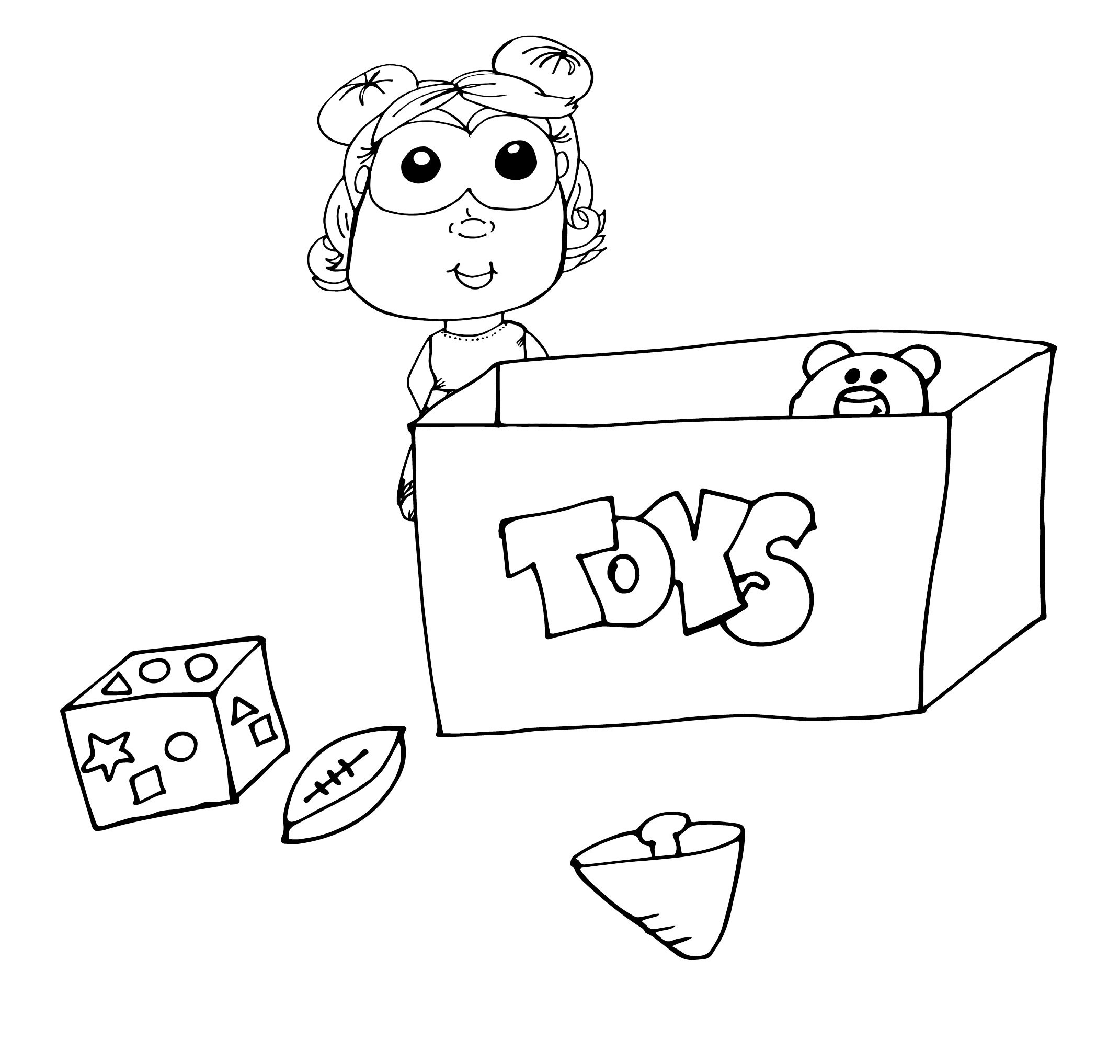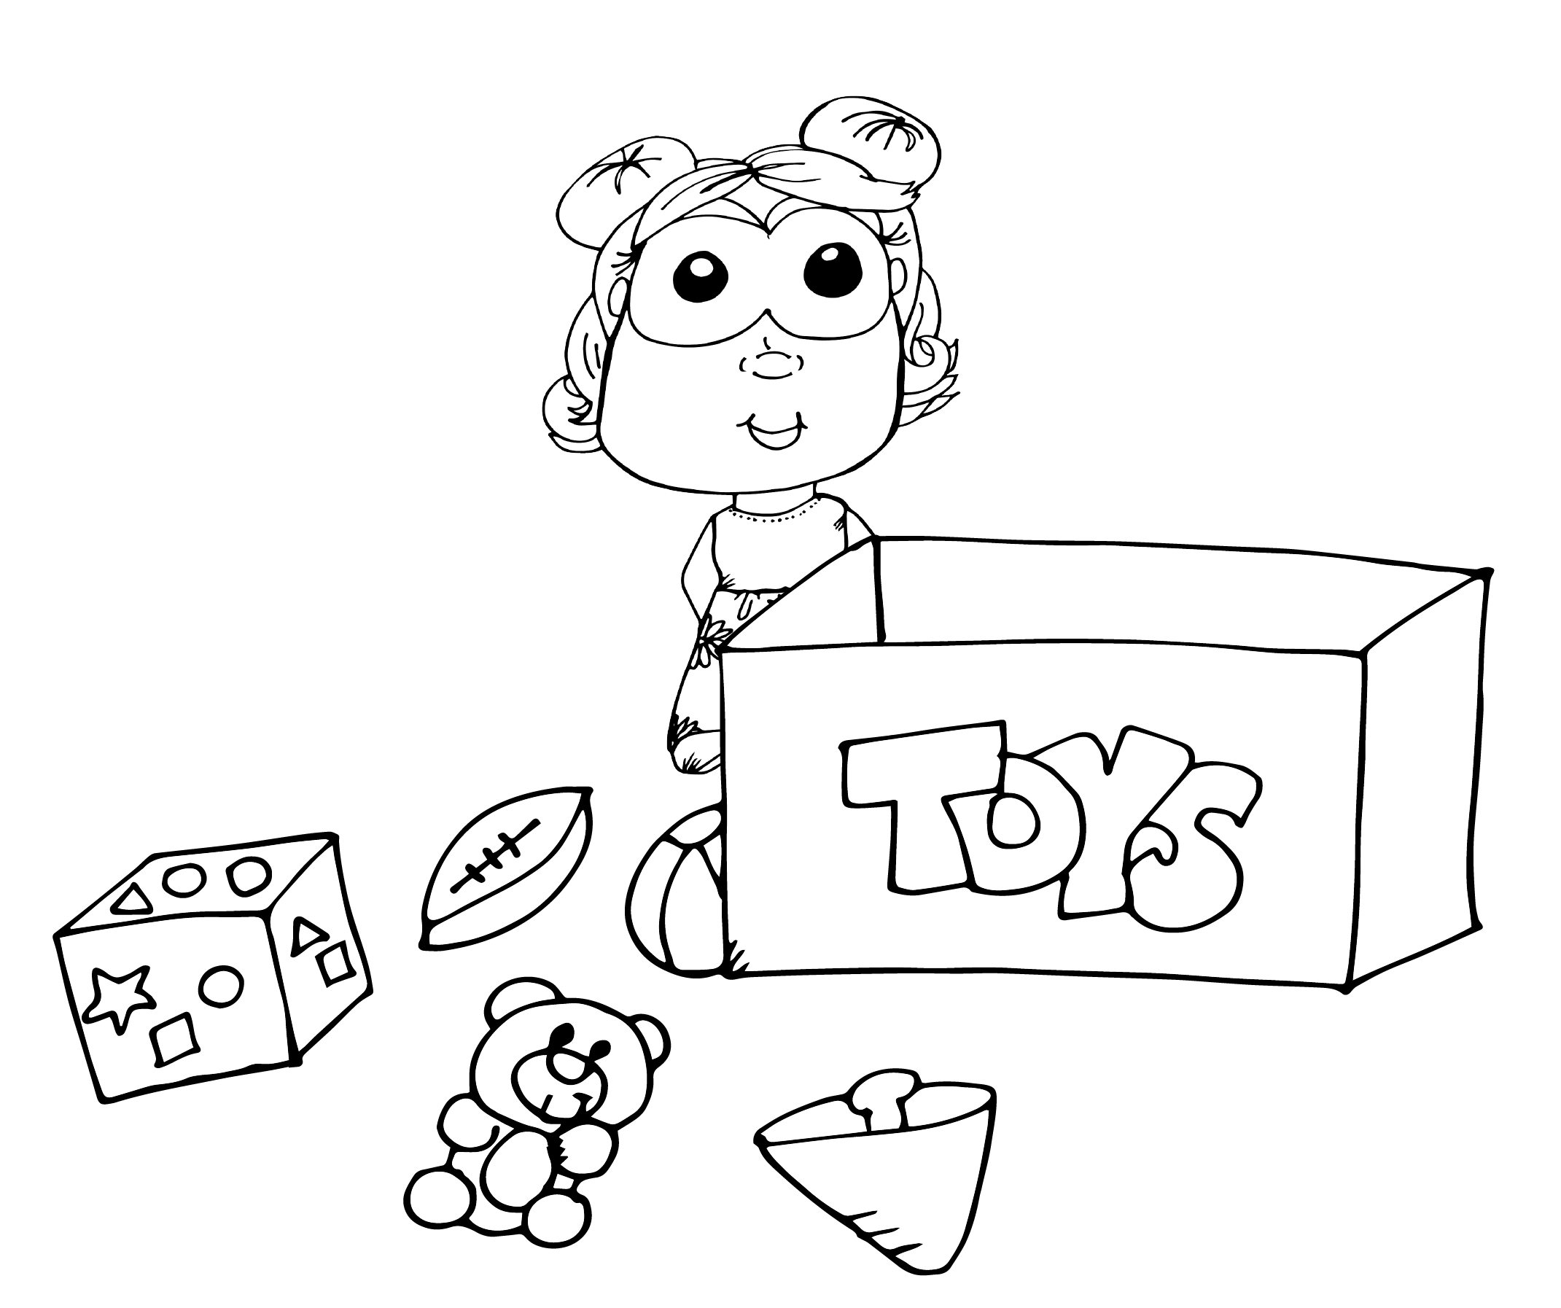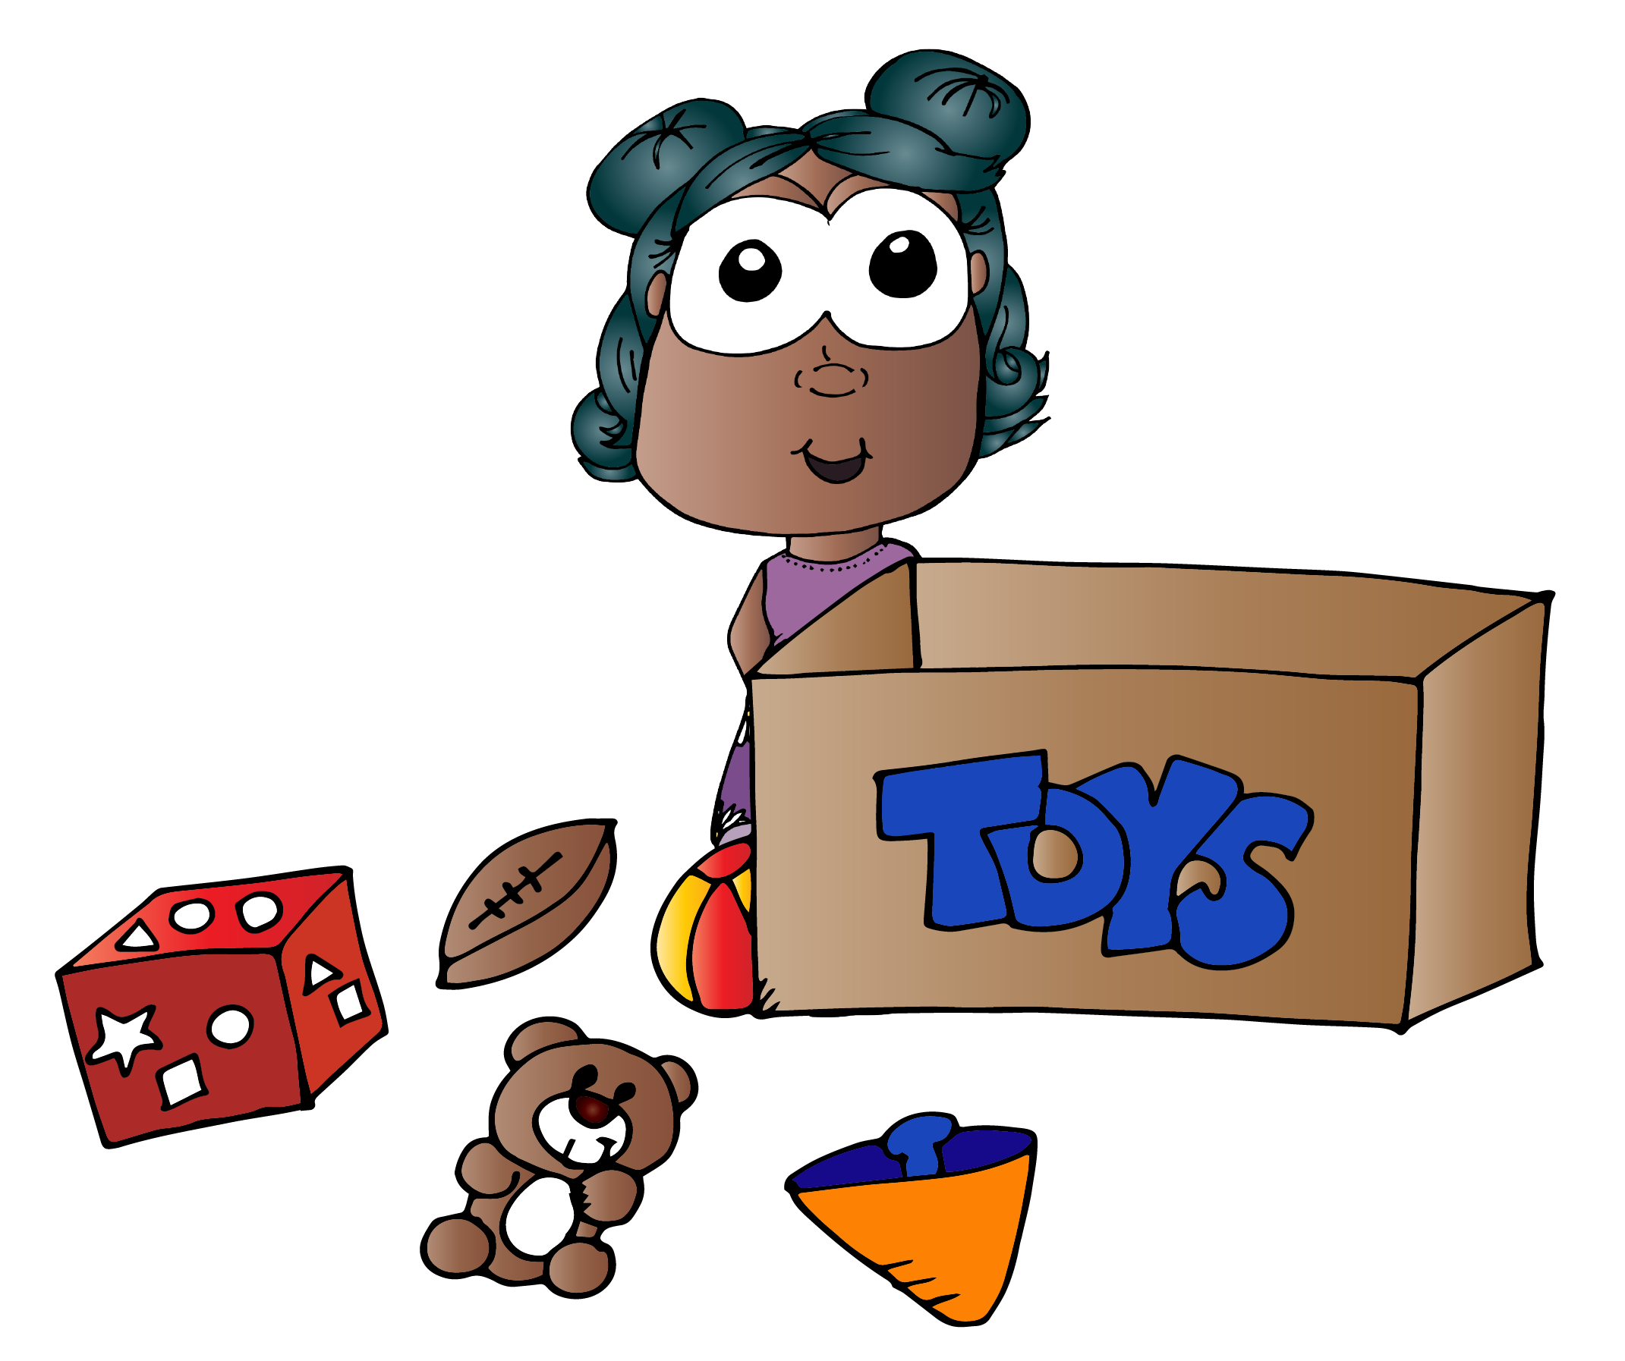

1. First, Jane sees her toys are a mess.
2. So, she puts her beach ball and bear in the toy box.
3. Next, she puts her football in the toy box.
4. Then, she puts her cube in the toy box.
5. Finally, Jane puts her top in and she has a clean room.

|  |  |  |  |  |
| --- | --- | --- | --- | --- |
|  |  |  |  |  |