

**Kate makes a sandwich.**

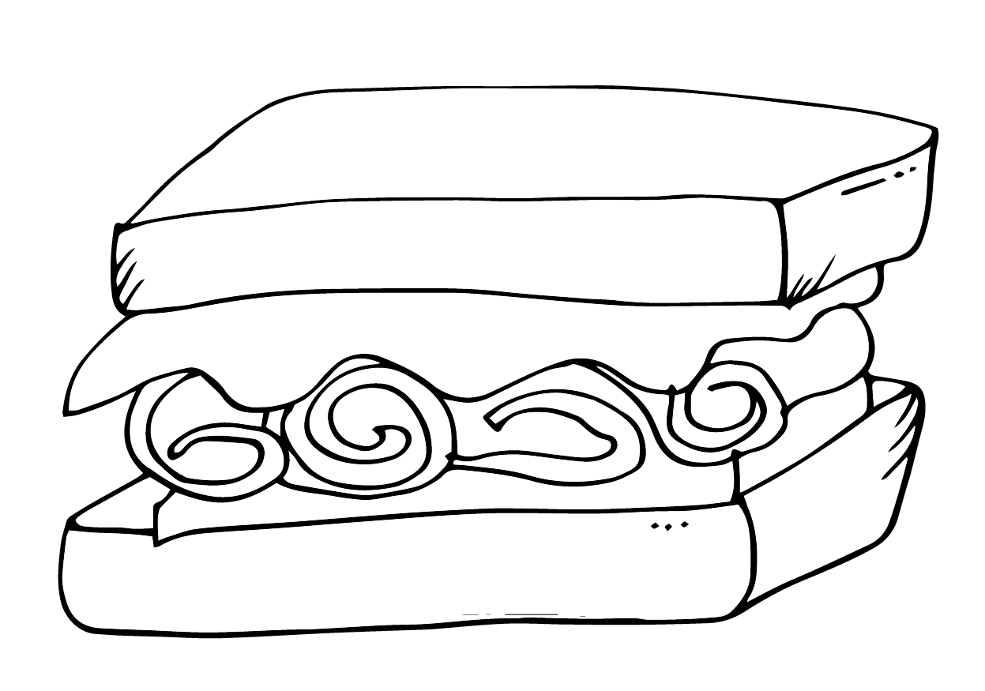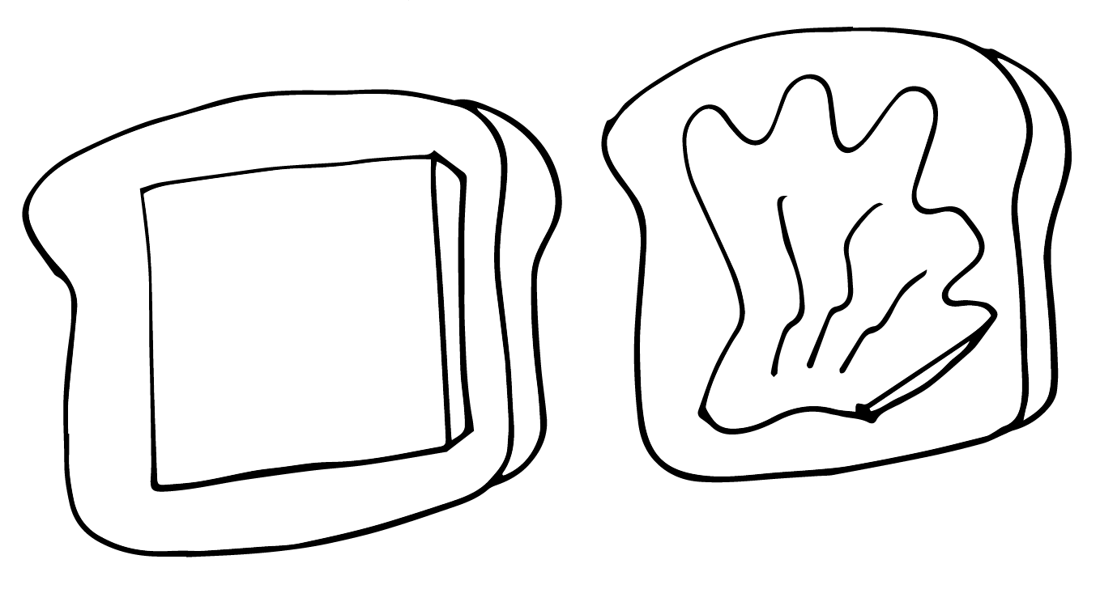

1. First, Kate gets two slices of bread.
2. Next, she adds lettuce and cheese.
3. Then, she adds the meat.
4. Finally, she puts her sandwich together.

|  |  |  |  |
| --- | --- | --- | --- |
|  |  |  |  |