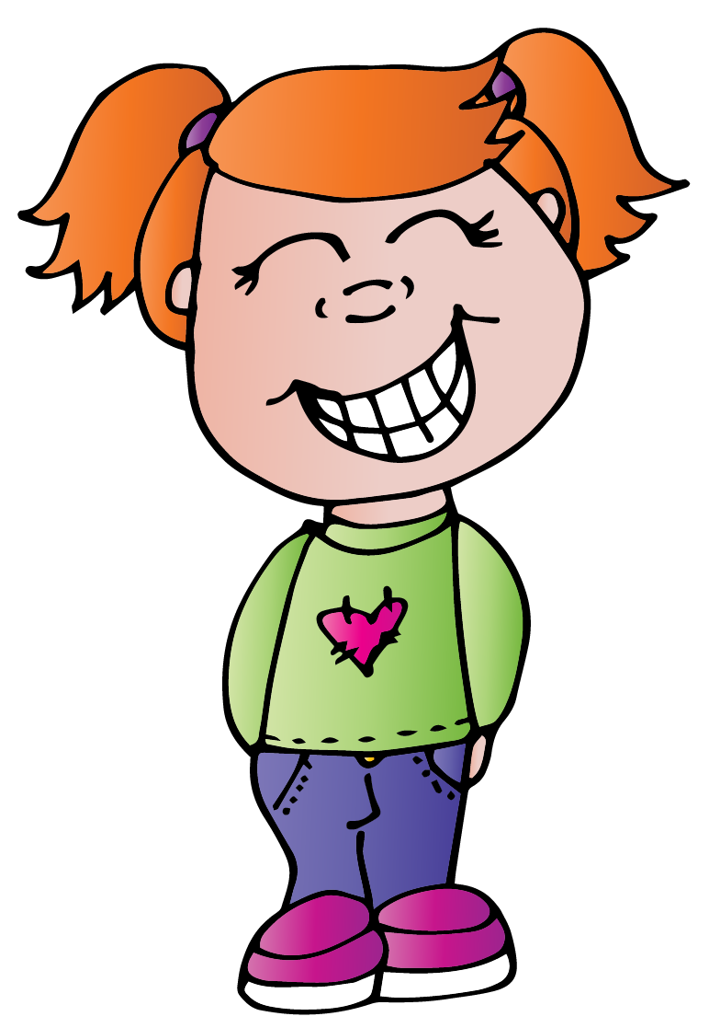

**Liz brushes her teeth.**

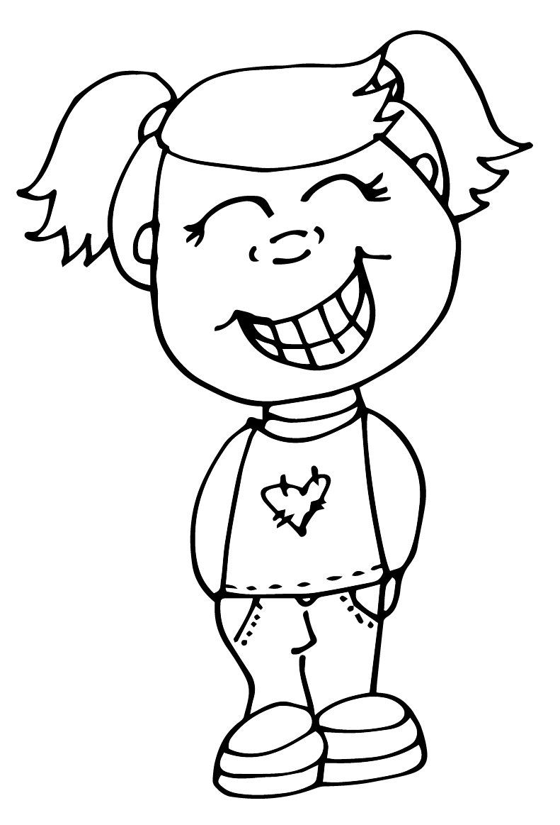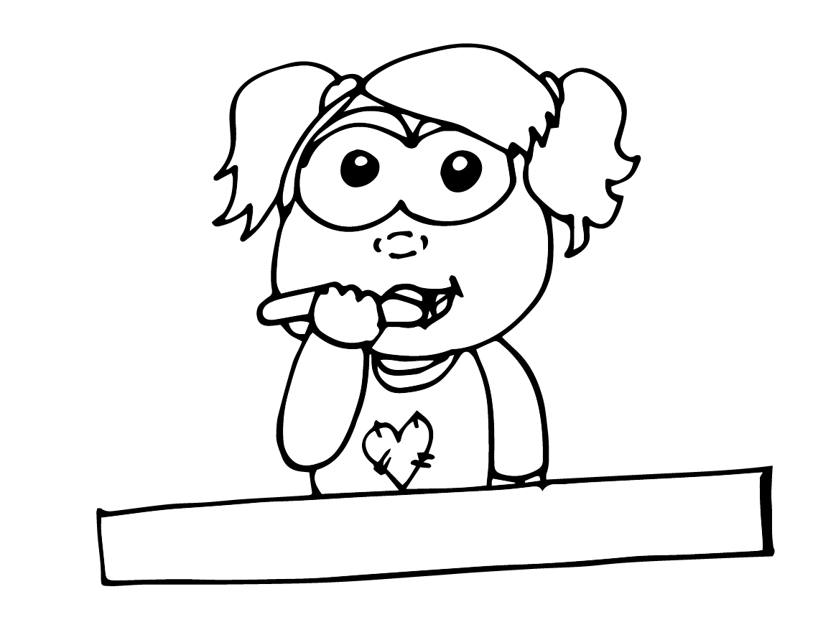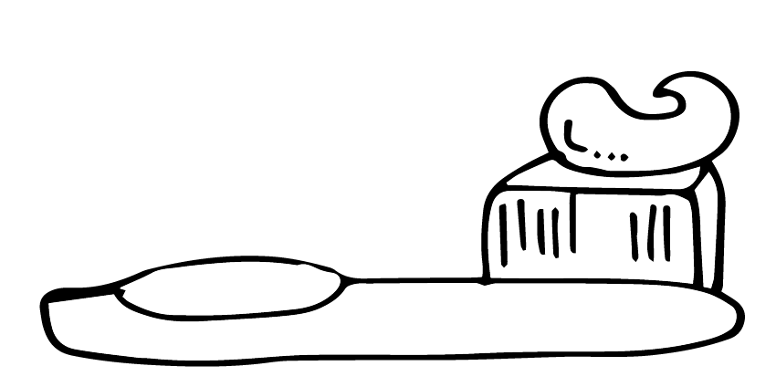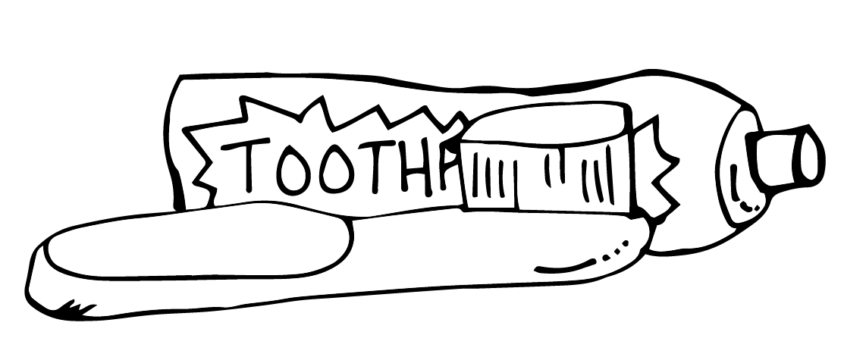

|  |  |  |  |
| --- | --- | --- | --- |
|  |  |  |  |

1. First, Liz gets out the toothpaste.
2. Next, she puts toothpaste on her toothbrush.
3. Then, she brushes her teeth.
4. Finally, her teeth are shiny and clean.