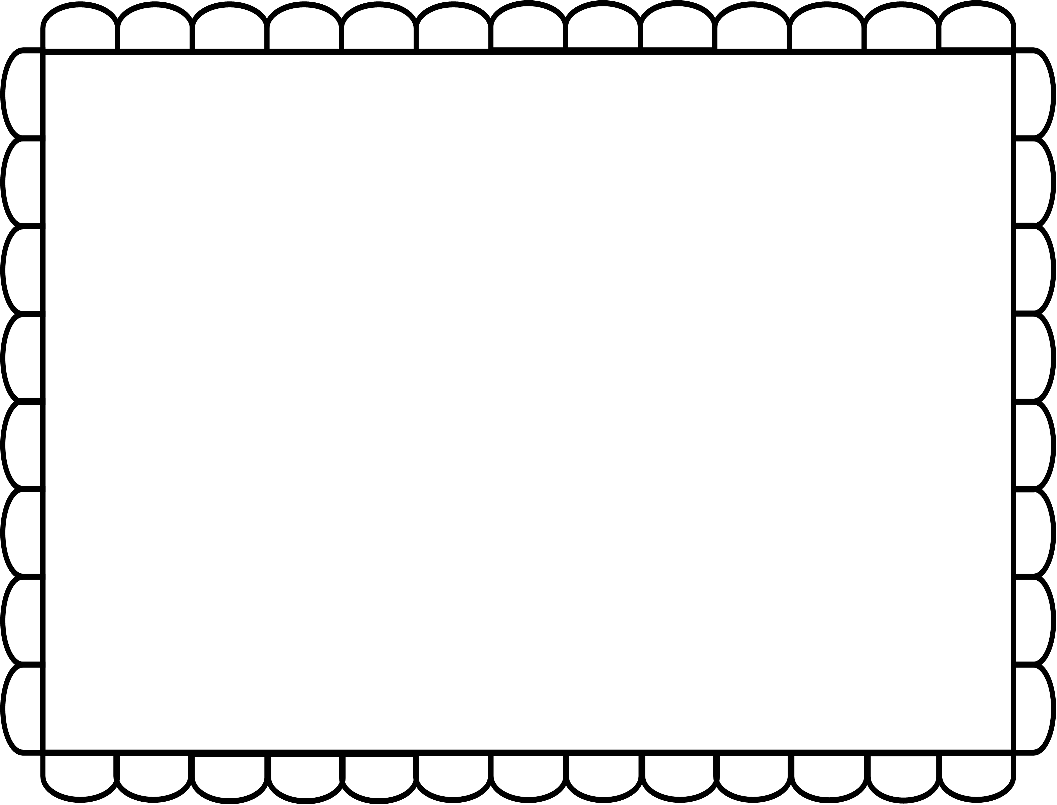

**Lynn bakes a cake.**

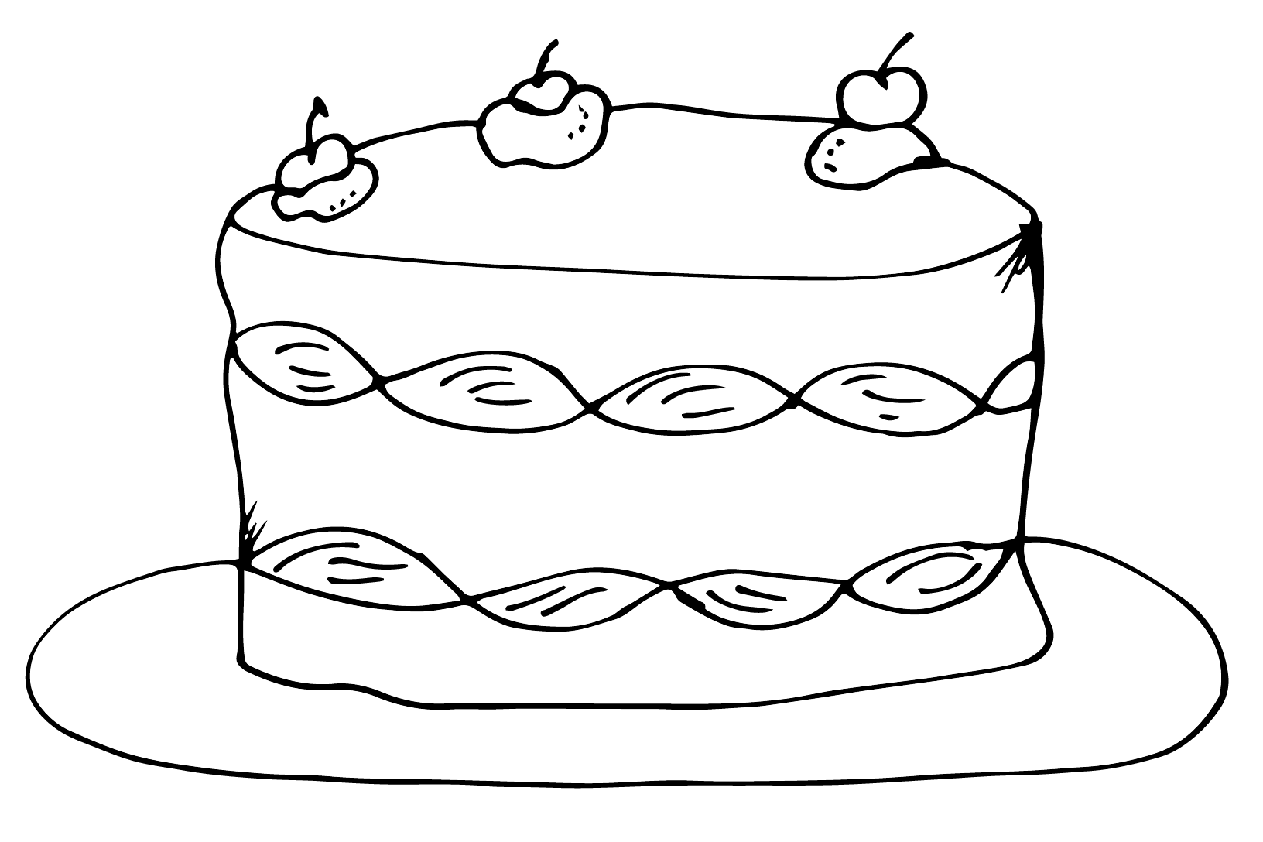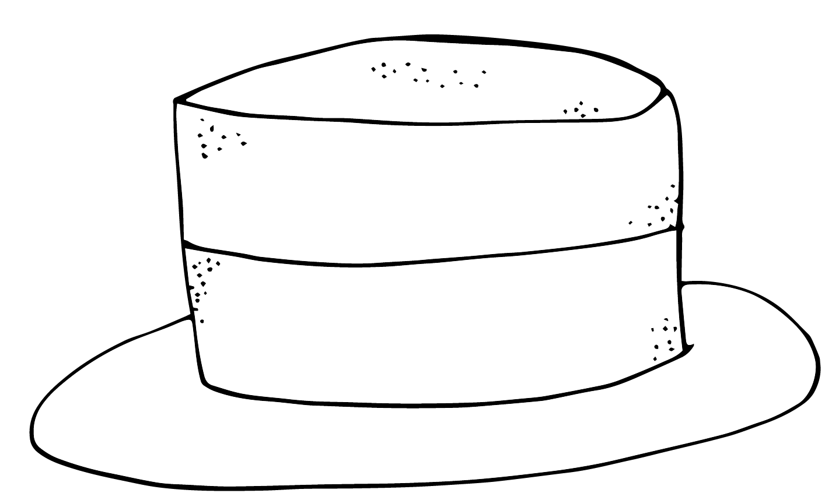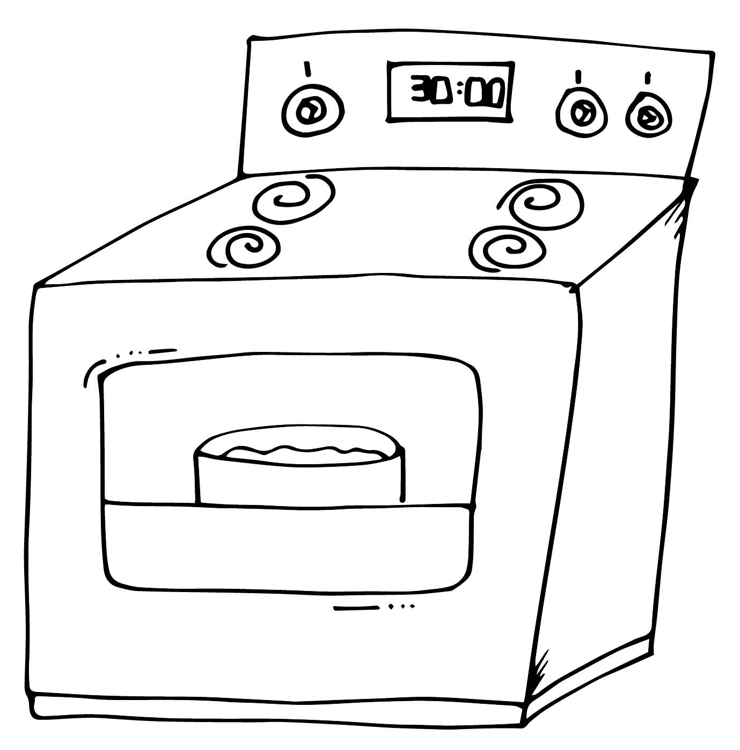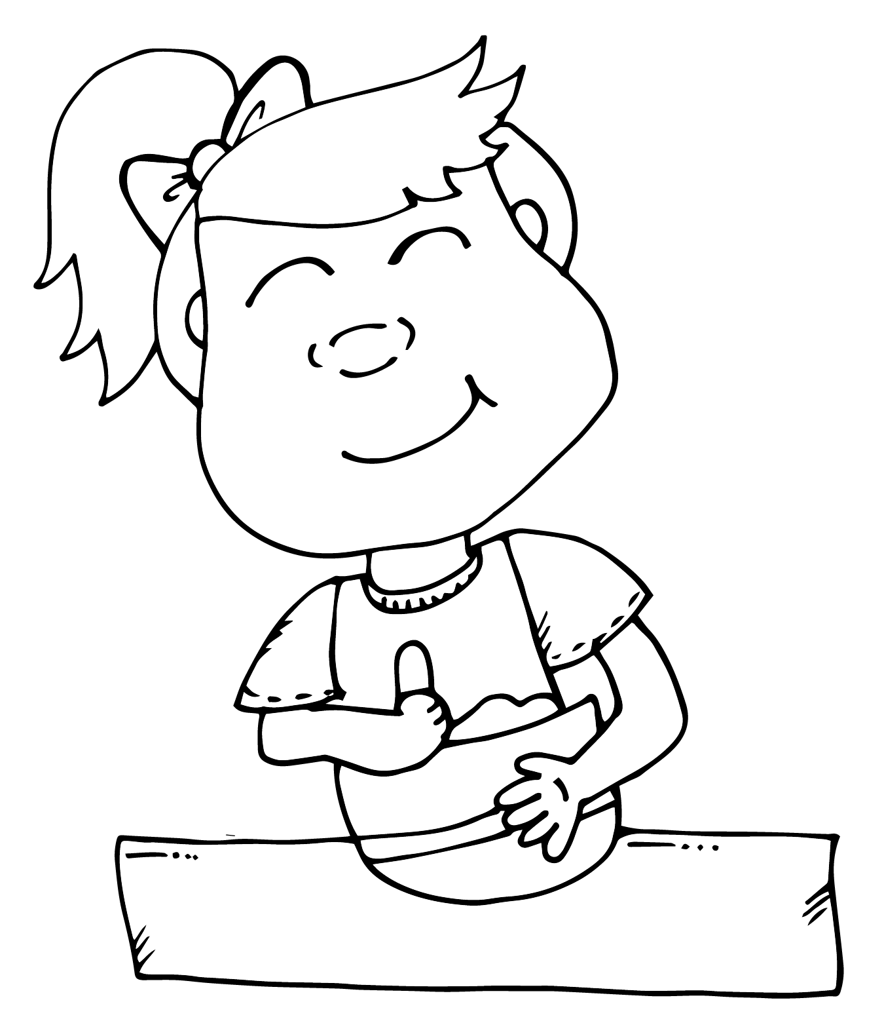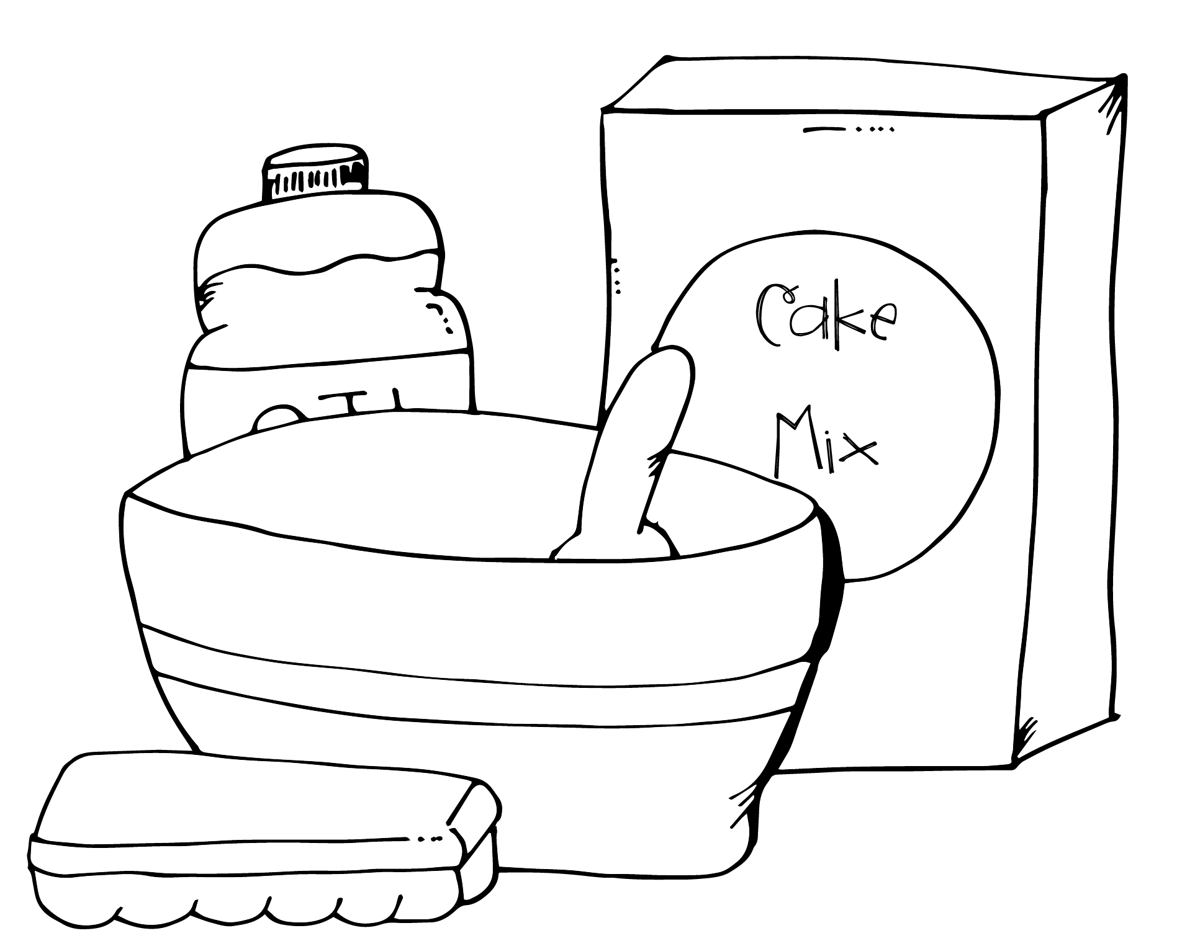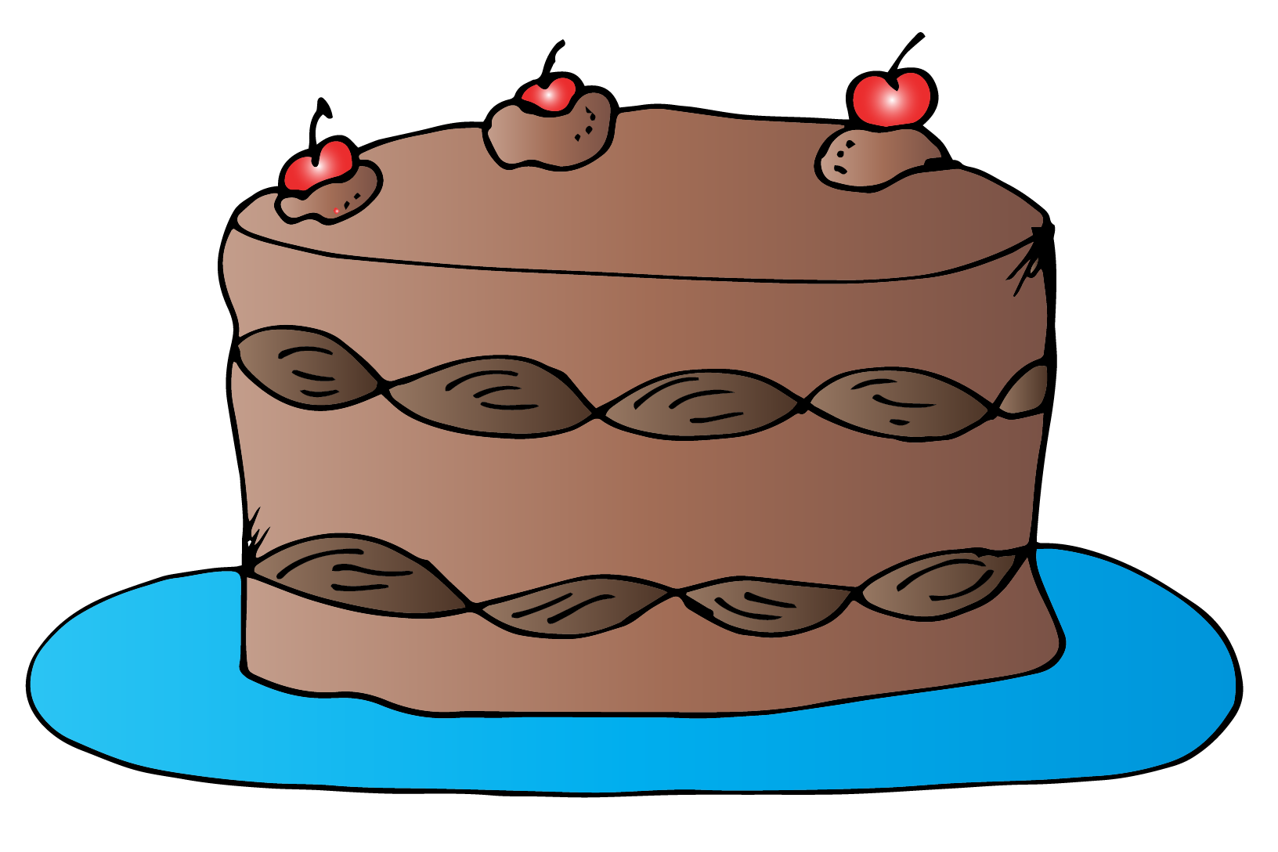

|  |  |  |  |  |
| --- | --- | --- | --- | --- |
|  |  |  |  |  |

1. First, Lynn finds her supplies.
2. Next, she stirs everything together.
3. Then, she bakes the cake.
4. Now, she puts icing on the cake.
5. Finally, Lynn adds cherries to the top of the cake.