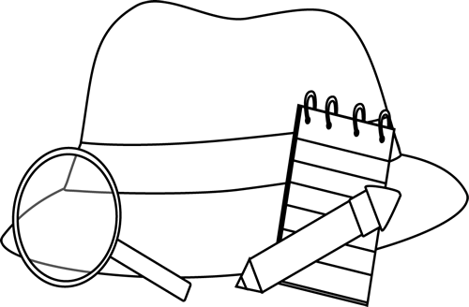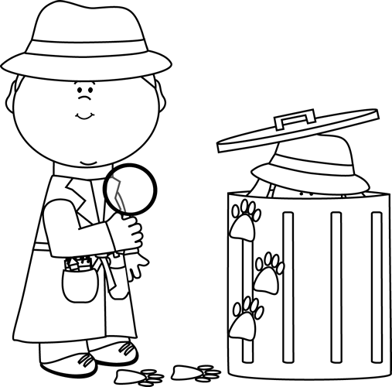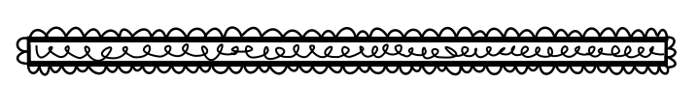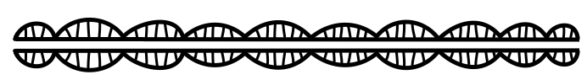

**Were there any red herrings? Explain.**

**Explain how the mystery is solved.**

Mystery Stories

**Describe the puzzling event.**

**List some of the clues.**

**Who is the detective?**

**Who are the main suspects?**

**Book Title:**

**Name:___________________________**

**My Little Activity Book About**