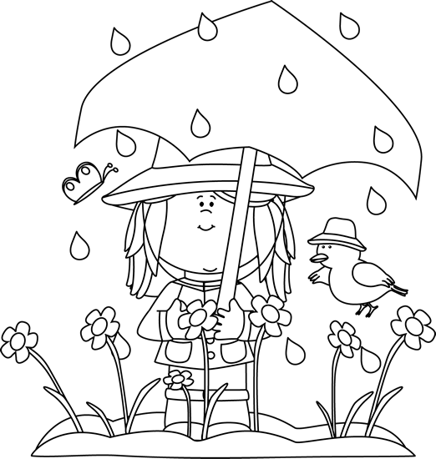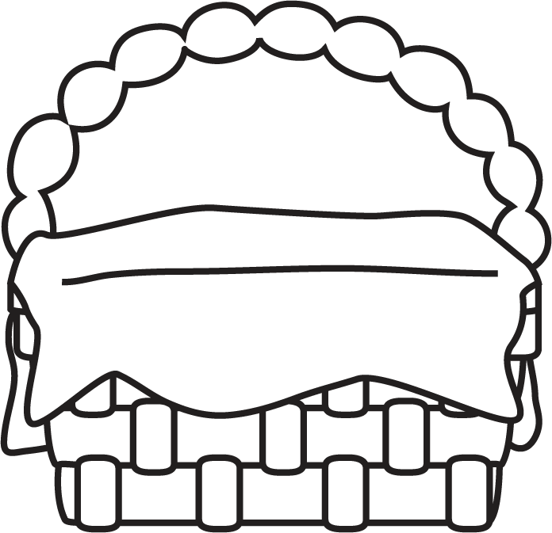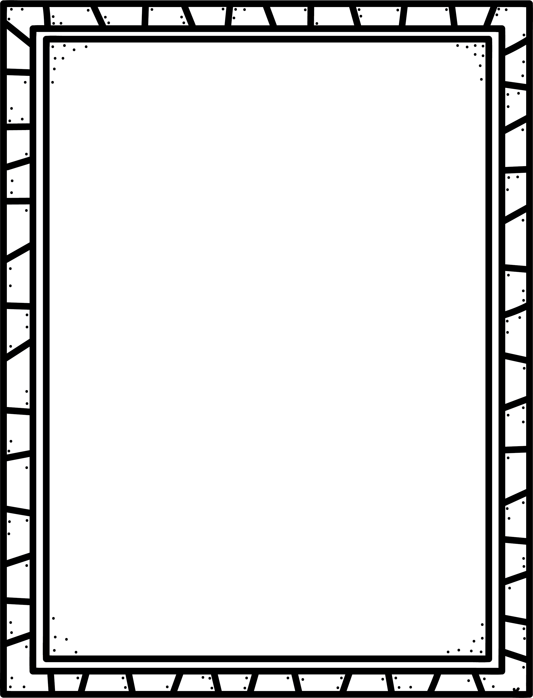

**Some poems or poetry books I know are:**

Poetry

**Characteristics of Poetry**

* Words are chosen carefully to create a feeling or emotion.
* Poetry doesn’t have to rhyme, but there is usually a rhythm to the words.
* Poets use lots of describing words, comparisons and details to tell about people, places, things and experiences.
* Authors choose words for their sound and beauty as well as for their meaning .

**Author’s Purpose:**

**To entertain**

**Keep track of the poems and poetry books you read here!**

**Name:___________________________**

**Good Readers Know About Genres**