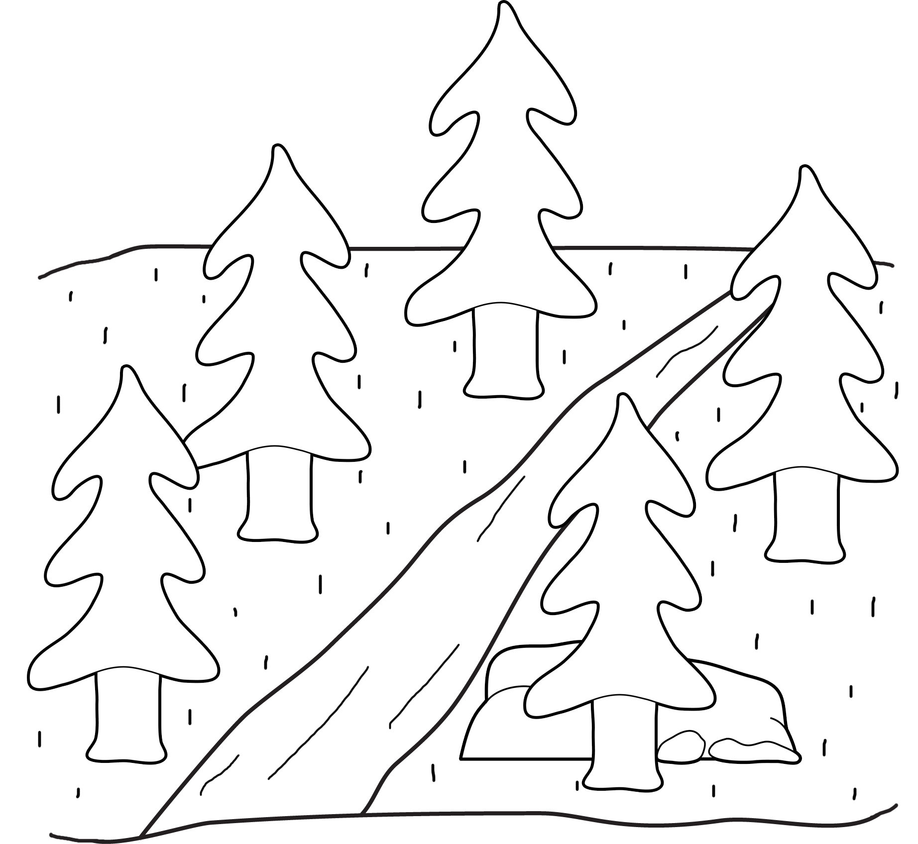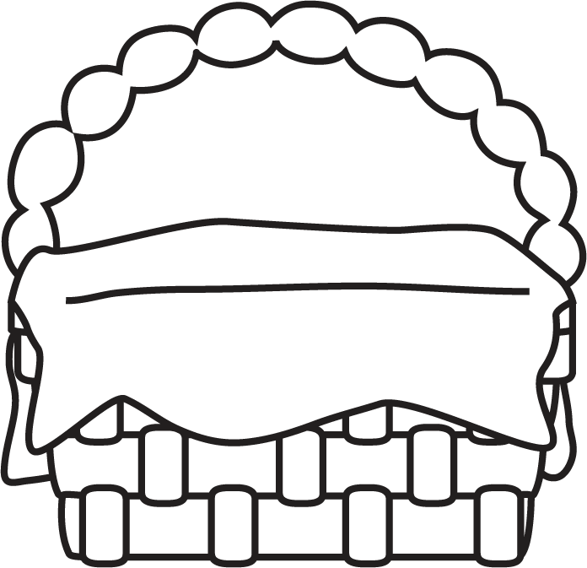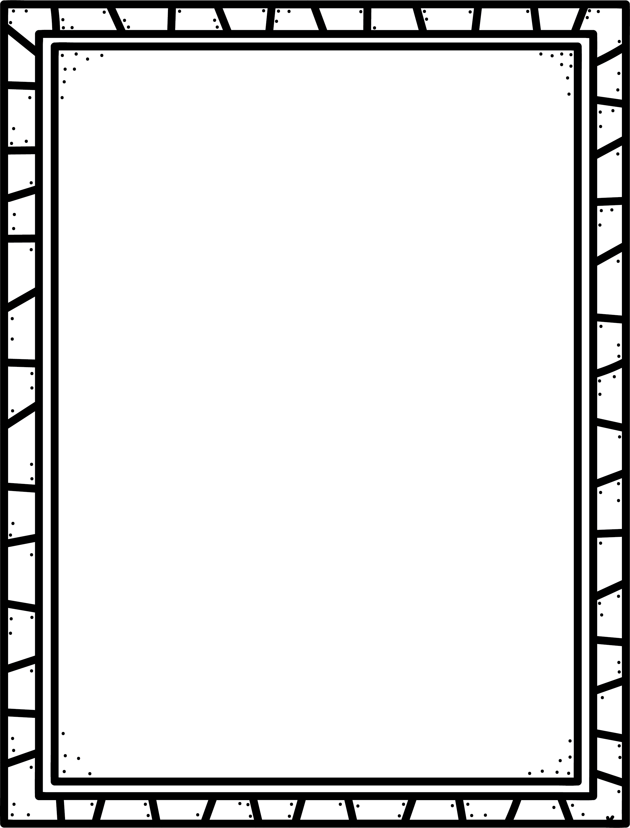

**Some realistic fiction stories I know are:**

**Characteristics of Realistic Fiction**

* Settings, characters and events are realistic and believable.
* A story that could happen in real life.
* Examples are family stories, school stories, and friendship stories.
* Details help you really visualise the place and characters.
* Story events happen around the present time.

**Author’s Purpose:**

**To entertain**

**Keep track of the realistic fiction stories you read here!**

**Name:___________________________**

Realistic Fiction

**Good Readers Know About Genres**