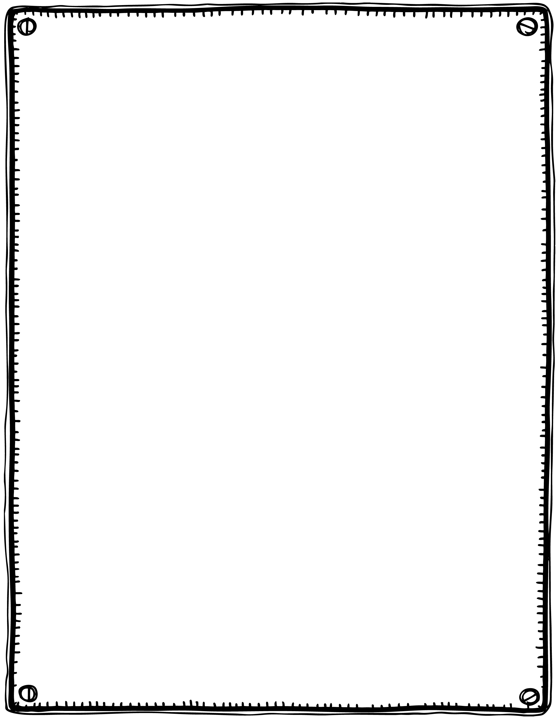

Hey, diddle, diddle,

The cat and the fiddle,

The cow jumped over the moon,

The little dog laughed

To see such fun

And the dish ran away with the spoon.

**Hey, Diddle, Diddle**