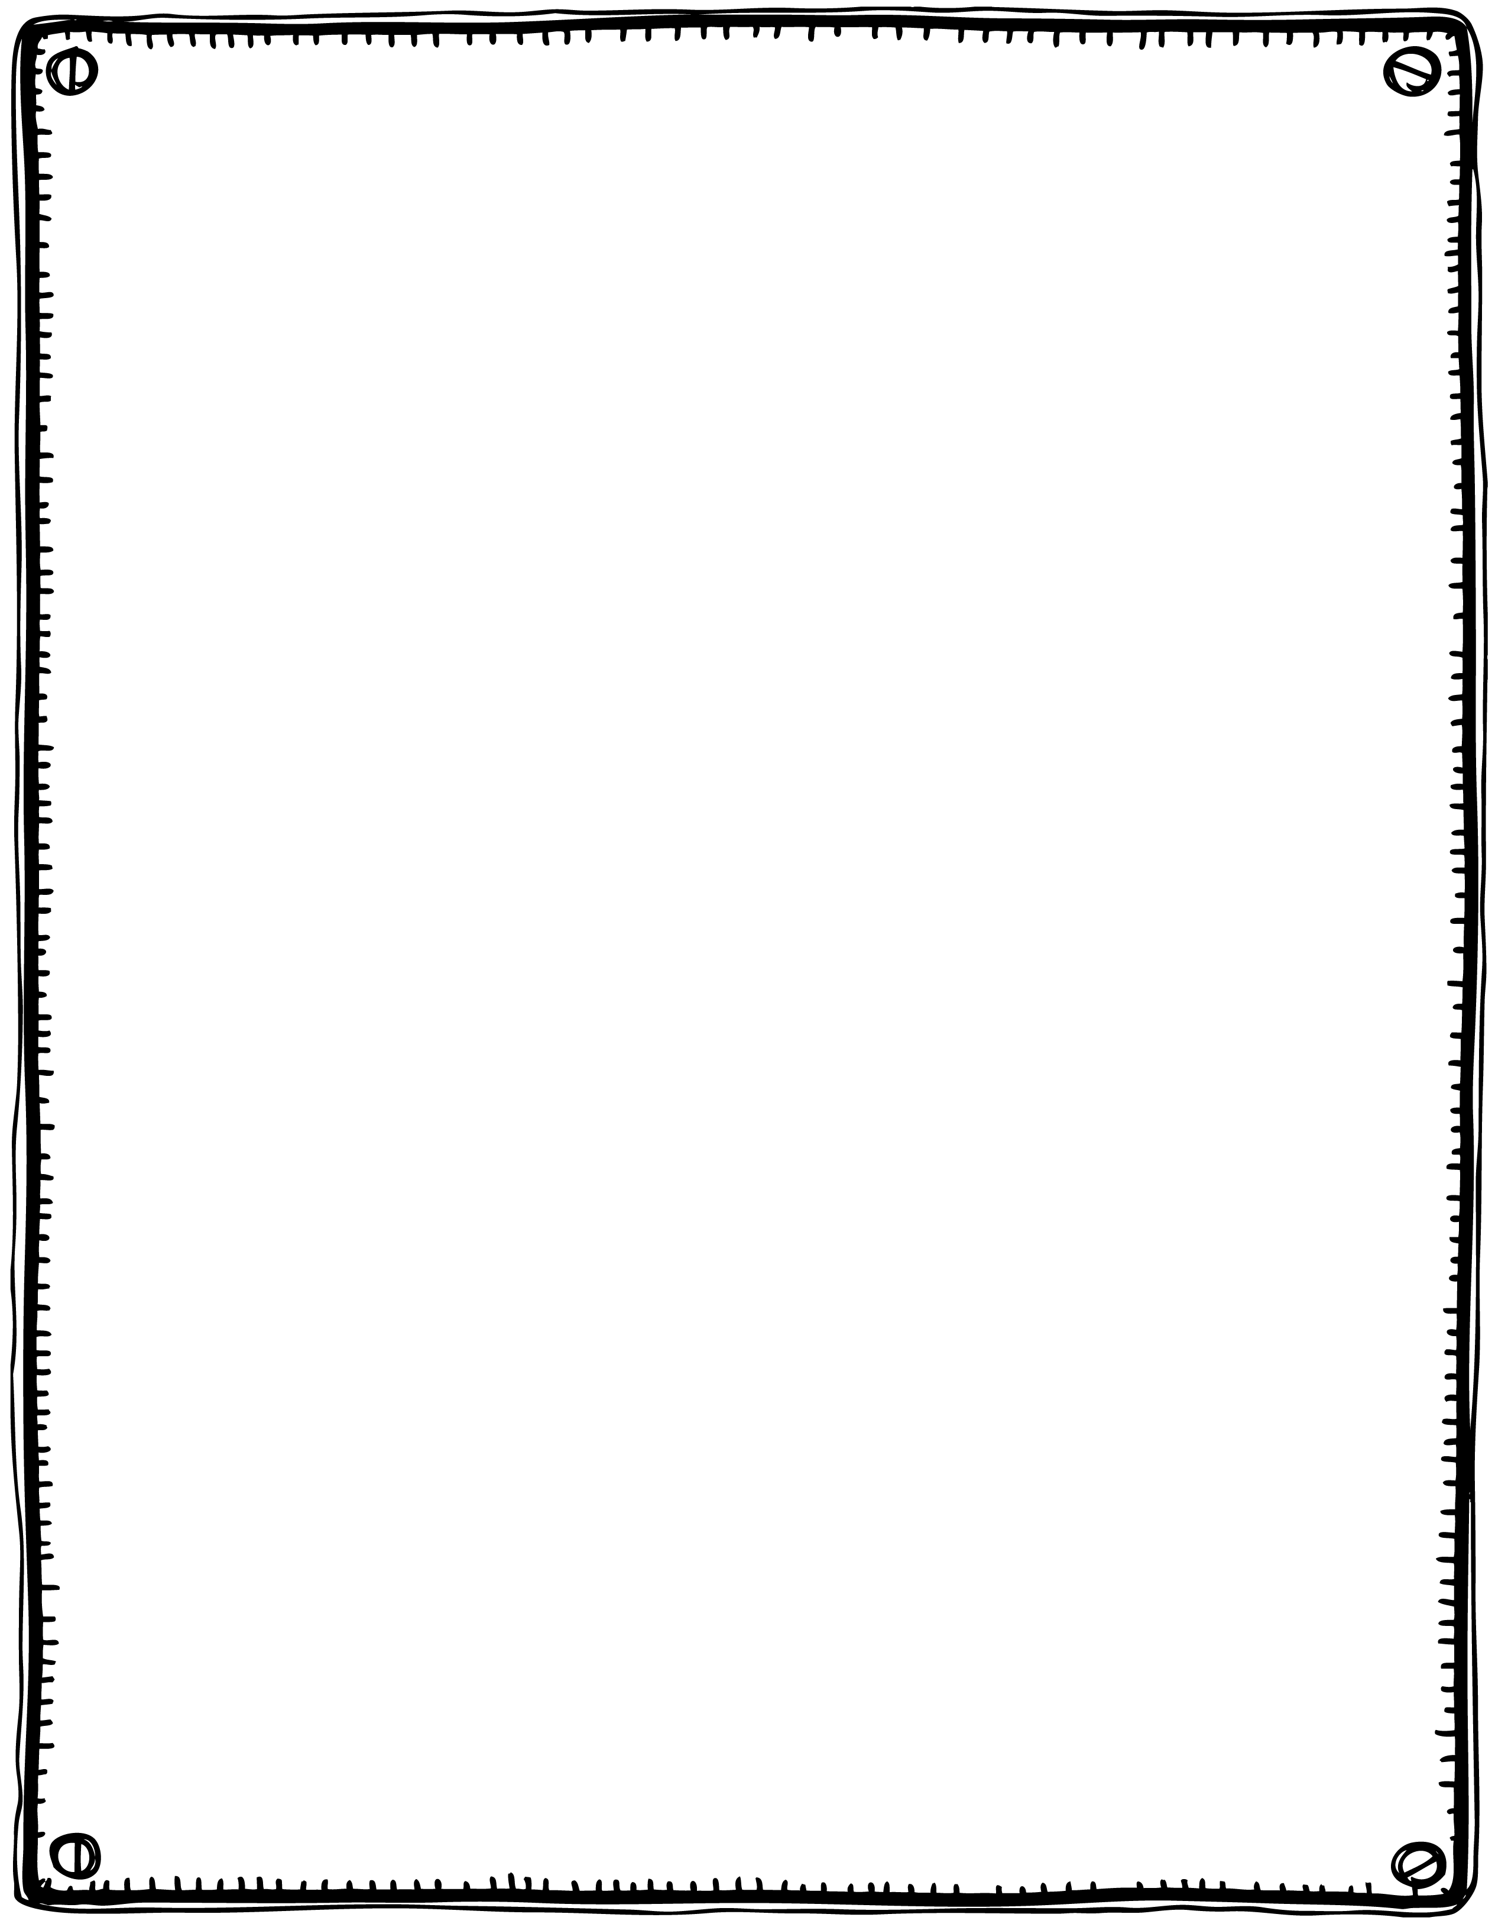

Humpty Dumpty sat on a wall,

Humpty Dumpty had a great fall,

All the king’s horses and all the king’s men Couldn’t put Humpty together again.

**Humpty Dumpty**