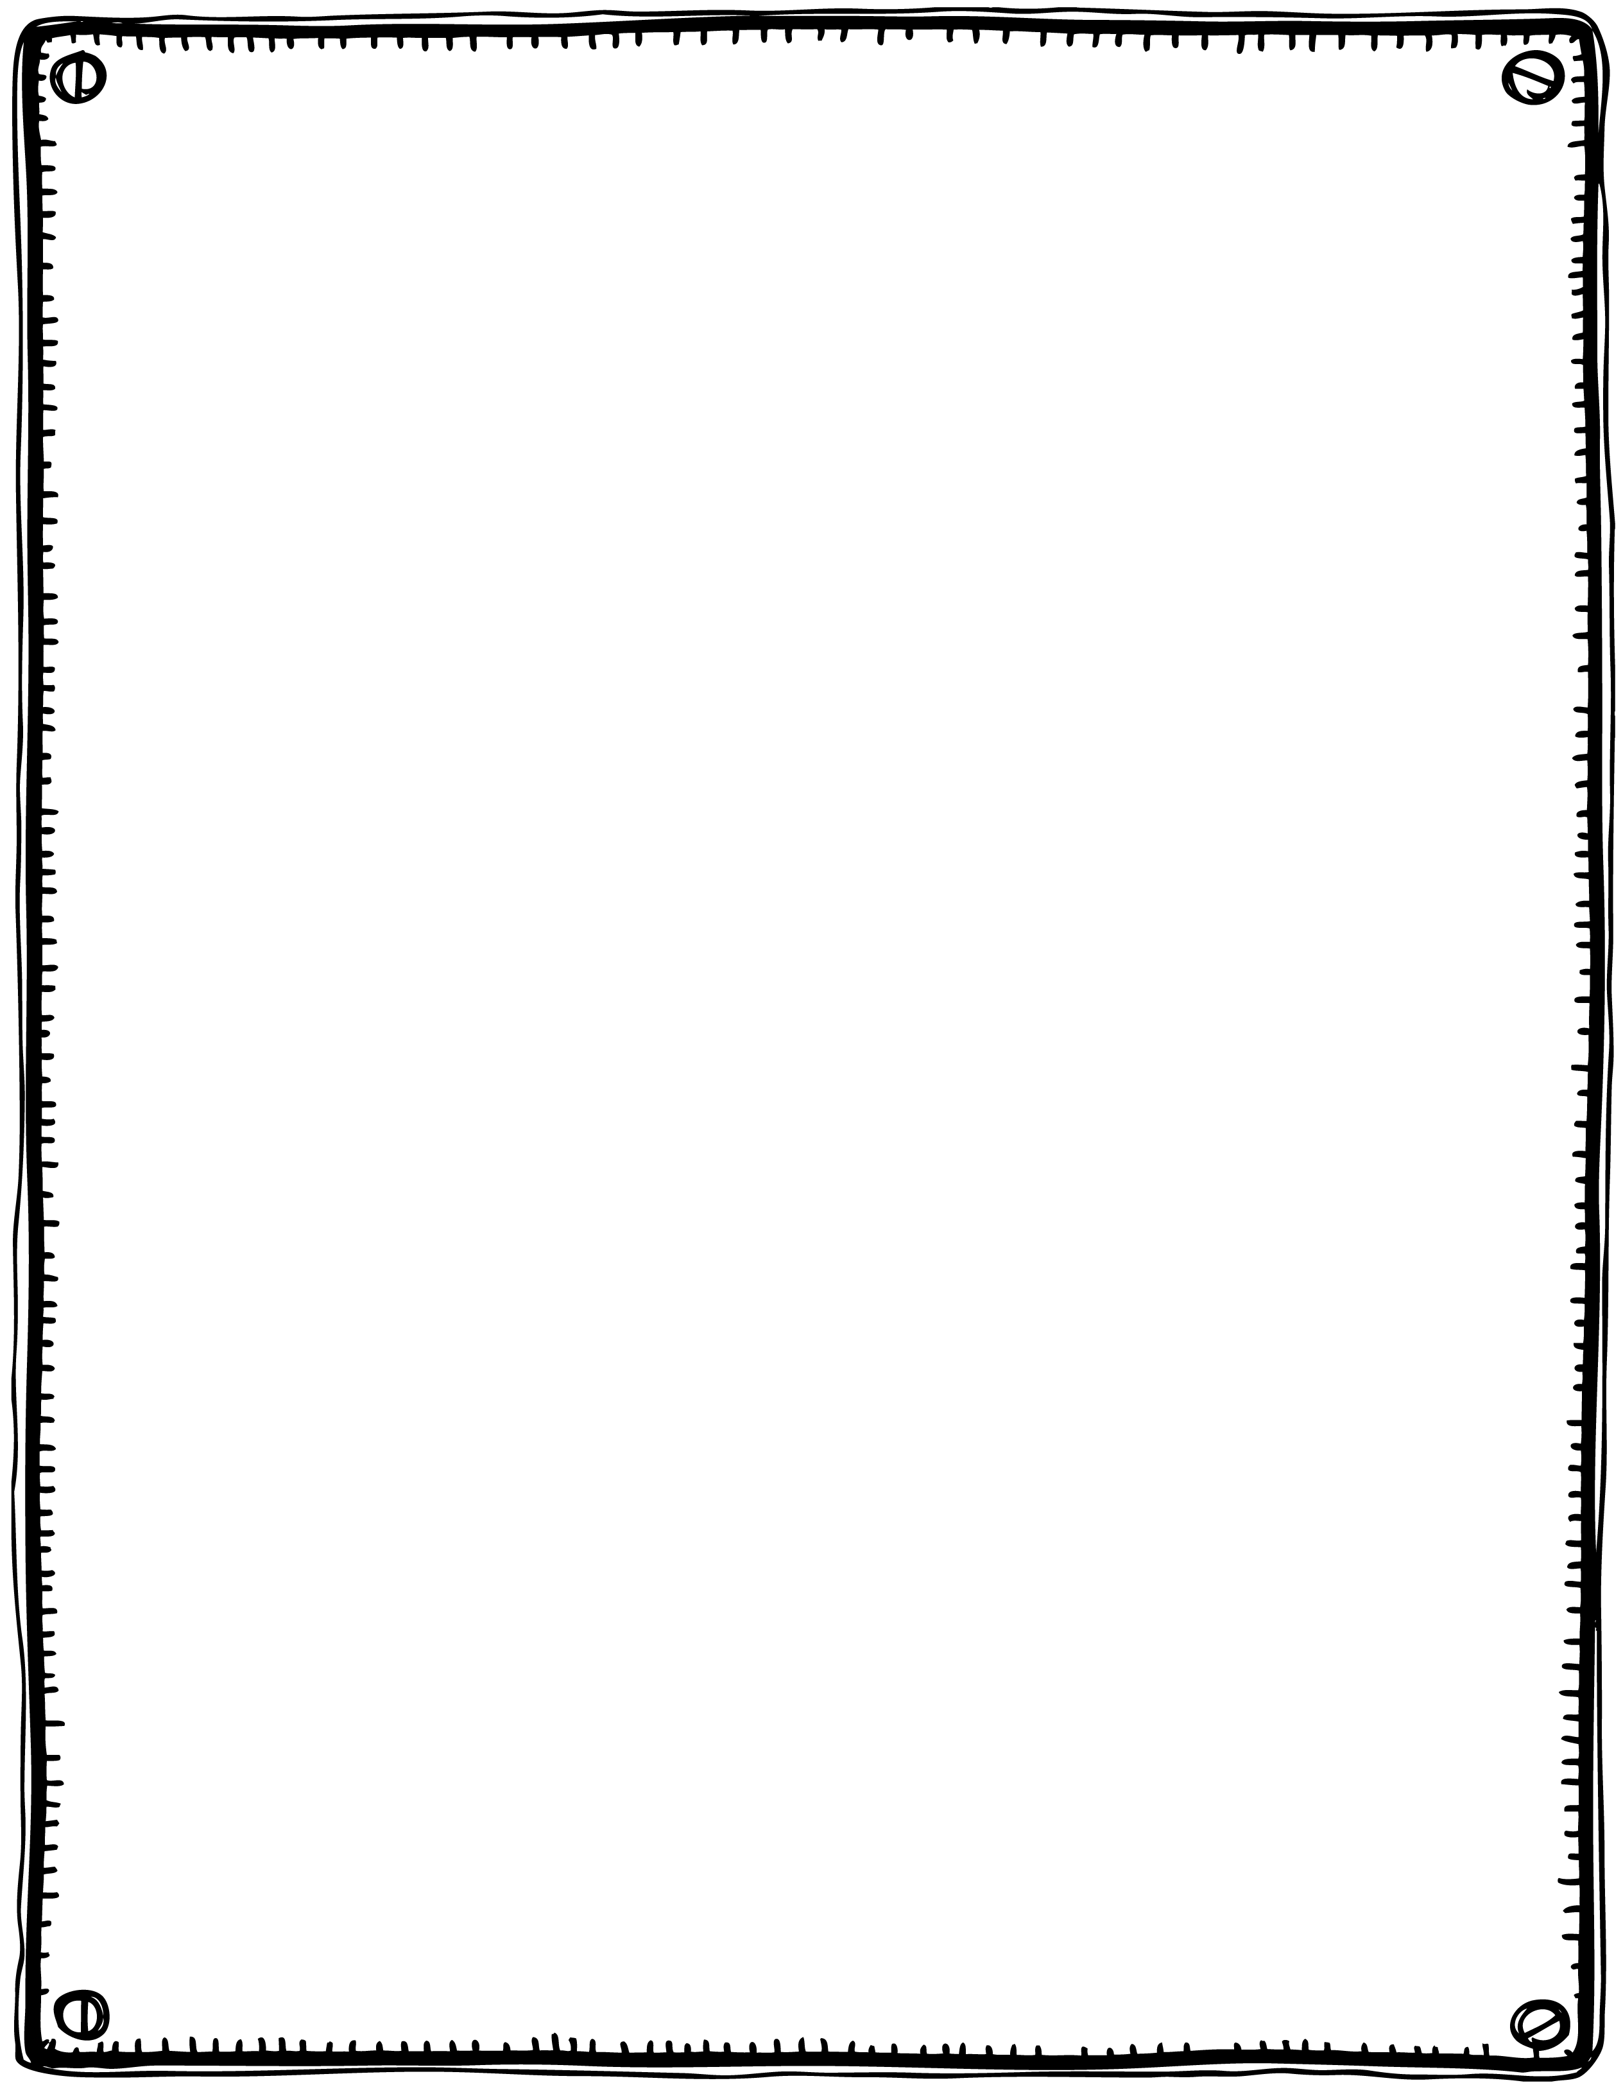

Jack and Jill

Went up the hill

To fetch a pail of water,

Jack fell down

And broke his crown,

And Jill came tumbling after.

**Jack and Jill**

Second and third verses.

Up Jack got and home did trot

as fast as he could caper;

And went to bed

And plastered his head

With vinegar and brown paper

When Jill came in

How she did grin

To see Jack’s paper plaster;

Mother vexed

Did whip her next

For causing Jack’s disaster.