d | e | s | r | u | n | g
e | o | v | e | t | m | f
n | f | c | u | n | a | a
t Workerst | e | d | t | c | y | r
i | h | o | s | o | o | m
s | c | t | s | e | r | e
t | e | a | c | h | e | r

See if you can find and colour these words!

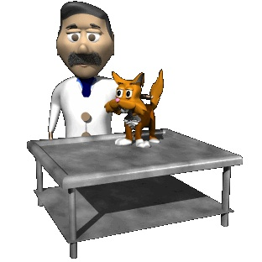
teacher farmer chef
dentist nurse mayor
vet doctor

