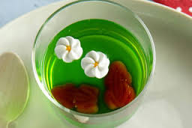
Frog in the Pond

Find the missing words in this recipe.
- The colour of the jelly is g .
- Mix the jelly crystals and water in a b .
- This recipe is called ‘Frog in the P ‘.
- The frogs are made of c .
- The green jelly must be c before you pour it into the plastic c .

Now look for the words you have found in the word maze.

S | E | T | D | K | M | N | Y | P | G
X | C | V | F | R | O | G | P | I | R
R | K | B | B | A | S | F | O | U | E
B | C | H | O | C | O | L | A | T | E
P | J | D | W | R | Y | U | M | B | N
C | O | O | L | P | R | F | A | Z | Q
U | J | E | L | L | Y | P | K | R | T
P | O | N | D | L | T | P | E | C | E
