Delete the WRONG answer.

- The school sports day will be on Monday. Yes No
- It will go for 6 hours. Yes No
- The first activity is to march around the oval. Yes No
- There are 3 team events. Yes No
- Lunch will be at 12:00. Yes No
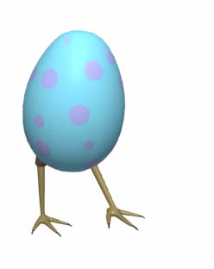

Highlight then drag ‘n’ drop these events in order from 1 to 4. Careful, not all the events are listed.

Tunnel ball
50m girls age race
sack rack
egg and spoon race

1.
2.
3.
4.

Ask your teacher to print this page.

Draw a picture for each of the numbered events.

1 | 2 | 3 | 4

