Delete the WRONG answer.

- Phil is the bus driver. Yes No
- Jenny did not hang out the bus window. Yes No
- Peter did not hang out the bus window. Yes No
- Peter liked the music on the bus. Yes No
- Bobby was stung by a bee because he was hanging out the bus window. Yes No
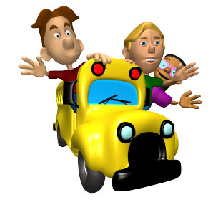

Find the red words in the story, hidden in the Find-a-Word. You will need to fill the boxes with the table shading tool. There are 11 words to find.

w | z | s | c | h | o | o | l | p | b
i | v | t | a | a | q | y | h | d | o
n | r | u | g | n | w | b | j | a | i
d | y | n | g | g | e | u | n | y | d
o | u | g | h | q | d | s | a | h | r
w | j | s | w | r | o | n | g | i | i
f | o | t | n | w | o | w | n | f | v
y | f | u | n | k | c | f | q | d | e
j | p | w | m | v | b | e | e | s | r
m | u | s | i | c | a | v | z | v | b

Ask your teacher to print the page.

