Delete the WRONG answer.

- The tigers are near the kangaroos. Yes No
- The buffalo are near the toucans. Yes No
- The reptile house is to the right of the main gate. Yes No
- The seals are next to the beavers. Yes No
- There are two types of bears at the zoo. Yes No

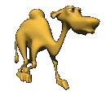
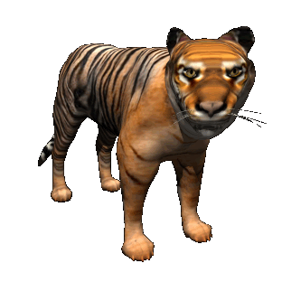
Highlight then drag ‘n’ drop these words in alphabetical order from a to z.

camel
tiger
bear
monkey
1.
2.
3.
4.
Ask your teacher to print this page.

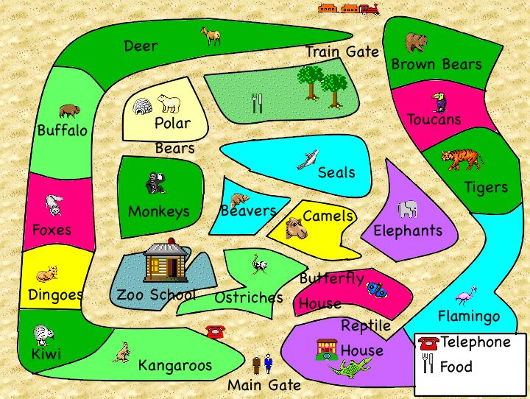
- With a red coloured pencil show the way from the main gate to the seals.
- Use a blue coloured pencil to show another way.
- Draw the quickest way from the rail gate to the zoo school in green.
- After visiting zoo school it will be lunchtime. Show two different way to get to the eating area using your writing pencil.

