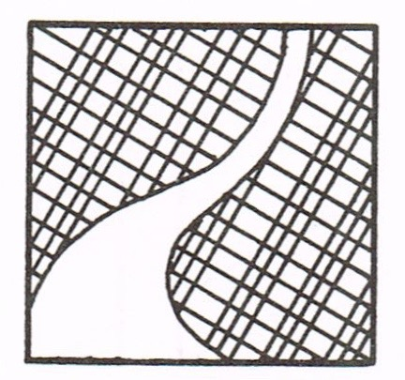
Line Art 4

- Use Shape tools to connect each pair of numbers that is the same.
- Now connect the letters that are the same, drawing through the design.
- Erase the part of the line where it crosses the curves by drawing a line through the space between the curves. Make the colour white and change the weight of the line to 3 - it will make it easier to cover the old line. (Hint: make your page viewing 200% and turn off snap to grid.)
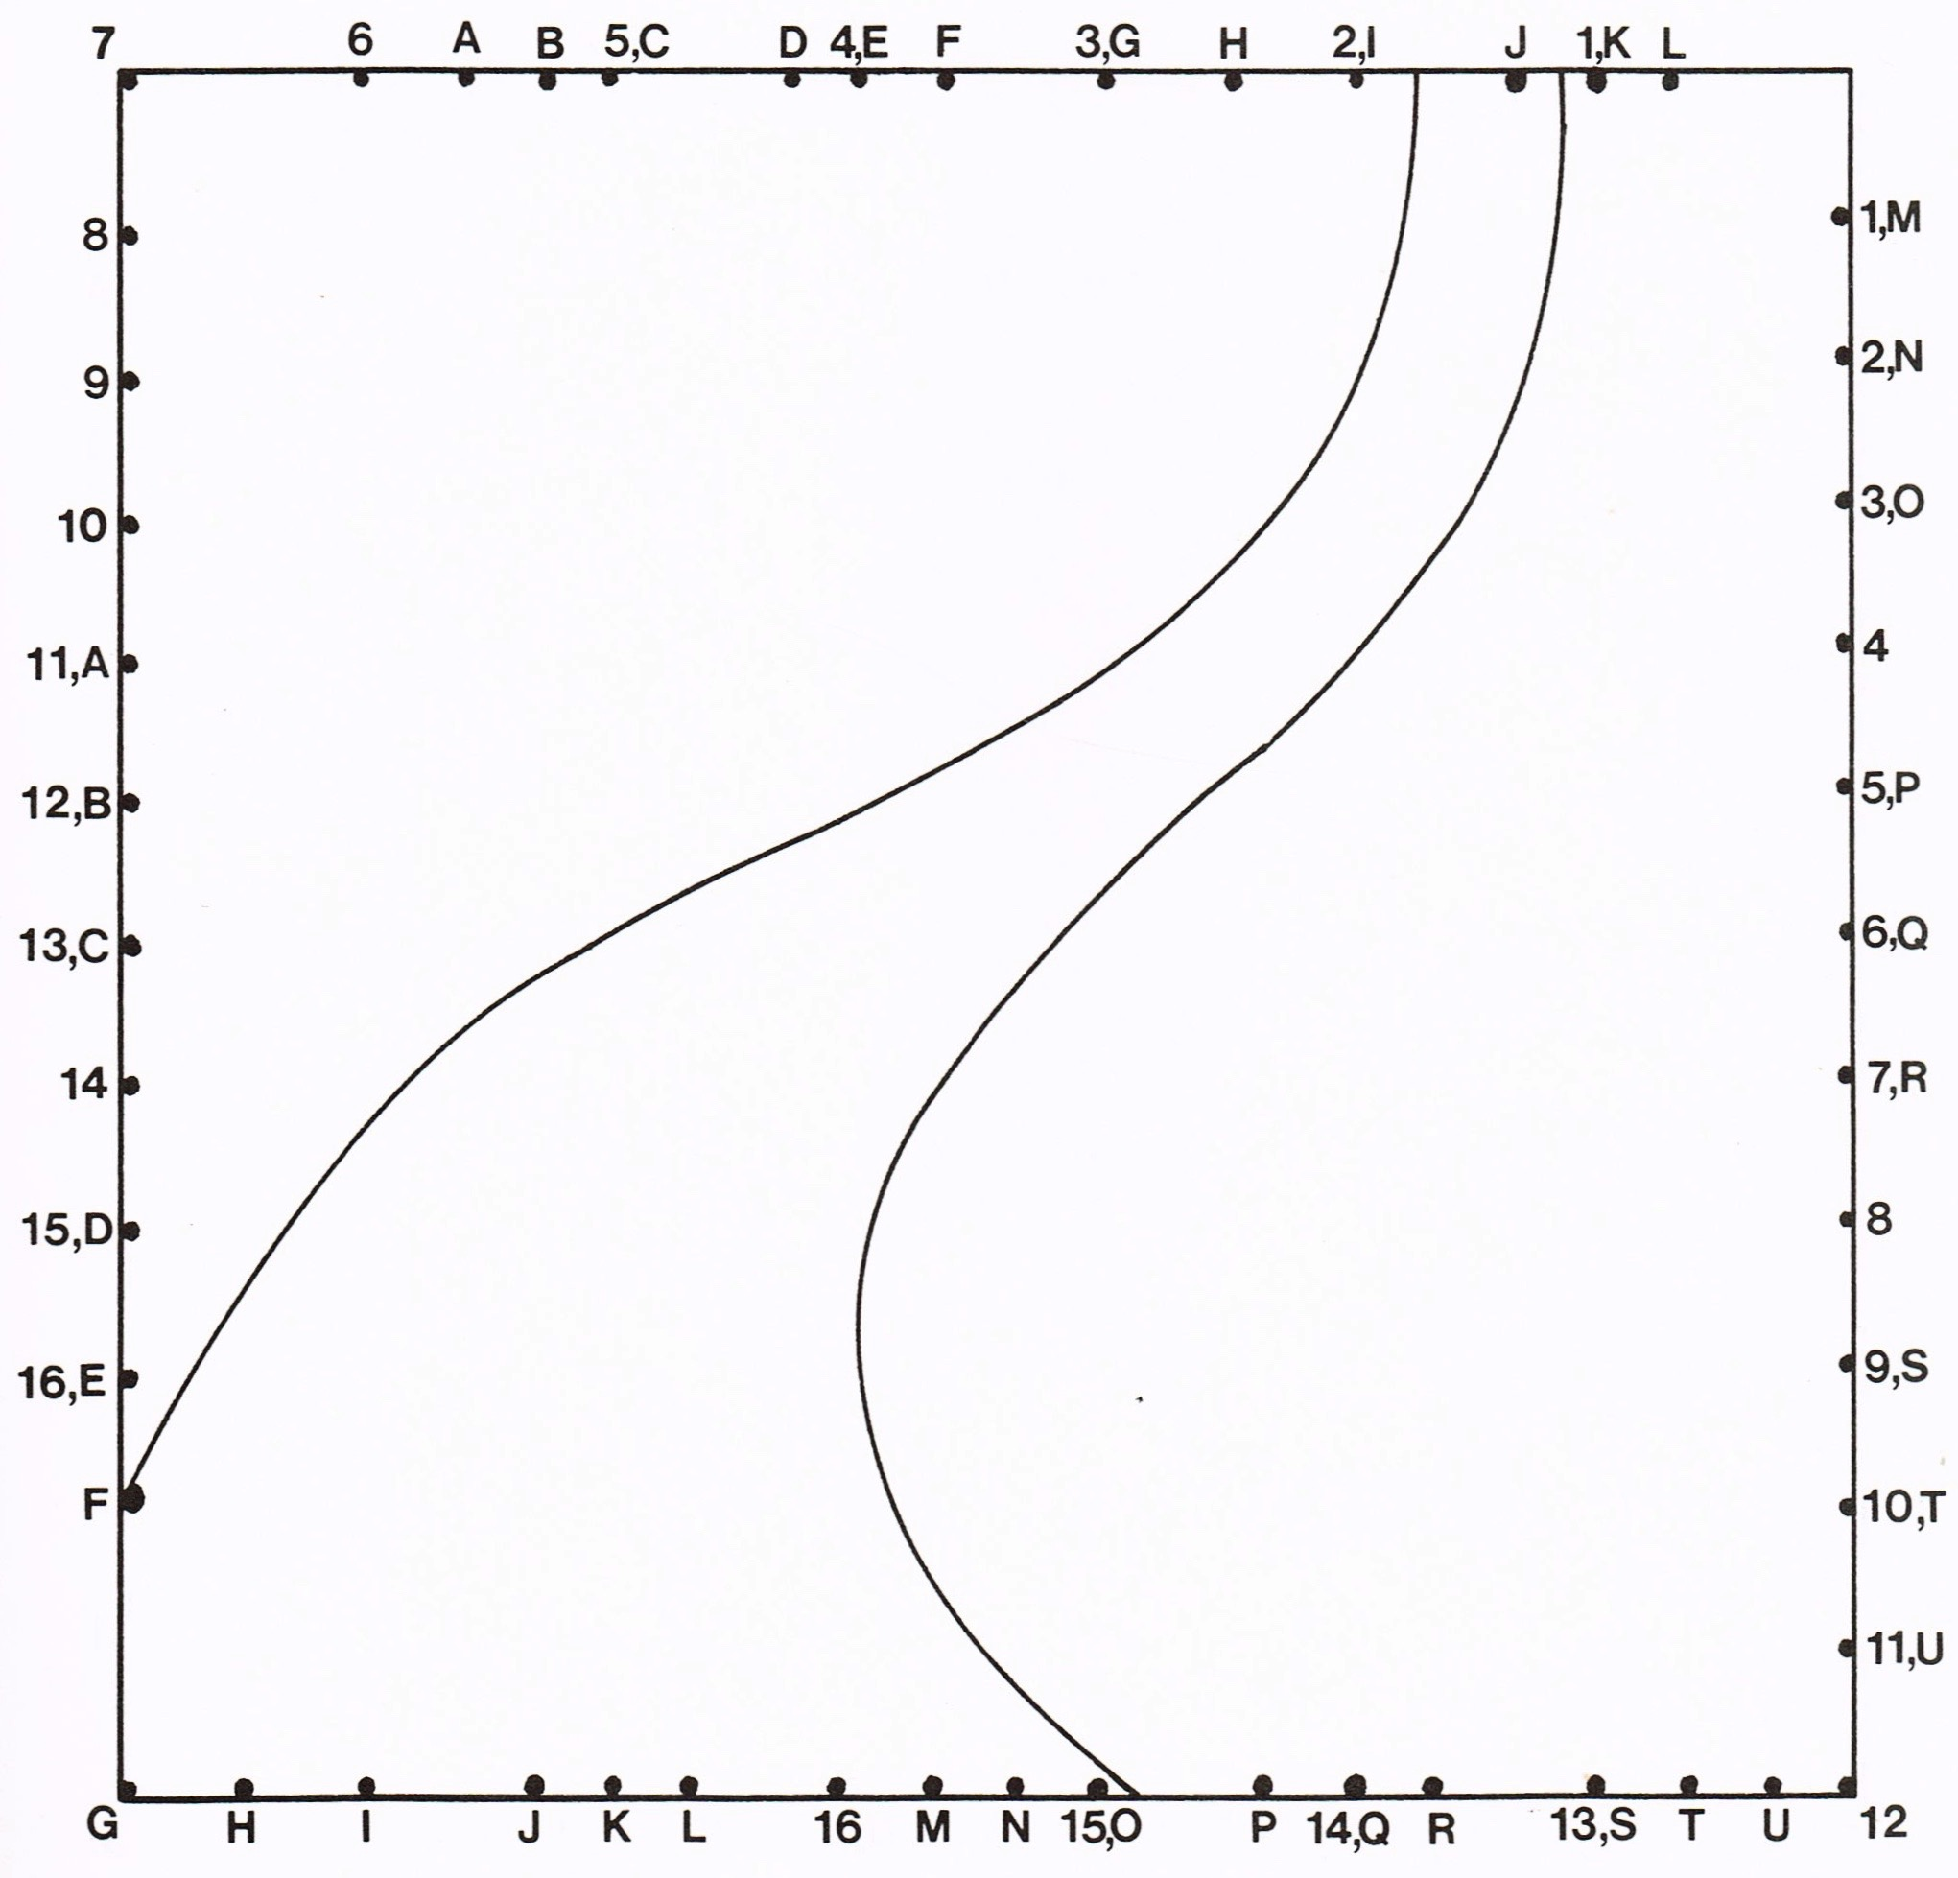
- Print and colour your design.
- Give it to the teacher to mark.

