Searching on the Internet – Keywords

Finding the right information on the internet can be tricky. A search engine can help you locate information quickly and accurately.
When searching for information on the internet it is important to think carefully about the words you use. These words are called keywords.
Look at these questions about the human body and highlight two of three keywords that would help to find the most relevant information.

- Humans have skeletons made up of bones. What are the main functions of a skeleton? Keywords-

- Some animals have exoskeletons on the outside of their bodies. Which animals have exoskeletons? Keywords-

- What are two main muscles that work together to make the arm move up and down? Keywords-

- What is the largest internal organ in the human body and what does it do? Keywords-
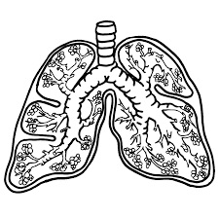

- How do your lungs help you breathe? Keywords-

Add the keywords to the search engine. Do the keywords find good information to help answer the questions?
________________________________________________________________________________________________________

Next to the magnifying glass under each question, write a brief answer. We will come back to this next term so save your work in the class folder.

