Name: Class:
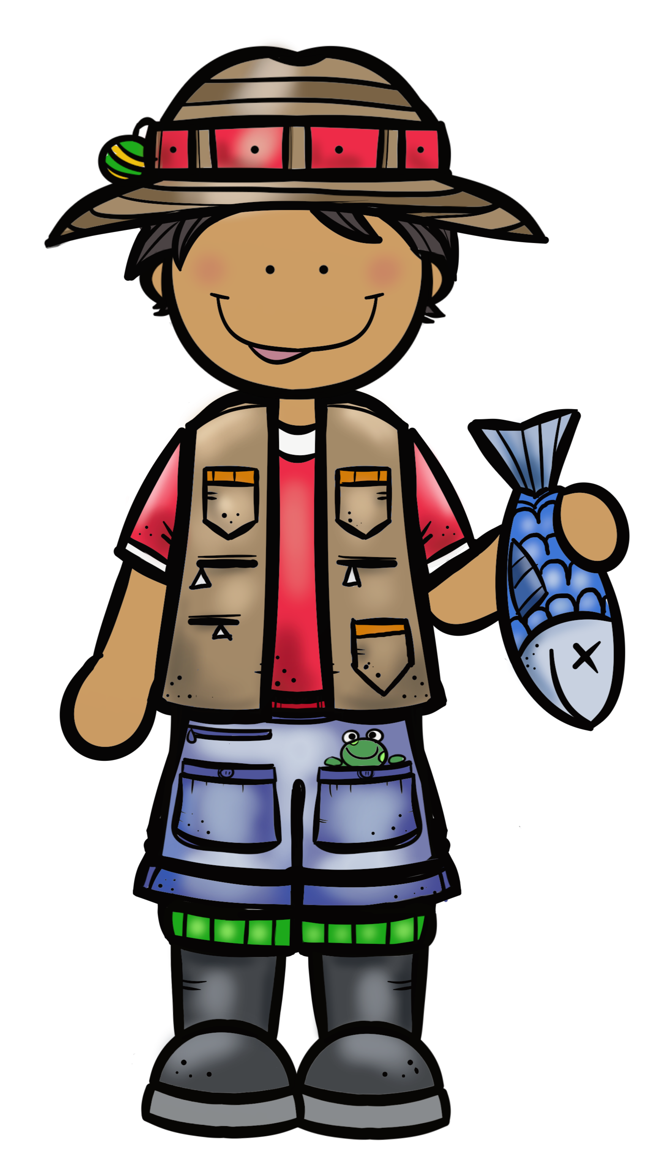
Somethings ‘Fishy’!

A fishing competition has been conducted throughout Australia. You are given the names of the people who won prizes and the types of fish caught. However, to find out who won you have to order both the people’s names and the types of fish in alphabetical order. Once you have done this you then number the people’s names from 1 to 15 and the fish types from 1 to 15. You are now ready to help the judges decide who won the prizes, so fill in the honour board.

Fishermen’s names: Swain, Thompson, Kirkland, Johnston, Swan, Kirkman, Kirkby, Jonson, Thomson, Swanson, Kirby, Johnstone, Kirkwood, Swanton, Johnson.

Fish Types: bream, mullet, perch, jew, flathead, eel, catfish, dogfish, whiting, barramundi, trout, redfin, carp, tailor, snapper.

FISHING COMPETITION HONOUR BOARD
Person’s Name Fish Types
 |  | Biggest | Smallest | Most
1 |  | 15
2 |  |  | 8
3 |  |  |  | 3
4 |  |  |  | 13
5 |  | 12
6 |  |  | 9
7 |  |  |  | 7
8 |  | 14
9 |  |  | 2
10 |  |  |  | 1
11 |  | 10
12 |  |  | 5
13 |  |  | 11
14 |  |  |  | 6
15 |  | 4
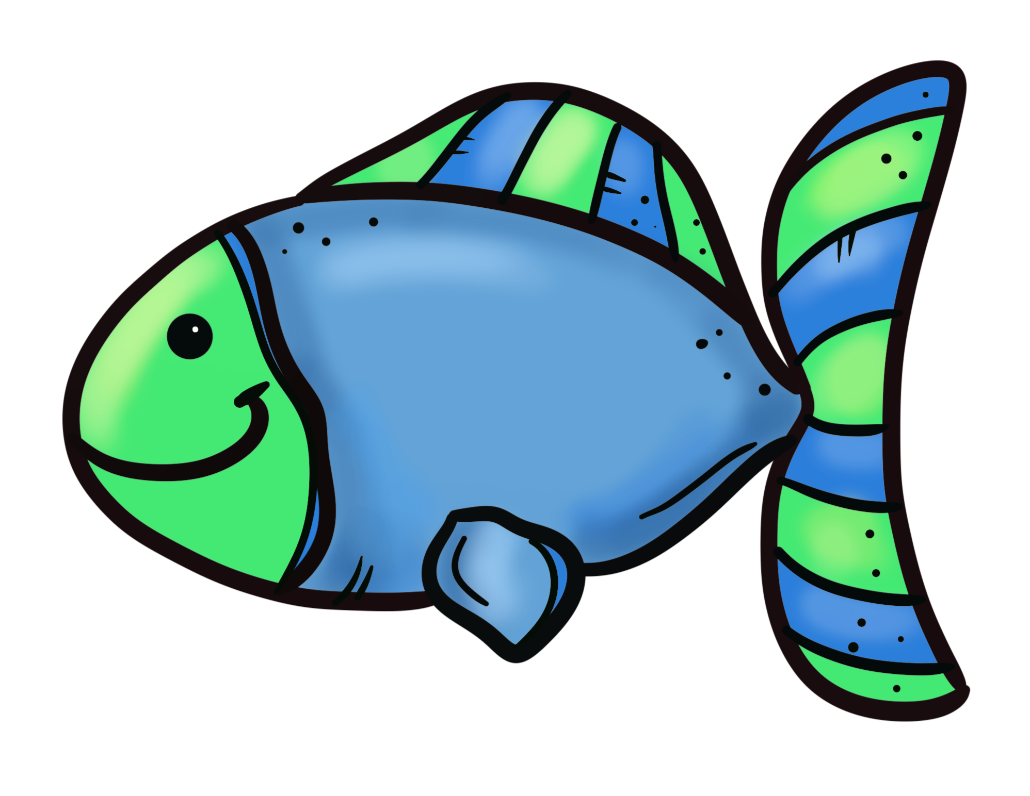
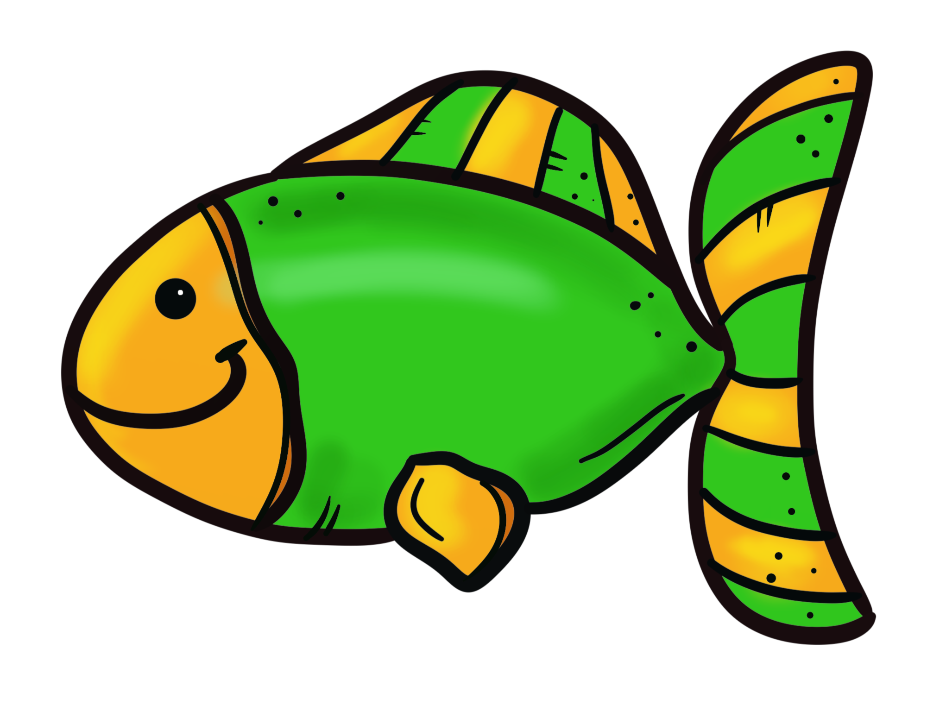
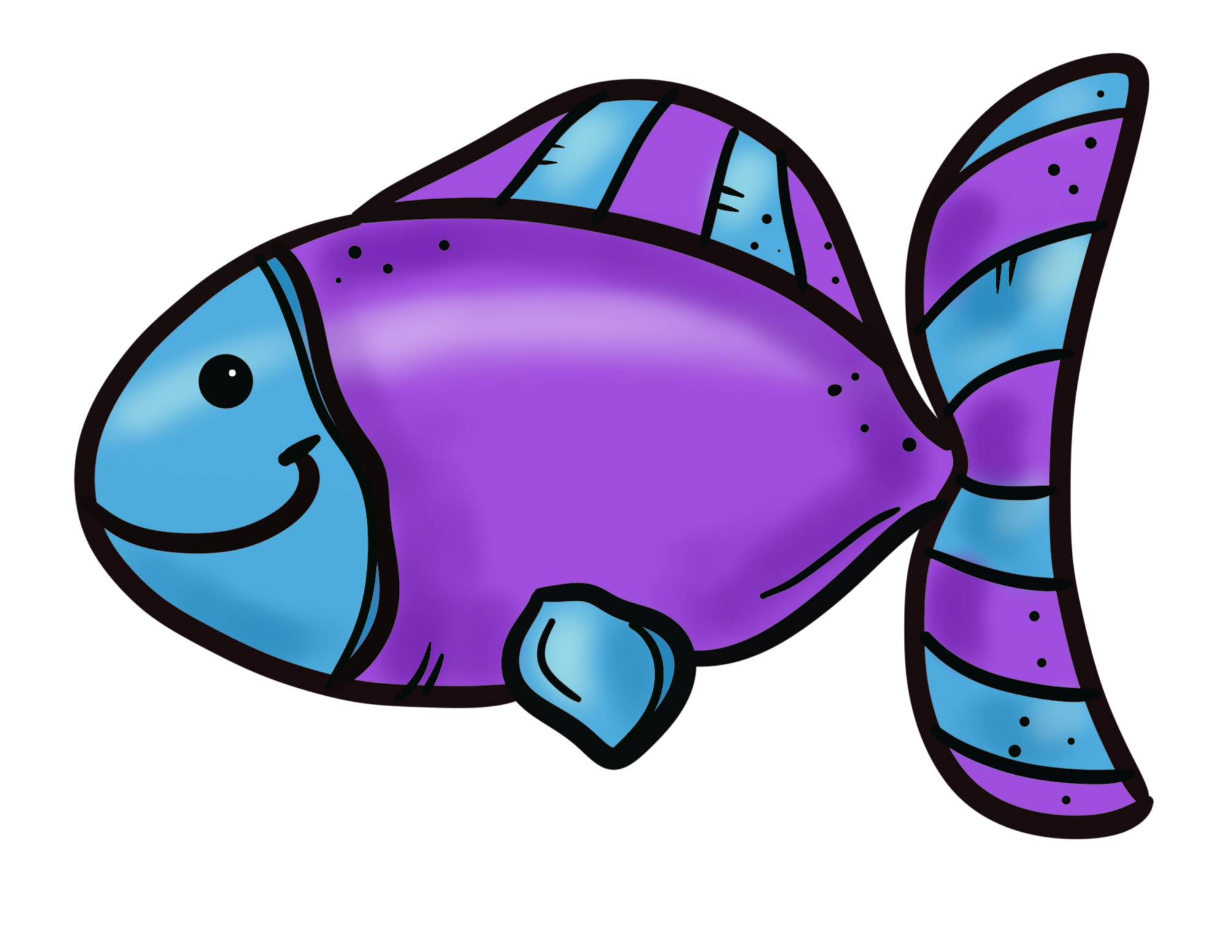
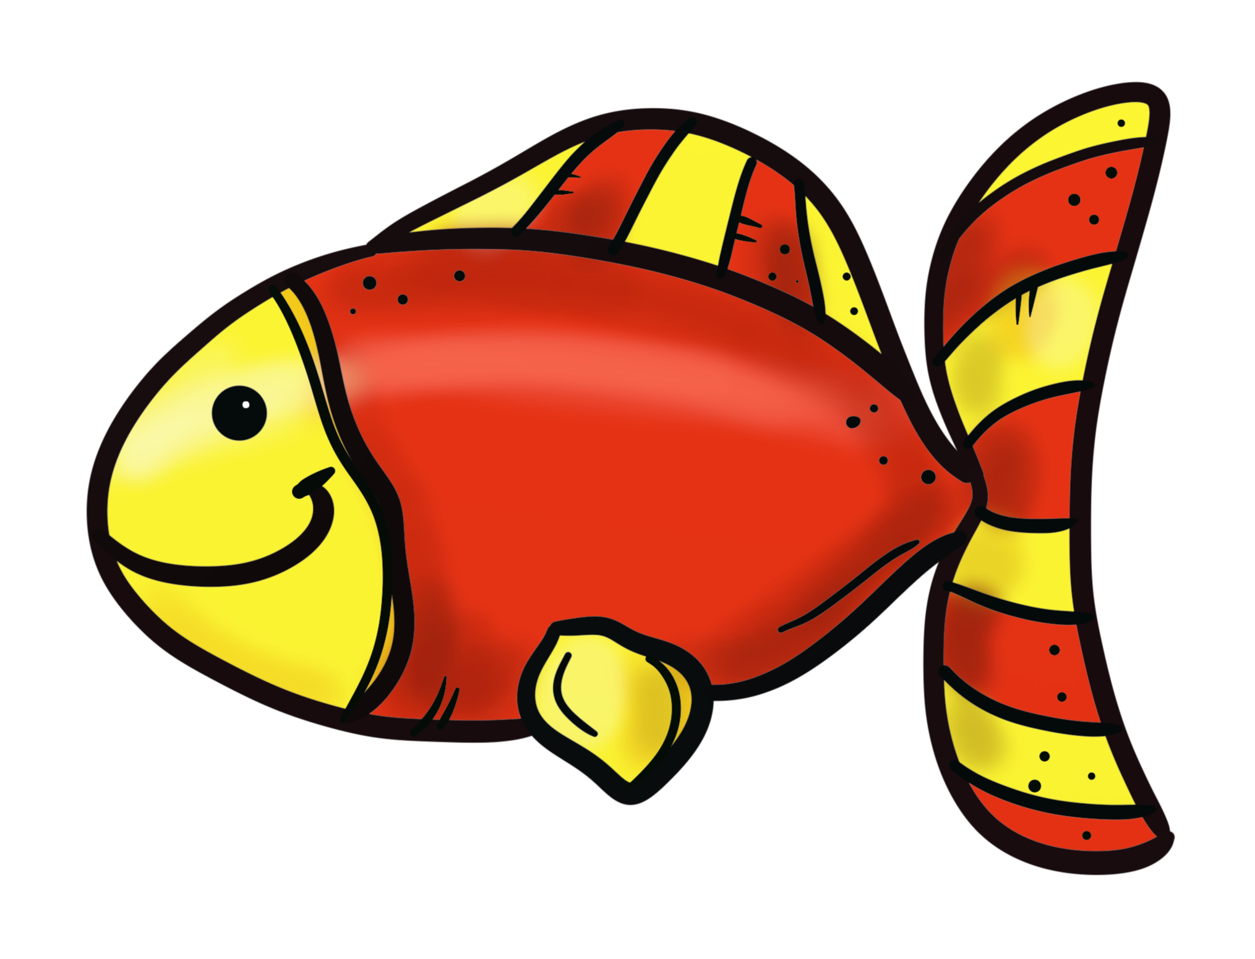

From the table answer these questions.

- Who caught the biggest perch?
- Who caught the most eels?
- Who caught the smallest mullet?
- Who caught the biggest trout?
- What did Johnson do?
- What did Kirkby do?
- What did Kirkland do?
- What did Swanton do?
- What did Thomson do?
- Who caught the most carp?

