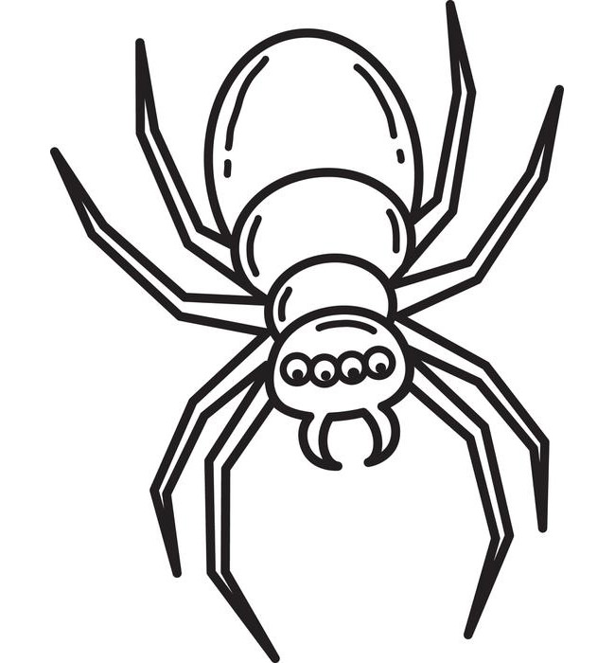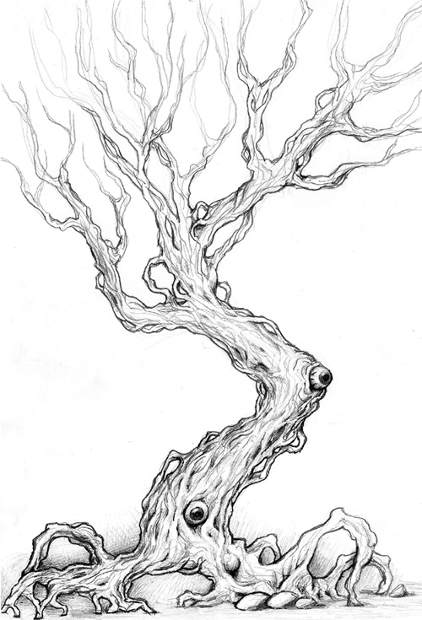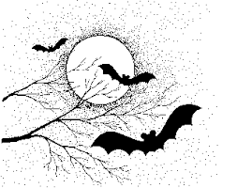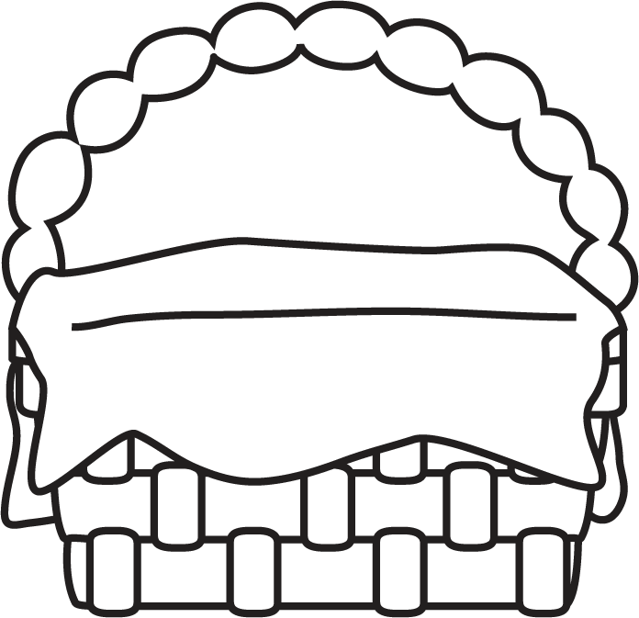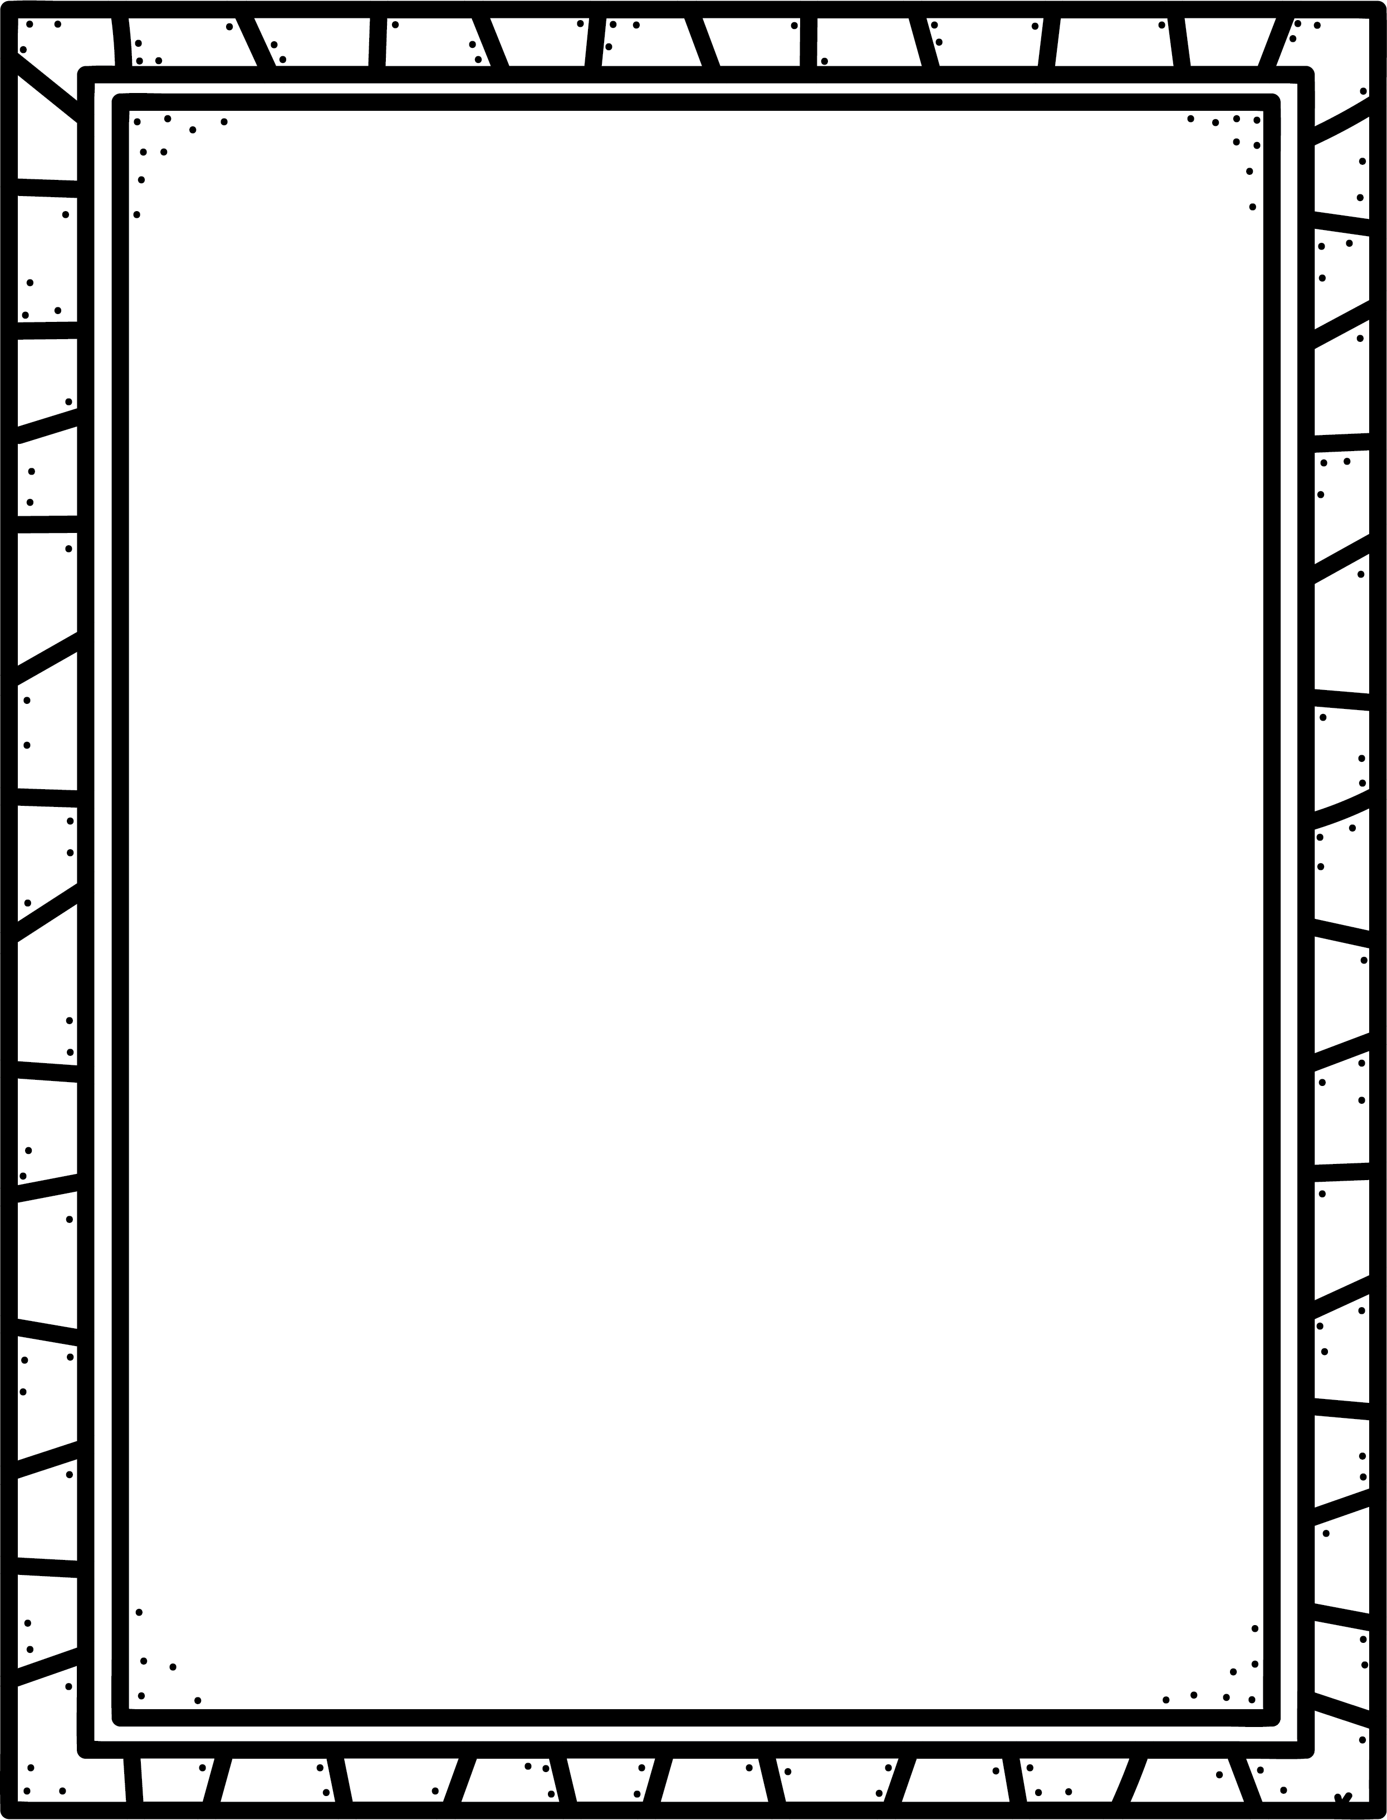

**Characteristics of Spooky Stories**

* Often the main character has a goal, but something stands in the way.
* Creepy setting – dark, abandoned places.
* Creepy characters – something not quite right about them.
* Lots of suspense.
* Shocking events. Sometimes there is a ‘twist’ – something you weren’t expecting.

Spooky

**Author’s Purpose:**

**To entertain.**

**Some spooky stories or series I know are:**

**Keep track of the spooky stories you read here!**

**Name:___________________________**

**Good Readers Know About Genres**