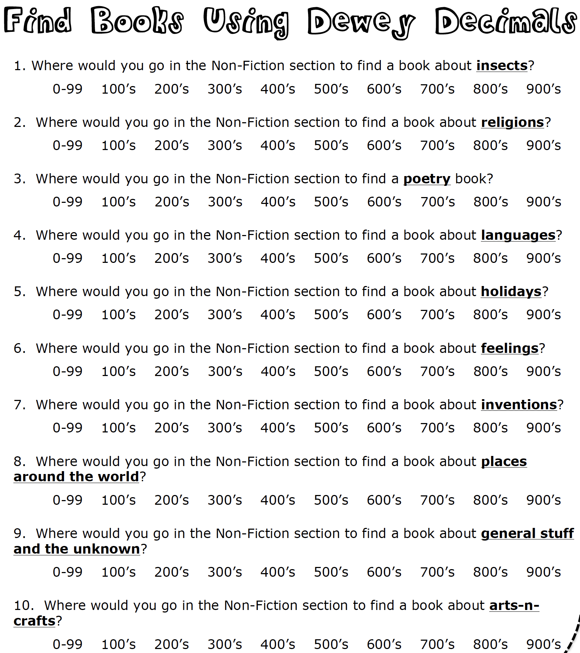

**/ 10**

**YOU CAN…**

Name: ­­­­­­­­­­­­­­­_______________________________ Class: ____________________