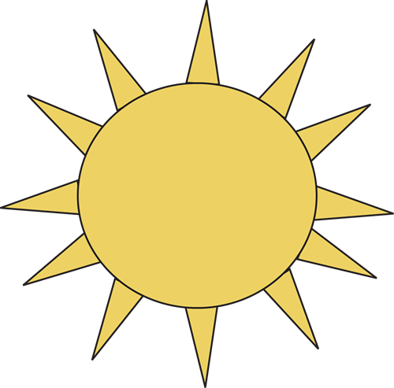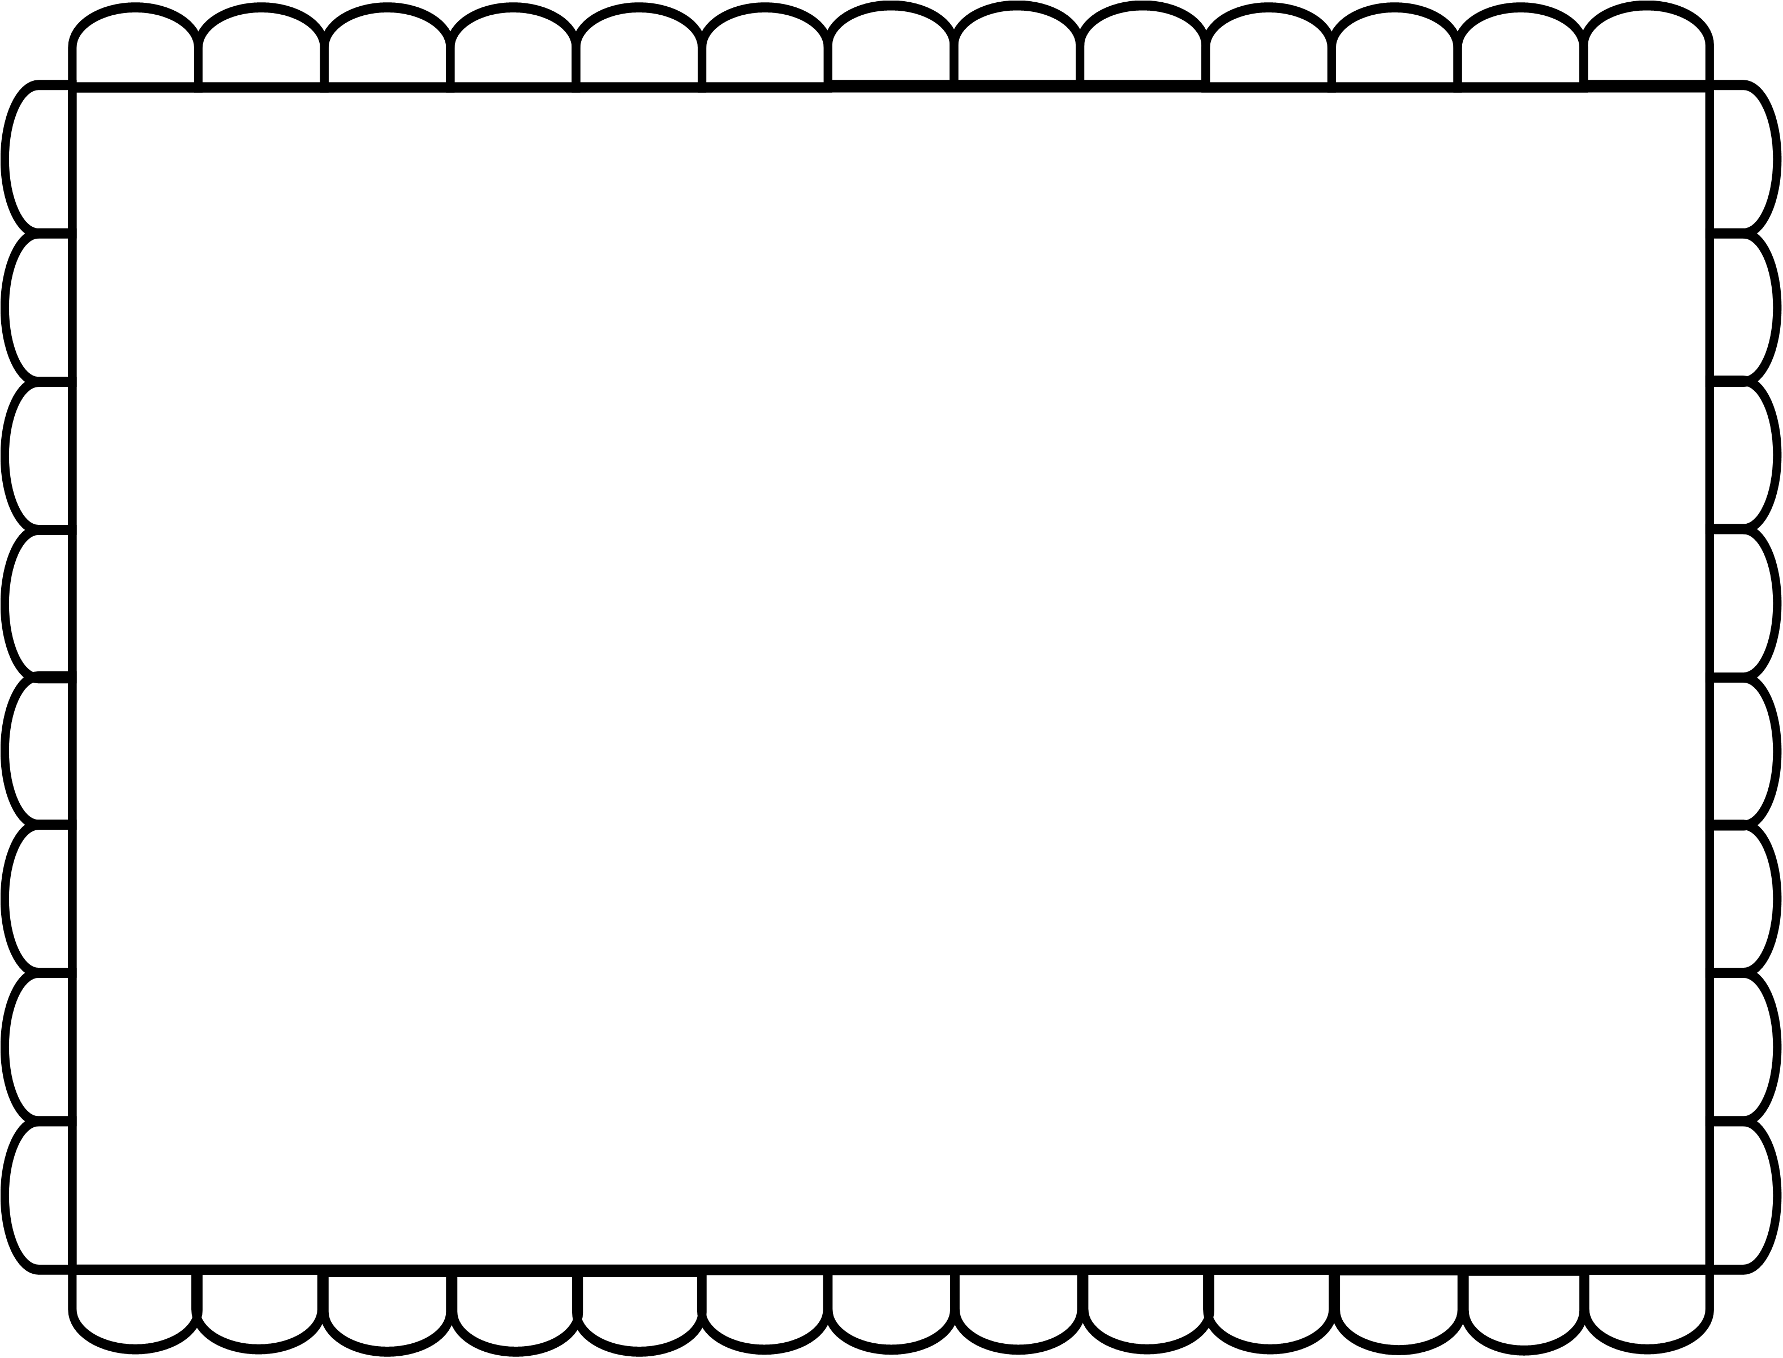

**Tom paints the sun.**

1. First, Tom gets out his supplies.
2. Next, he paints a yellow circle.
3. Then, he paints triangles around the circle.
4. Finally, Tom enjoys his artwork.

|  |  |  |  |
| --- | --- | --- | --- |
|  |  |  |  |

