Name(s): Class:

Tasks:

- There are 12 spelling errors. Not all of them are recognized by the spell checker. Find and correct all 12 words.
- Place the picture of penguins somewhere with the second paragraph.
- Save the document in your class folder
- Name the document –
‘your name(s)+Playful Penguins’

Playful Penguins

Most people associate Antartica with penguins. These unique flightless birds that waddle around in an awkward fashion, are the subject of many wildlife documentaries and are found in abundance in the cold icy enviroment of the Antartic waters.

Penguin are amazing animals that have gradually evolved over many millions of years, allowing their wings to develop into flipers. They are excellent swimers and move much more easily in water than they do on land. Penguins are only found in the southern part of the world. As well as in Antartica, colonies – known as rookeries – exist in parts of Australia and New Zeeland. The Galapagos penguin is to be found in regions surrounding the equator, which of course has a completly differant climate to that of Antarctica.

Walking is not the preferred method of getting around. Penguins spend most of their time in the water. When they dot walk, it is rather awkward and clumsy and many penguins prefer to move along the ice by “toboganing”, which is where they slide along the ice belly first - a sight to behold, which certainly looks like a lot of fun! Using their flipers to push them, penguins can efficiently travel distances of up to 100 km in this manner.

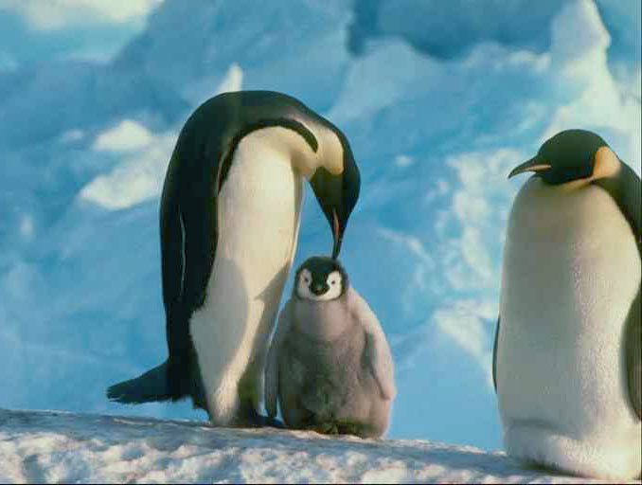

MARK YOURSELF
 | Check I did it | Looks same as Example
Error 1
Error 2
Error 3
Error 4
Error 5
Error 6
Error 7
Error 8
Error 10
Error 11
Error 12
Penguin picture second paragraph

