Tasks:
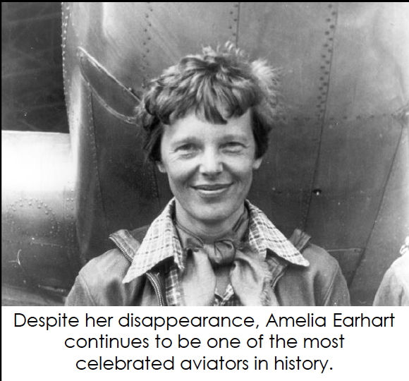
- Open the “Using Shapes” worksheet.
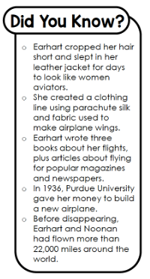
- Copy and paste this image so it appears at the top of column 2 next to ‘Background’. Resize the picture.
- Copy and paste this image so it appears at the top of column 2 page 2. Resize and rotate the picture.
- Add two more images so one overlaps the other. You choose. 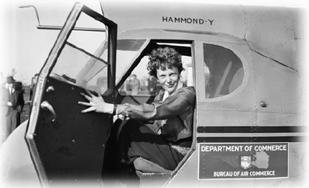 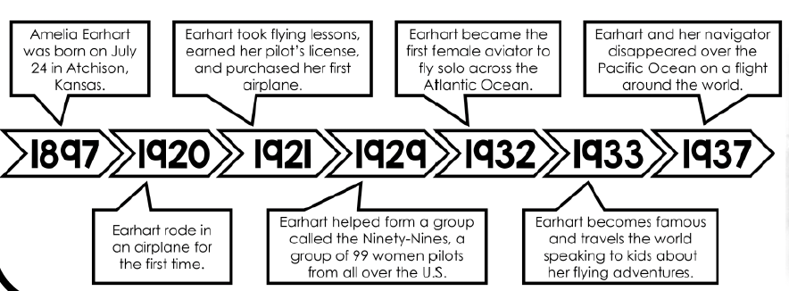 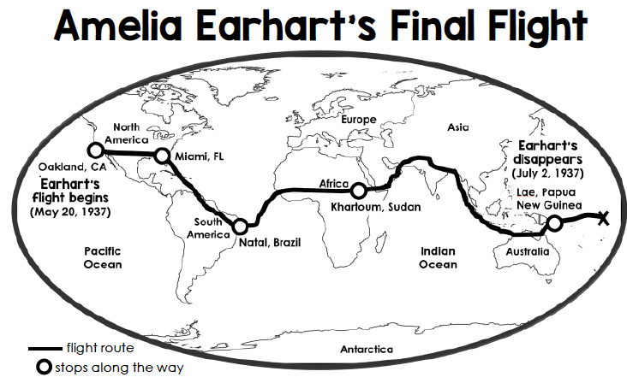
- Resize the images.
- Add borders to your pictures if you wish.
- Check the example to make sure yours looks the same and fix any errors but you do not need the same two pictures as the example has on page 3.

Special Note: If you don’t have “Using Shapes” worksheet in your class folder, make a second download from the website.

MARK YOURSELF
 | Check I did it | Looks same as Example
Copy image 1 into column 2 page 1
Copy image 2 into column 2 page 2
Resize 4 images
Rotate image
Add 2 more images at end of document
1 image overlaps the other

