Name(s): Class:

Tasks:

- Give the title, Playful Penguins, a Title Style. (found on Home Tab) You can choose one of the preformatted title styles or make one of your own.
- Change the rest of the text to a Normal Style, this changes the font. Make it look professional. You may even customize your own style with a font of your choice.
- Limit yourself to one page.
- Format the picture so it fits next to the text in paragraph 2 and give it s border.
- Save the document in your class folder
- Name the document –
‘your name(s)+Playful Penguins Finished’
Delete all the tasks and remember – print 1 page.

Playful Penguins

Most people associate Antarctica with penguins. These unique flightless birds that waddle around in an awkward fashion, are the subject of many wildlife documentaries and are found in abundance in the cold icy environment of the Antarctic waters.

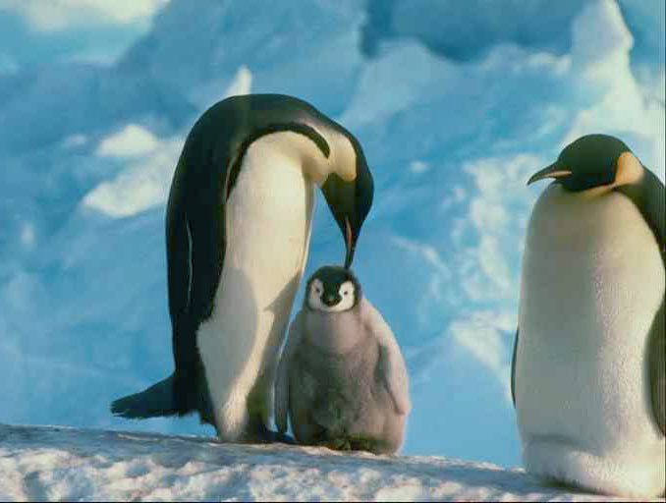
Penguin are amazing animals that have gradually evolved over many millions of years, allowing their wings to develop into flippers. They are excellent swimmers and move much more easily in water than they do on land. Penguins are only found in the southern part of the world. As well as in Antarctica, colonies – known as rookeries – exist in parts of Australia and New Zealand. The Galapagos penguin is to be found in regions surrounding the equator, which of course has a completely different climate to that of Antarctica.

Walking is not the preferred method of getting around. Penguins spend most of their time in the water. When they do walk, it is rather awkward and clumsy and many penguins prefer to move along the ice by “tobogganing”, which is where they slide along the ice belly first - a sight to behold, which certainly looks like a lot of fun! Using their flippers to push them, penguins can efficiently travel distances of up to 100 km in this manner.

MARK YOURSELF
 | Check I did it | Looks same as Example
Playful Penguins to Title Style
text body to Normal Style

