Will we eat Bugs?

BUG EATING COUNTRIES

In Australia, bugs are often thought of as a nuisance and it’s no surprise why. They ruin plants, destroy houses and sometimes hurt people. In many places outside Australia, bugs are viewed differently. Countries such as Thailand, Mexico, Chana and France, entomophagy is common and embraced. For people in those countries, bugs provide a delicious snack or an entire meal. Sometimes bugs are cooked special ways and viewed as a delicacy.

Thailand
People in Thailand are no strangers to eating bugs. In many cities, including Bangkok, it is not hard to find carts piled high with freshly cooked insects. Most of the bugs they sell have been deep-fried to a crisp and then heavily coated with seasonings. An insect cart in Thailand often includes 5-10 different choices. The people of Thailand love purchasing these bugs to snack on. To them, it’s as tasty as chips are to us. One of the country’s most loved snacks is Jing Leed which is deep-fried cricket that has been seasoned with a lite sauce and some pepper. Other favourites include bamboo worms, silkworms, fried grasshopper and water bugs.

Mexico
Mexico has a large variety of edible insects. The most common edible bug eaten in Mexico is Chapulines, or grasshoppers. These bugs are often deep-fried and then seasoned with salt, lime and chilli. Chapulines are typically eaten as a snack, but they can also be used to enhance a meal. For example, they could be sprinkled on top of fried eggs, or they can be used to make a flavourful taco. Chapulines are so popular that they can be purchased on Amazon.com. A small bag costs $8 and so far, it has many good reviews.

Another type of edible bug that is eaten in Mexico is Gusanos, or maguey worms, which are said to taste like French fries. Chicatana are really big red ants with wings that can be found in Oaxaca. Mexico. Locals roast the fat red ants in a pan with lime, getting rid of their heads and wings. Then they grind them into a paste with chilli, salt and garlic and spread it liberally onto a tortilla.

Ghana
In Ghana and many other African countries, there are people have to eat edible insects to survive. The bugs they eat include termites, grasshoppers and dung beetles. But there it is one edible bug that is becoming more popular in Ghana whether you are poor or not. Aspire, a food company, is teaching people how to farm and sell the palm weevil larvae which is full of protein and iron. Anaemia is very common in Ghana, so these nutritious bugs are helping many people. Families in Ghana like to fry them or eat them in a soup.
France
Le Festin Nu, a restaurant in Paris, France is a bistro that serves insects on the menu. Elie Daviron, the head chef, imports grasshoppers, beetles and water scorpions from Thailand. When the insects arrive, Daviron opens up the sealed packages and uses the bugs to make fancy dishes. Then he sells them for between $9.50 and $12.50. Daviron’s customers doubled just after a week asserting insects.
Bugs are the future

- Eating bugs is not something that just a few people do. It is estimated that about 2 billion people around the world are incorporating bugs into their diet and that about 1,900 species of bugs have been consumed and enjoyed. Even though entomophagy, the practice of eating bugs, is not very acceptable in western countries, entomophagy advocates are trying to change that by teaching people that eating bugs doesn’t have to be weird and that it’s very beneficial.

- You might be wondering, “Why are people saying we should eat bugs ? What are the benefits?” Many experts predict that the number of people in the world will continue to increase and that the amount of agricultural land and water sources will decrease. If that happens, then there will be less crops and livestock available. Humans need protein and other nutrients to grow and be healthy. Right now, most Australians get their protein from plants and animals. But what if those things became scarce? How else can people get their protein? Believe it or not, they can get it from eating bugs. Bugs are very healthy source of food. They contain a lot of protein, fibre, healthy fats and important nutrients such as calcium and iron. Grasshoppers, for example, have almost as much protein as lean ground beef, but less fat. Mealworms have a lot of the same health benefits as fish. Experts believe bugs are the food of the future. CSIRO has been and still are investigating bugs as our future food and a possible waste disposal system in Australia. The nutritionist and dietician at Bug Me are investigating the benefits of bugs in our diet and creating recipes to incorporate bugs into our meals.

- By 2050, there will be more than 9 billion people on the planet. The United Nations estimates that to feed everyone, sustainable food production will have to increase by 70% and bugs will need to be a critical source of protein.

- Another reason why people are excited about entomophagy is because they say it’ll help the environment. Raising livestock requires many resources. Think about a cow and how much space it needs. The bigger the animal, the more land, food (grain) and water needed to raise it. Think about growing crops. You need clean the air, healthy soil, sunlight, warm temperatures, and room for the plants to grow. Bugs, on the other hand don’t need a lot of room or resources to grow. They could be fed and nurtured in almost any setting. Meal worms, for example, can be raised in plastic tub. For food, all they need is a layer of oats or other grains. Then slices of potatoes, vegetables or fruit provide water to the worms. they don’t need sunlight. One more exciting thing about farming bugs is that it doesn’t require using special machinery, which means that anyone, could participate and earn money.

Facts in Brief

- 2 million people eat bugs regularly
- 1,900 species of bugs eaten and enjoyed
- Agricultural land and water are decreasing
  - Human population is rapidly increasing
    - 9 billion people by 2050
- Need sustainable food
- Bugs high in protein, fibre, healthy fats with some calcium and iron
  - Need minimal space to grow
  - Need minimal resources (e.g. food and water) to grow

Bugs are the Future

There are many different ways to cook insects and it isn’t hard to do. They can be fried in a pan, boiled, sautéed, roasted or baked with a bit of oil and salt. They can be ground into a powdery flower and used to make bars, breads, biscuits, and crackers.

There are so many different types of edible bugs that if you don’t like one kind, you can try another. Many people who try bugs for the first time are surprised that they don’t taste gross or “buggy”. In fact, many people have said that they taste like other foods that people in Australia love. Mealworms taste like roasted peanuts, or do they – check out this link https://thecookscook.com/columns/meat-insects-poultry-seafood/insect-flour/ crickets taste like almonds, bamboo worms taste like salty popcorn, tarantula legs taste like chicken wings and sago grubs taste like bacon.

Not everyone in Australia is against trying bugs. Some celebrities have even eaten bugs and think they are tasty. Zac Efron, for example, ate a scorpion in front of a live audience and said it was “really good”. Then he tried a Taiwanese cricket and said, “That is the best one.” Kids are trying bugs too! In America, there is a Brooklyn Bugs festival. Many elementary (primary) children will attend. While at that festival, Holly and her friend Tennessee both ate a cricket for the first time. When asked what they thought, Holly said, “it’s good!” Brooklyn Bugs is a group that is trying to make eating bugs normal. They are really trying to get kids involved because they believe the kids are much more willing to try new things and this will help change the stigma that people have against bugs.

Alethia Price has been trying to change the stigma for a while. She has been eating bugs since she was 13 years old in her American Indian culture and written books and a website. Her website teaches people how to raise bugs for food and how to eat them. Alethia’s favourite dishes include mealworm chocolate chip cookies and ant tacos. If you think about it, Aboriginal Australians been eating bugs for centuries. The more familiar bugs include witchety grubs and honey ants. Witchety grubs are found in the roots of some wattle trees. I have eaten witchety grubs and I prefer them fried. They taste a little like chips. To eat a honey ant, you hold the ant and suck their abdomen that is engorged with honey – very sweet.

Entomophagy advocates are hopeful Australia will eventually except eating bugs. History has shown that dietary patterns can change. In fact, about 20 years ago, people thought eating raw fish was disgusting. Now, almost everybody loves sushi. So, things can change, it just takes time.

NO WAY !

Even though other countries may embrace eating bugs, most Australians don’t. Here are some of the reasons why people are against eating bugs.

Allergies
About 6 million children in the world are allergic to some sort of food. What about eating bugs? If kids start eating bugs, is it possible that someone will have an allergic reaction? Of course! Even though there isn’t a lot of research about eating bugs and allergies, we do know that there are similarities between bugs and sea creatures. So, if someone is allergic to mollusks or shellfish, it is advised that they avoid eating bugs.

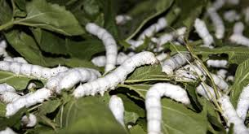
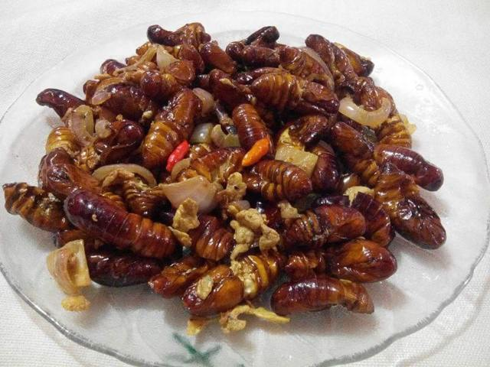
Those that are allergic to insect venom should also not eat bugs. But they aren’t the only ones who should be cautious. Everyone is at risk of an allergic reaction. One man from France tried a silkworm first time while in China. The only thing he was allergic to was pollen. After trying the bug, he went into anaphylactic shock and was rushed to hospital. Thankfully, he didn’t die and recovered quickly.

Serving bugs to the public in Australia is risky because you never know what allergies may occur. Even entomophagy advocates are hesitant to serve bugs publicly until more research is done. They are worried that if allergic reactions start happening, then people will be even more scared to start eating bugs.

Ick!
No matter how many times people are told bugs are nutritious and good for the environment, most of them, especially adults, still cringe and say, “No.” Why? Because Australian culture view bugs as annoying and disgusting. Getting them to think otherwise is challenging. Once the human mind decides something is gross, is very difficult to convince it otherwise. Right now, if you started serving bugs publicly, it would not go smoothly. Many people would be grossed out and feel sick. It’s risky to start
serving bugs to people freely because so many of them, particularly adults, are incredibly grossed out by just the thought of it. Here are some of the things that people are saying on Facebook about eating bugs :

“No thank you!! I’m sorry, I’m not going to do that even to save my life.”
“Nope, I hate insects. Hate the legs, eyes, and the way they look all over. Nope, nope, nope…!”
I tried crickets at a market awhile back. I was still gagging three hours later, much to the delight of my wife and daughter.

“You can keep your bugs if that’s all have in the future. I’ll become a vegetarian.”

