Worksheet 1 Hunt The Smileys

Once upon ☺☺☺ a time ☺☺☺ there was a ☺☺☺ pair of naughty ☺☺☺ friends called ☺☺☺ Scott and Arabella. They ☺☺☺ were always being ☺☺☺ pests in ☺☺☺ the classroom, and their ☺☺☺ teacher, Mr Douglas, had just had ☺☺☺ enough.

The last ☺☺☺ time they were ☺☺☺ naughty they took ☺☺☺ all the children’s ☺☺☺ lunches and fed ☺☺☺ them to the school’s ☺☺☺ pet fighting fish.
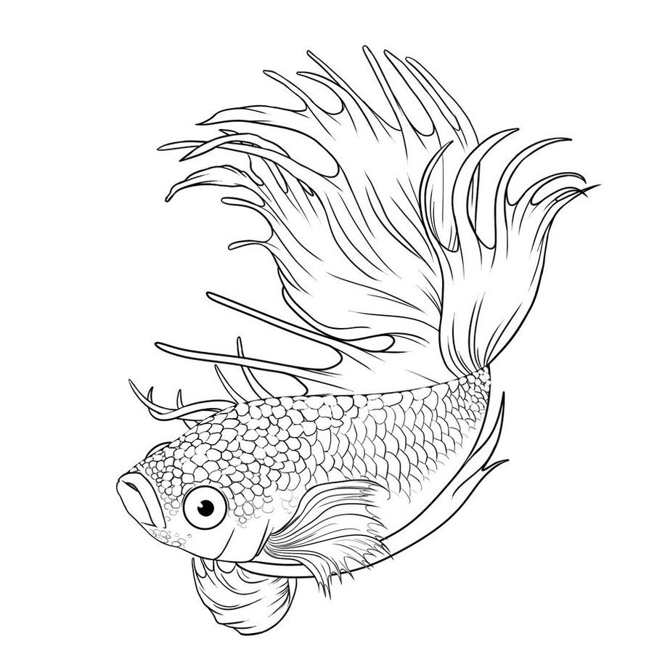

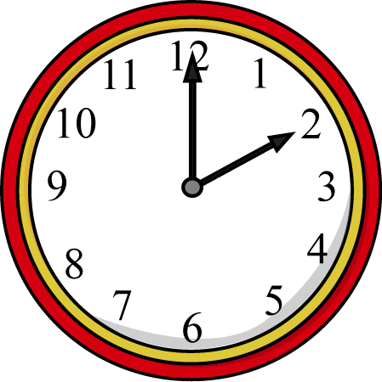
The time before ☺☺☺ that they put ☺☺☺ the school clock ☺☺☺ forward an hour so that the bell ☺☺☺ for home time rang at ☺☺☺ 2pm instead of 3pm.

What ☺☺☺ was Mr ☺☺☺ Douglas going to ☺☺☺ do about ☺☺☺ them? Can you give him some advice?

My advice is

