Worksheet 12 Ants

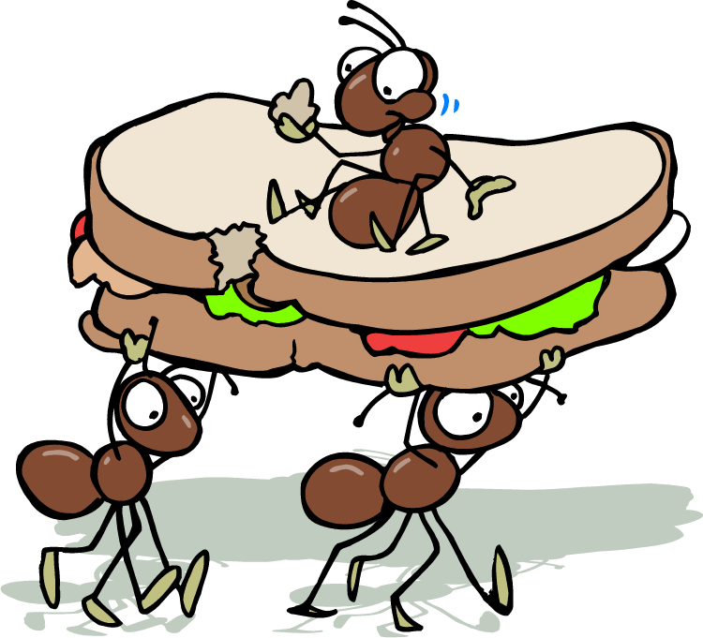
Ants, they were everyyyyyyywhere. When Room 8 came in forrrrrrr their Mathssssss lesson they couldn’t even seeeeee the floor of the classroom. Jasper was looking really worrrried. He knew that it was his lunch-boxxxxxxx they were after. No one elssssssssse ever haddddd syrup and honey sandwichessss in their lunch box. No one elssse evvver had a whole loaf of bread there to last them all weeeekkk. But Jasper he wassss absolutely mad on his syyyyrup and honnnney sandwiches. Madddd for them!

So thousands upoooooooon millions upon trillions of ants swarmed over thhhhhe classroom floor. The Jackson twins were rrrrrrrrunning around screaming. Half the bbbbboys were tryyyyyyying to stamp on them. Dear old Mr. Rogers had no idea what to doooooo. To be quite honest itttttt was a shambles.

So, young Francis came up with an idea… well I’ll let you decide whattttt really happpppppened to them. You can type it here if you have finished.

