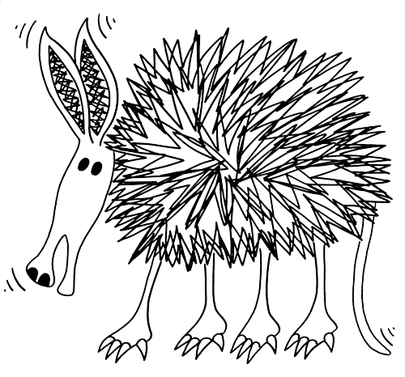
Worksheet 14 Hunting A’s

One bright August afternoon two African aardvarks were annoying all the other animals in the jungle. They always did this at the most awful times, even when their Auntie was giving them their allowance. Anyway they had all had enough and agreed to amend the problem. The other animals all got together to assess how to annoy the aardvarks so much that they’d never attempt to annoy them again. An hour or so after discussing their answer to the problem they came up with the solution. “The only thing we can do is to move to Australia.”

You can probably make a better story than me. Try a B story.

