Worksheet 15 Food People or Places
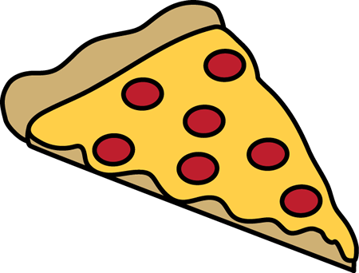
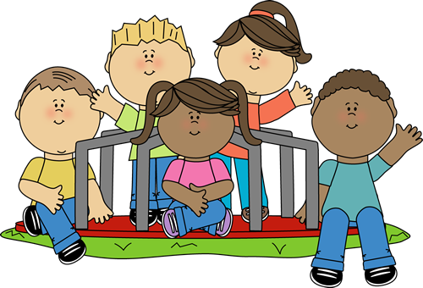
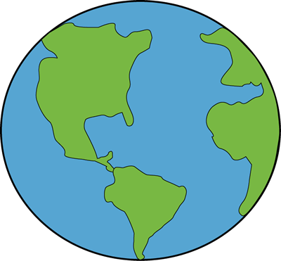

New York
Mount Everest
Michael Jackson
Chocolate cake
Jonah Lomu
Spaghetti
Strawberry cheesecake
London
The Pyramids of Egypt
Ayers Rock
Sporty Spice
Fish and Chips
Sydney
Tom Cruise
A cup of tea
Baked beans
Custard
Ice Cream
Auckland
Sausages
Julia Roberts
Sydney Harbour Bridge
Your teacher

