Worksheet 17 Change The Rules

Room 8’s Class Rules
DON’T YOU DARE steal the teacher’s chocolate biscuits.
PLEASE DON’T put salt in the teacher’s tea.
DO NOT touch anything on the teacher’s desk.
TRY NOT TO talk when the teacher is talking.

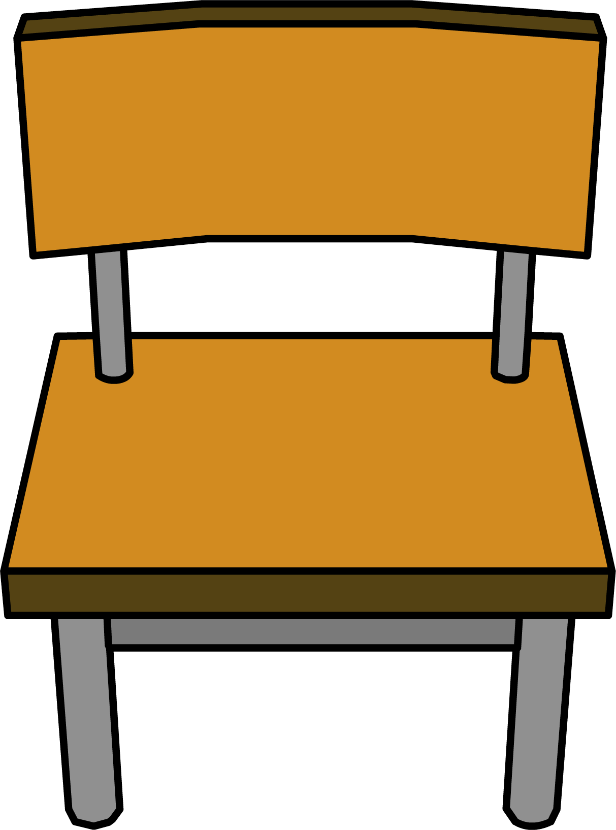
DON’T YOU DARE write on the blackboard.
PLEASE DON’T leave your desk in a mess.
DO NOT forget to put your chairs up at the end of the day.
TRY NOT TO hand your homework in late.

DON’T YOU DARE run in the classroom.
PLEASE DON’T make lots of noise in class.
DO NOT eat gum or lollies in class.
TRY NOT TO come to school with a messy uniform.
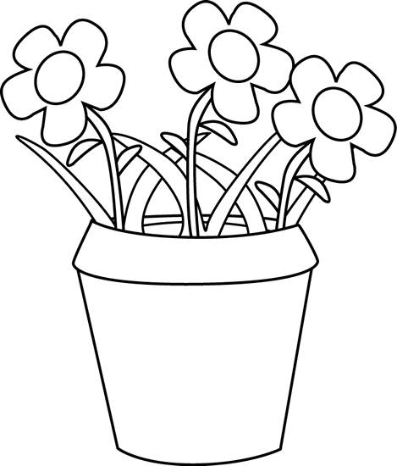
DON’T YOU DARE call the class plant nasty names.
PLEASE DON’T draw silly pictures of the teachers on your books.
DO NOT throw food at lunchtime.
DEFINITELY DO NOT DISOBEY THESE RULES.

